11#DEL:

This command is used to delete one or more files or directories form a more file system.

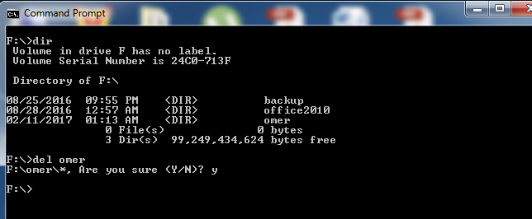

12#TYPE:

This command is used to display the contents of specified files.

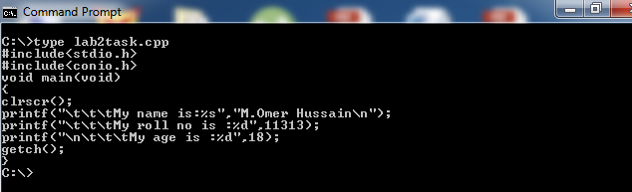

13#COPY:

This command is used to copy one or more files from one location to another. However ,copy can also be used to create new files.

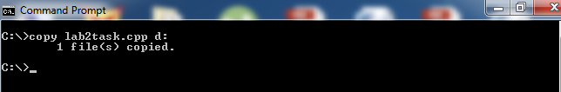

14#XCOPY:

This command is used for copying multiple files or entire directory trees from one directory to another and for copying files across a network.

