OBJECTIVE:

Draw the following patterns by using nested for loop.

SOURCE CODE:

#include<stdio.h>

#include<conio.h>

void main(void)

{

clrscr();

int a,b;

for(a=1;a<=5;a++)

{

for(b=1;b<=a;b++)

{

printf("\*",b);

}

printf("\n");

}

getch();

}

OUTPUT:

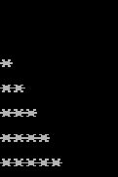

SOURCE CODE:

#include<stdio.h>

#include<conio.h>

void main(void)

{

clrscr();

int a,b;

for(a=1;a<=5;a++)

{

for(b=a;b<=5;b++)

{

printf(" ");

}

for(b=1;b<=a;b++)

{

printf("\*",a);

}

printf("\n");

}

getch();

}

OUTPUT:

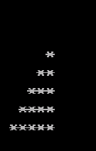

SOURCE CODE:

#include<stdio.h>

#include<conio.h>

void main(void)

{

clrscr();

int a,b;

for(a=1;a<=5;a++)

{

for(b=a;b<=5;b++)

{

printf("%d",a);

}

printf("\n");

}

getch();

}

OUTPUT:

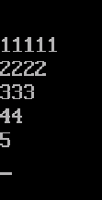

SOURCE CODE:

#include<stdio.h>

#include<conio.h>

void main(void)

{

clrscr();

int a,b;

for(a=1;a<=5;a++)

{

for(b=1;b<=a;b++)

{

printf("%d",b);

}

printf("\n");

}

getch();

}

OUTPUT:

