Lab # 11

Exception Handling

OBJECTive
To study exception-handling (try, catch, throw, throws, finally) and creating your own exception subclasses.

THEORY

Exception
An exception is an abnormal condition that arises in a code sequence at run time. In other words, an exception is a run-time error. In computer languages that do not support exception handling, errors must be checked and handled manually—typically through the use of error codes, and so on. This approach is as cumbersome as it is troublesome. Java’s exception handling avoids these problems and, in the process, brings run-time error management into the object-oriented world.

Exception-Handling Fundamentals
A Java exception is an object that describes an exceptional (that is, error) condition that has occurred in a piece of code. When an exceptional condition arises, an object representing that exception is created and thrown in the method that caused the error.
That method may choose to handle the exception itself, or pass it on. Either way, at some point, the exception is caught and processed. Exceptions can be generated by the Java run-time system, or they can be manually generated by your code.

Java exception handling is managed via five keywords: try, catch, throw, throws, and finally.

Using try and catch
Although the default exception handler provided by the Java run-time system is useful for debugging, you will usually want to handle an exception yourself. Doing so provides two benefits. First, it allows you to fix the error. Second, it prevents the program from automatically terminating.

To guard against and handle a run-time error, simply enclose the code that you want to monitor inside a try block. Immediately following the try block, include a catch clause that specifies the exception type that you wish to catch.

class Exc2 {
public static void main(String args[]) {
int d, a;
try { // monitor a block of code.
d = 0;
a = 42 / d;
System.out.println("This will not be printed.");
} catch (ArithmeticException e) { // catch divide-by-zero error
System.out.println("Division by zero.");
}
System.out.println("After catch statement.");
}
}

Output:
Division by zero.
After catch statement.

Using throw

So far, you have only been catching exceptions that are thrown by the Java run-time system. However, it is possible for your program to throw an exception explicitly, using the throw statement. The general form of throw is shown here:

throw ThrowableInstance;

Here, ThrowableInstance must be an object of type Throw able or a subclass of
Throwable. Simple types, such as int or char, as well as non-Throwable classes, such as String and Object, cannot be used as exceptions. There are two ways you can obtain a Throwable object: using a parameter into a catch clause, or creating one with the new operator.

Here is a sample program that creates and throws an exception. The handler that catches the exception rethrows it to the outer handler.

// Demonstrate throw.
class ThrowDemo {
static void demoproc() {
try {
throw new NullPointerException("demo");
} catch(NullPointerException e) {
System.out.println("Caught inside demoproc.");
throw e; // rethrow the exception
}
}
public static void main(String args[]) {
try {
demoproc();
} catch(NullPointerException e) {
System.out.println("Recaught: " + e);
}
}
}

OUTPUT:
Caught inside demoproc.
Recaught: java.lang.NullPointerException: demo

Throws
If a method is capable of causing an exception that it does not handle, it must specify
this behavior so that callers of the method can guard themselves against that exception.
You do this by including a throws clause in the method’s declaration. A throws clause lists the types of exceptions that a method might throw. This is necessary for all exceptions, except those of type Error or RuntimeException, or any of their subclasses.
All other exceptions that a method can throw must be declared in the throws clause. If they are not, a compile-time error will result.
This is the general form of a method declaration that includes a throws clause:

type method-name(parameter-list) throws exception-list
{
// body of method
}

Example

class ThrowsDemo {
static void throwOne() throws IllegalAccessException {
System.out.println("Inside throwOne.");
throw new IllegalAccessException("demo");
}
public static void main(String args[]) {
try {
throwOne();
} catch (IllegalAccessException e) {
System.out.println("Caught " + e);
}
}
}

OUTPUT:
inside throwOne
caught java.lang.IllegalAccessException: demo

finally

finally creates a block of code that will be executed after a try/catch block has completed and before the code following the try/catch block. The finally block will
execute whether or not an exception is thrown. If an exception is thrown, the finally
block will execute even if no catch statement matches the exception.
The finally clause is optional. However, each try statement requires at least one catch or a finally clause.

Creating Your Own Exception Subclasses

Although Java’s built-in exceptions handle most common errors, you will probably want to create your own exception types to handle situations specific to your applications.
This is quite easy to do: just define a subclass of Exception (which is, of course, a subclass of Throwable). The Exception class does not define any methods of its own. It does, of course, Inherit those methods provided by Throwable. Thus, all exceptions, including those that you create, have the methods defined by Throwable available to them. You may also wish to override one or more of these methods in exception classes that you create.
The following example declares a new subclass of Exception and then uses that subclass to signal an error condition in a method. It overrides the toString( ) method,
allowing the description of the exception to be displayed using println( ).

// This program creates a custom exception type.
class MyException extends Exception {
private int detail;
MyException(int a) {
detail = a;
}
public String toString() {
return "MyException[" + detail + "]";
}
}
class ExceptionDemo {
static void compute(int a) throws MyException {
System.out.println("Called compute(" + a + ")");
if(a > 10)
throw new MyException(a);
System.out.println("Normal exit");
}
public static void main(String args[]) {
try {
compute(1);
compute(20);
} catch (MyException e) {
System.out.println("Caught " + e);
}
}}

OUTPUT:
Called compute(1)
Normal exit
Called compute(20)
Caught MyException[20]

Java’s Built-in Exceptions
Inside the standard package java.lang, Java defines several exception classes. A few
have been used by the preceding examples.
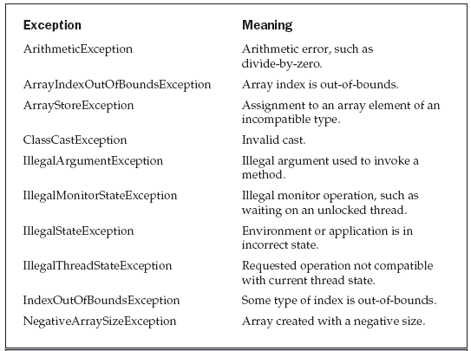

LAB TASK

Refining Your Calculator: Your primary task for this lab is to restructure your calculator to handle exceptions. You can put the method in a try ... catch clause.
- Extend stack with push and pop method with the help of stack class with an Exception handling capability, by raising an exception of type EmptyStackException whenever you try to print from an empty stack. Use the try-catch block when invoking the printStack method. When trying to print from an empty stack the message “Reading from an Empty Stack” should be displayed. You should Define the class EmptyStackException that derives from Exception.
- Create a class with a main( ) that throws an object of class Exception inside a try block. Give the constructor for Exception a String argument. Catch the exception inside a catch clause and print the String argument. Add a finally clause and print a message to prove you were there.
- Create your own exception class using the extends keyword. Write a constructor for this class that takes a String argument and stores it inside the object with a String reference. Write a method that prints out the stored String. Create a try-catch clause to exercise your new exception.
- Write code to generate and catch an ArrayIndexOutOfBoundsException.

