**1st OBJECTIVE:**

To understand java environment and java data types.

**PROGRAM # 1:**

SOURCE CODE:

public class hello

{

public static void main(String args[])

{

System.out.println("THIS IS MY FIRST JAVA PROGRAM");

}

}

OUTPUT:

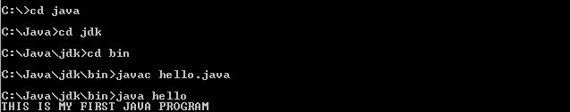

CONCLUSION:

In this program we have print the output on screen.

**PROGRAM # 2:**

SOURCE CODE:

public class Biodata

{

public static void main(String args[])

{

System.out.println("NAME:M.OMER HUSSAIN");

System.out.println("ROLL NO:258");

System.out.println("EMAIL:omerhussain850@yahoo.com");

System.out.println("SECTION:E");

System.out.println("SUBJECT:OOP");

System.out.println("FACULTY:SOFTWARE ENG.");

}

}

OUTPUT:

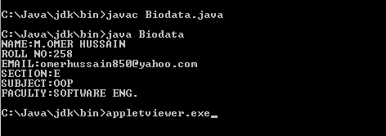

CONCLUSION:

In this program we have print biodata.

**PROGRAM # 3:**

SOURCE CODE:

public class light

{

public static void main(String args[])

{

int lightspeed;

long days;

long distance;

long seconds;

lightspeed=186000;

days=1000;

seconds=days*24*60*60;

distance=lightspeed*seconds;

System.out.print("In"+days);

System.out.print("days light will travel about");

System.out.print(distance+"miles");

} }

OUTPUT:

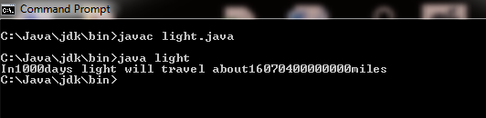

CONCLUSION:

In this program we have calculated the speed of light.

**PROGRAM # 4:**

SOURCE CODE:

public class Area

{

public static void main(String args[])

{

double pi = 3.1416;

double r = 10.8;

double a = pi * r * r;

System.out.print("Value of PI is " + pi );

System.out.println(" and radius is " + r );

System.out.print("Area of Circle is " + a );

} }

OUTPUT:

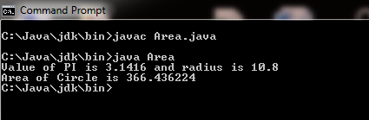

CONCLUSION:

In this program we have calculated the area of circle.

**2nd OBJECTIVE:**

Write program that can take 2 integer values as input between 1 to 50000 (or assign them).Add the values and then write the sum of the 2 values in vertical order.

**PROGRAM # 5:**

SOURCE CODE:

public class add

{

public static void main(String args[])

{

long a=6850;

long b=7752;

long sum;

sum=a+b;

System.out.println("Value of a="+a);

System.out.println("Value of a="+b);

System.out.println("Sum is ="+sum);

}

}

OUTPUT:

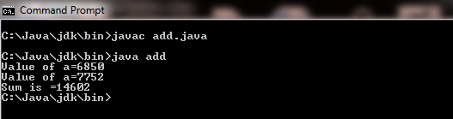

CONCLUSION:

In this program we are performing the addition of two numbers.

**3rd OBJECTIVE:**

Write a program for finding equivalent resistance of the following circuit.

**PROGRAM # 6:**

SOURCE CODE:

public class circuit

{

public static void main(String args[])

{

long R1=15;

long R2=12;

long R3=20;

long RT=R2+R3;

float R=(R1*RT)/(RT+R1);

System.out.println("Resistance in series"+RT);

System.out.println("Equivalent Resistance"+R);

}

}

OUTPUT:

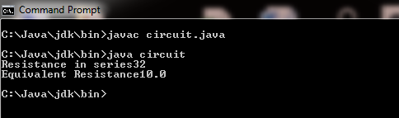

CONCLUSION:

In this program we are calculating equivalent resistance.