**1st OBJECTIVE:**

Write a program to implement calculator that can perform all function define above.

**PROGRAM # 1:**

SOURCE CODE:

public class math

{

public static void main(String[] args)

{ double num = -5000.1874d;

double x=10.0,y=20.0;

int max=15;

System.out.println("\nMath.abs(" + x + ")= " + Math.abs(num));

System.out.println("\nMath.sqrt(" + x + ")= " + Math.sqrt(x));

System.out.println("\nMath.pow(" + x + ")= " + Math.pow(x,y));

System.out.println("\nMath.exp(" + x + ")= " + Math.exp(x));

System.out.println("\nMath.sin(" + x + ")= " + Math.sin(x));

System.out.println("\nMath.max(" + x + ")= " + Math.max(x,y));

System.out.println("\nMath.random()= " +(Math.random()));

}

}

OUTPUT:

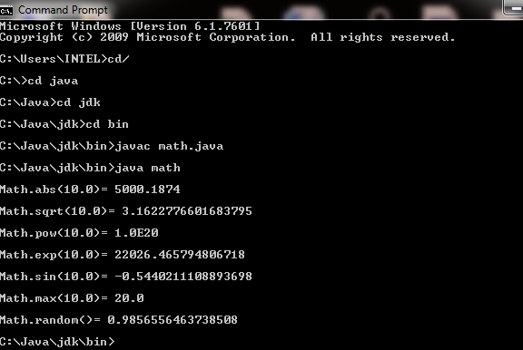

CONCLUSION:

In this program we are learning how to use Math file.

**2nd OBJECTIVE:**

Write a program to perform a calculation of quadratic formula, by using Math class.

**PROGRAM # 2:**

SOURCE CODE:

public class quad

{

public static void main(String args[])

{

int a=4;

int b=40;

int c=8;

double d;

double sq;

double x;

d=((b*b)-(4*a*c));

sq=Math.sqrt(d);

x=(((-b)+(sq))/(2*a));

System.out.println("Value of a="+a);

System.out.println("Value of b="+b);

System.out.println("Value of c="+c);

System.out.println("Square root is="+x);

}}

OUTPUT:

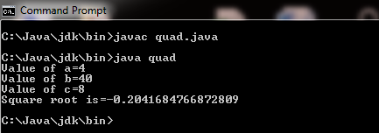

CONCLUSION:

In this program we are learning how to calculate quadratic equation.

**3rd OBJECTIVE:**

Write a program that take two inputs string arguments and add them as a integers.(use Integer.parseInt()).

**PROGRAM # 3:**

SOURCE CODE:

public class arg

{

public static void main(String args[])

{

int a,b;

a=Integer.parseInt(args[0]);

b=Integer.parseInt(args[1]);

System.out.println("Enter two string arguments");

System.out.println("a="+a+" and b="+b);

System.out.println("addition="+(a+b));

}}

OUTPUT:

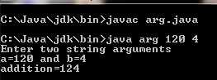

CONCLUSION:

In this program we are learning how to convert string into integer by using Integer.parseInt() class.

**4th OBJECTIVE:**

Write a program to convert given no. of days into months and days.

(Assume that each month is of 30 days).

**PROGRAM # 4:**

SOURCE CODE:

public class mon

{

public static void main(String args[])

{

int days=201;

int months;

months=days/30;

days=days%30;

System.out.println("90 days= " +months+"Months and "+days+ " Days ");

}}

OUTPUT:

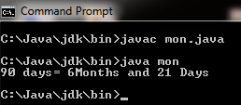

CONCLUSION:

In this program we are learning how to calculate days,month .

**5th OBJECTIVE:**

Write a program that can generates 100 random characters but prints only Vowels.

**PROGRAM # 5:**

SOURCE CODE:

public class vowels

{

public static void main(String args[])

{

char a;

a=(char)(100.0*Math.random());

if(a=='A'||a=='E'||a=='I'||a=='O'||a=='U'||a=='a'||a=='e'||a=='i'||a=='o'||a=='u')

System.out.println("vowel are="+a);

else

System.out.println("there is novowel");

}}

OUTPUT:

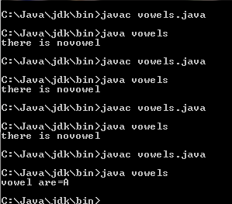

CONCLUSION:

In this program we are selecting random character and print only vowels.

**6th OBJECTIVE:**

Write a program that inputs a decimal integer and displays its value in hexadecimal.

**PROGRAM # 6:**

SOURCE CODE:

public class abcd

{

public static void main(String args[])

{

char a[]={'0','1','2','3','4','5','6','7','8','9','A','B','C','D','E','F'};

int b=1234;

int hex=16;

int d=1;

int rem1;

int rem2;

rem1=220%16;

rem2=13%16;

System.out.println("1st remender is"+rem1);

System.out.println("2nd remender is"+rem2);

System.out.println("last remender is"+d);

System.out.println("After convert decimal into hexdecemial="+(d)+(a[12])+(a[13]));

}}

OUTPUT:

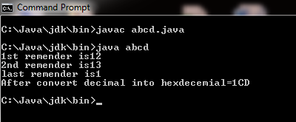

CONCLUSION:

In this program we are learning how to convert decimal to hexadecimal.