**1st OBJECTIVE:**

Write Java program to allow the user to input his/her age. Then the program will show if the person is eligible to vote. A person who is eligible to vote must be older than or equal to 18 years old.

**PROGRAM # 1:**

SOURCE CODE:

import java.util.Scanner;

public class vote

{

public static void main(String args[])

{

Scanner input= new Scanner(System.in);

int age;

System.out.println("Enter your age");

age = input.nextInt();

if(age>=18)

System.out.println("you are eligible to vote");

else

System.out.println("eligible to vote must be older than or equal to 18 years old");

}}

OUTPUT:

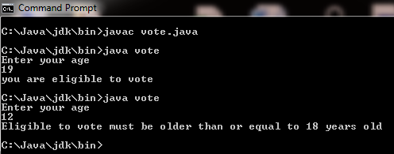

CONCLUSION:

In this program we are learning how to take user input in java.

**2nd OBJECTIVE:**

Write a program that takes input of three subjects. Find the average marks & display it.

**PROGRAM # 2:**

SOURCE CODE:

import java.util.Scanner;

public class sub

{

public static void main(String args[])

{

float a,b,c,sum;

float avg;

Scanner input=new Scanner(System.in);

System.out.println("Enter marks of 3 subjects");

a=input.nextInt();

System.out.println("1st subject="+a);

b=input.nextInt();

System.out.println("2nd subject="+b);

c=input.nextInt();

System.out.println("3rd subject="+c);

sum=a+b+c;

avg=((sum/300)*(100));

System.out.println("Average of 3 subjects is="+avg);

}}

OUTPUT:

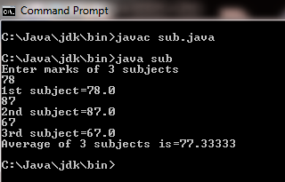

CONCLUSION:

In this program we are calculating average of 3 subjects.

**3rd OBJECTIVE:**

Input integer value and display its square root.

**PROGRAM # 3:**

SOURCE CODE:

import java.util.Scanner;

public class root

{

public static void main(String args[])

{

double a,b;

Scanner input=new Scanner(System.in);

System.out.println("Enter integer number");

a=input.nextInt();

b=Math.sqrt(a);

System.out.println("Square Root is="+b);

}}

OUTPUT:

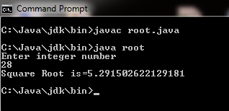

CONCLUSION:

In this program we are calculating square root of user input value.

**4th OBJECTIVE:**

Write a program that print salary sheet of employee by taking input employee name, designation, date of joining, department, basic salary and allowances.

**PROGRAM # 4:**

SOURCE CODE:

import java.util.Scanner;

public class sheet

{

public static void main(String args[])

{

String name,des,date,dep,allow;

int sal;

Scanner inp=new Scanner(System.in);

System.out.println("Salary sheet of Employee");

System.out.println("Employee Name:");

name=inp.nextLine();

System.out.println("Designation:");

des=inp.nextLine();

System.out.println("Date of joining:");

date=inp.nextLine();

System.out.println("Department:");

dep=inp.nextLine();

System.out.println("Allowances:");

allow=inp.nextLine();

System.out.println("Basic Salary:");

sal=inp.nextInt();

System.out.println("Employee Name:"+name);

System.out.println("Designation:"+des);

System.out.println("Date of joining:"+date);

System.out.println("Department:"+dep);

System.out.println("Allowances:"+allow);

System.out.println("Basic Salary:"+sal);

}}

OUTPUT:



CONCLUSION:

In this program we are learning how to take input string values.

**5th OBJECTIVE:**

Write a program that print the student Biodata by taking all data input from user.

**PROGRAM # 5:**

SOURCE CODE:

import java.util.Scanner;

public class bio

{

public static void main(String args[])

{

String n,f,d,e;

long p;

int a;

Scanner inp=new Scanner(System.in);

System.out.println("Bio Data");

System.out.println("Name:");

n=inp.nextLine();

System.out.println("Father name:");

f=inp.nextLine();

System.out.println("Date of Birth:");

d=inp.nextLine();

System.out.println("Email Address:");

e=inp.nextLine();

System.out.println("Age:");

a=inp.nextInt();

System.out.println("Phone Number:");

p=inp.nextLong();

System.out.println("Name:"+n);

System.out.println("Father name:"+f);

System.out.println("Date of Birth:"+d);

System.out.println("Age:"+a);

System.out.println("Email Address:"+e);

System.out.println("Phone Number:"+p); }}

OUTPUT:

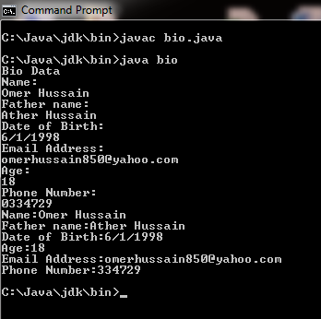

CONCLUSION:

In this program we are taking user input biodata.

**6th OBJECTIVE:**

Create a class containing main method and taking input int, float, string, double, long variables.

**PROGRAM # 6:**

SOURCE CODE:

import java.util.Scanner;

public class user

{

public static void main(String args[])

{

int a;

float b;

String c;

double d;

long e;

Scanner inp=new Scanner(System.in);

System.out.print("Integer Value=");

a=inp.nextInt();

System.out.print("Floating value=");

b=inp.nextFloat();

System.out.print("String value=");

c=inp.next();

System.out.print("Double value=");

d=inp.nextDouble();

System.out.print("Long value=");

e=inp.nextLong();

}}

OUTPUT:

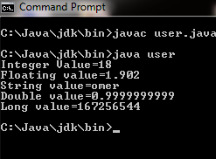

CONCLUSION:

In this program we are learning how to take input int ,float ,double ,long ,string.

**7th OBJECTIVE:**

Write a program that take 1 byte input integer (positive number) and generate its negative value.(Hint: use bitwise operators).

**PROGRAM # 7:**

SOURCE CODE:

import java.util.Scanner;

public class bit

{

public static void main(String args[])

{

int a,b;

Scanner inp=new Scanner(System.in);

System.out.print("Integer value is=");

a=inp.nextInt();

b=~a+1;

System.out.println("Negative Value is="+b);

}}

OUTPUT:

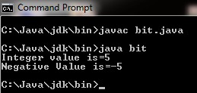

CONCLUSION:

In this program we are learning how to change positive integer value into negative integer value.

**8th OBJECTIVE:**

Write a dice program that generate random number from 1 to 6 and match it with user input, if inputted number match with dice number user win.

**PROGRAM # 8:**

SOURCE CODE:

import java.util.Scanner;

public class ran

{

public static void main(String args[])

{

int a,b;

a=(int)(6.0*Math.random());

Scanner inp=new Scanner(System.in);

System.out.println("Enter Dice number=");

b=inp.nextInt();

System.out.println("Random number="+a);

if(a==b)

System.out.println("You win");

else

System.out.println("You Loose");

}}

OUTPUT:

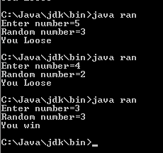

CONCLUSION:

In this program we are matching dice number and user input number.

**9th OBJECTIVE:**

Take a number as user input and convert this number into octal and binary number.

**PROGRAM # 9:**

SOURCE CODE:

import java.util.Scanner;

public class conv

{

public static void main(String args[])

{

int a;

Scanner inp=new Scanner(System.in);

System.out.print("Enetr number=");

a=inp.nextInt();

System.out.println("In Octal="+Integer.toOctalString(a));

System.out.println("In Binary="+Integer.toBinaryString(a));

}}

OUTPUT:

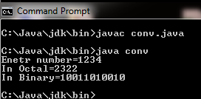

CONCLUSION:

In this program we are learning how to convert user input number into octal and binary.

**10th OBJECTIVE:**

Implement following circuit into java programming language.

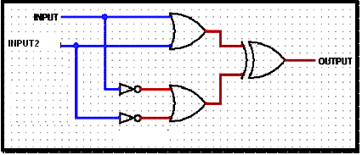

**PROGRAM # 10:**

SOURCE CODE:

public class cir

{

public static void main(String args[])

{

int a=12,b=6,c,d,e,f;

c=a|b;

d=~a|~b;

e=c^d;

System.out.println("value of c:"+c);

System.out.println("Value of d:"+d);

System.out.println("Value of e:"+e);

}}

OUTPUT:

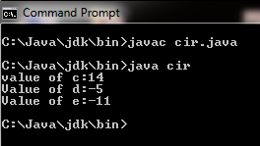

CONCLUSION:

In this program we are learning how to implement circuit in java.

**11th OBJECTIVE:**

Write a program to produce a series 64,16,8,4,2,1 by using shift operator.

**PROGRAM # 11:**

SOURCE CODE:

public class shift

{

public static void main(String args[])

{

byte a=1;

int b1,b2,b3,b4,b5,b6;

b1=a<<1;

b2=a<<2;

b3=a<<3;

b4=a<<4;

b5=a<<5;

b6=a<<6;

System.out.println("orignal value of a:"+a);

System.out.println(+a+","+b1+","+b2+","+b3+","+b4+","+b5+","+b6);

}}

OUTPUT:

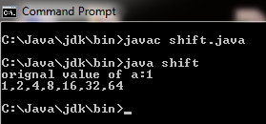

CONCLUSION:

In this program we are learning how to use shift operator.

**12th OBJECTIVE:**

Write a program to perform multiplication of a integer number by 2 and division by 2 without using arithmetic operators and math class.

**PROGRAM # 12:**

SOURCE CODE:

public class opre

{

public static void main(String args[])

{

byte a=64;

int i1,i2;

i1=a<<1;

i2=a>>1;

System.out.println("Multiplication of a integer="+i1);

System.out.println("Division of a integer="+i2);

}}

OUTPUT:

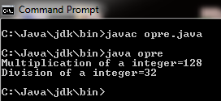

CONCLUSION:

In this program we are learning how to multiply and divide number without using arithmetic operator and math class.