**1st OBJECTIVE:**

Write a program to generate Fibonacci hypothesis for 19 generations given below.

0 1 1 2 3 5 8 13 21 34 55 89 144 233 377 610 987 1597 2584 4181 6765.

**PROGRAM # 1:**

SOURCE CODE:

public class fab

{ public static void main(String args[])

{

int a=0,b=1,c,i;

System.out.print(a+" "+b);

for(i=1;i<=19;i++)

{

c=a+b;

System.out.print(" "+c);

a=b;

b=c;

}

}}

OUTPUT:

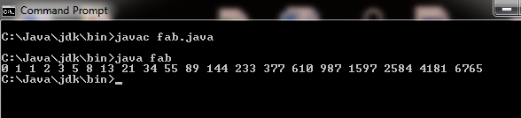

CONCLUSION:

In this program we are learning how to generate Fibonacci series.

**2nd OBJECTIVE:**

Write a menu driven program that take integer input and option from user and check whether number is even, odd or prime using Switch statement.

**PROGRAM # 2:**

SOURCE CODE:

import java.util.Scanner;

public class s1

{

public static void main(String[] args)

{

int a,b,c,d,i;

char f;

Scanner inp=new Scanner(System.in);

System.out.println("for even number press 1");

System.out.println("for odd number press 2");

System.out.println("for prime number press 3");

a=inp.nextInt();

switch(a)

{

case 1:

System.out.print("enter number");

b=inp.nextInt();

if(b%2==0)

System.out.print("this is even number");

else

System.out.print("this is not even number");

break;

case 2:

System.out.print("Enter number=");

c=inp.nextInt();

if(c%2!=0)

System.out.print("this is odd number");

else

System.out.print("this is not an odd number");

break;

case 3:

System.out.print("Enter number=");

d=inp.nextInt();

for(i=2;i<d;i++)

if(d%i==0)

break;

if(i==d)

System.out.print("this is a prime number");

else

System.out.print("this is not a prime number");

OUTPUT:

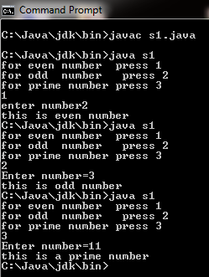

CONCLUSION:

In this program we are learning how to use switch statement.

**3rd OBJECTIVE:**

Write a Java program that determines a student’s grade.The program will read three types of scores(quiz, mid-term, and final scores) and determine the grade based on the following rules:  
-if the average score >=90% =>grade=A  
-if the average score >= 70% and <90% => grade=B  
-if the average score>=50% and <70% =>grade=C  
-if the average score<50% =>grade=F

**PROGRAM # 3:**

SOURCE CODE:

import java.util.Scanner;

public class grade

{

public static void main(String args[])

{

int a,b,c,sum;

float per;

Scanner inp=new Scanner(System.in);

System.out.println("Enter marks of quiz,mid-term,fanal");

a=inp.nextInt();

b=inp.nextInt();

c=inp.nextInt();

sum=a+b+c;

per=(sum*100)/300;

if(per>=90)

System.out.println("Average is= "+per+" Grade is A");

else if(per<90 && per>=70)

System.out.println("Average is= "+per+" Grade is B");

else if(per<70 && per>=50)

System.out.println("Average is= "+per+" Grade is C");

else

System.out.println("Average is= "+per+" Grade is F");

}}

OUTPUT:

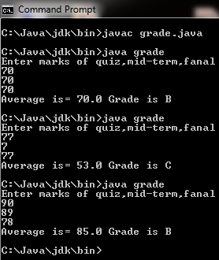

CONCLUSION:

In this program we are learning how to use conditions.

**4th OBJECTIVE:**

Write a Java program to get a number from the user and print whether it is positive or negative.

**PROGRAM # 4:**

SOURCE CODE:

import java.util.Scanner;

public class pn

{

public static void main(String args[])

{

int a;

Scanner inp=new Scanner(System.in);

System.out.print("Eneter number=");

a=inp.nextInt();

if(a>0)

System.out.println(a+" is Positive");

else

System.out.println(a+" is negative");

}}

OUTPUT:

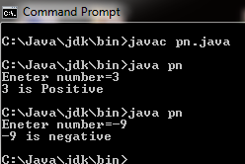

CONCLUSION:

In this program we are applying condition.

**5th OBJECTIVE:**

Take three numbers from the user and print the greatest number.

**PROGRAM # 5:**

SOURCE CODE:

import java.util.Scanner;

public class largest

{

public static void main(String args[])

{

int a,b,c;

Scanner inp=new Scanner(System.in);

System.out.println("Enter three Numbers");

a=inp.nextInt();

b=inp.nextInt();

c=inp.nextInt();

if(a>b && a>c)

System.out.println(a+" is largest value");

else if(b>c && b>a)

System.out.println(b+" is largest value");

else if(c>a && c>b)

System.out.println(c+" is largest value");

}}

OUTPUT:

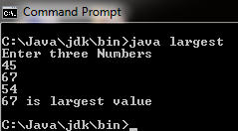

CONCLUSION:

In this program we are finding which number is greater.

**6th OBJECTIVE:**

Write a Java program to solve quadratic equations (use if, else if and else).

**PROGRAM # 6:**

SOURCE CODE:

import java.util.Scanner;

public class ifsqr

{

public static void main(String args[])

{

int a,b,c,D;

double x,y,s;

Scanner inp=new Scanner(System.in);

System.out.println("Enter values of a,b and c");

a=inp.nextInt();

b=inp.nextInt();

c=inp.nextInt();

D=b*b-4*a*c;

s=Math.sqrt(D);

if(D<0){

System.out.println("Both roots are imaginary");

}else if(D==0){

System.out.println("Both roots are equal");

x=-b/(2.0*a);

System.out.println("Root is="+x);

}else{

System.out.println("Roots are real and distinct");

x=(-b+s)/(2*a);

y=(-b-s)/(2*a);

System.out.println("Roots are : "+x+","+y);

}

}}

OUTPUT:

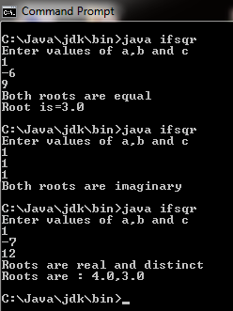

CONCLUSION:

In this program we are learning how to use if, else if, else in quadratic equation.

**7th OBJECTIVE:**

Write a program that accepts three numbers from the user and prints "increasing" if the numbers are in increasing order, "decreasing" if the numbers are in decreasing order, and "Neither increasing or decreasing order".

**PROGRAM # 7:**

SOURCE CODE:

import java.util.Scanner;

public class incre

{

public static void main(String args[])

{

int a,b,c;

Scanner inp=new Scanner(System.in);

System.out.println("Enter Three numbers");

a=inp.nextInt();

b=inp.nextInt();

c=inp.nextInt();

if(a<b&&b<c){

System.out.println("Increasing");

}else if(a>b&&b>c){

System.out.println("Dicreasing");

}else{

System.out.println("Neither increasing or decreasing");

}

}}

OUTPUT:

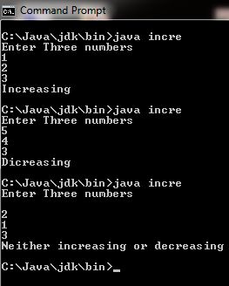

CONCLUSION:

In this program we are learning how to identify that number is increasing, decreasing or else.

**8th OBJECTIVE:**

Write a Java program that reads a positive integer and count the number of digits (less than ten billion) by using for loop.

**PROGRAM # 8:**

SOURCE CODE:

import java.util.Scanner;

public class count

{

public static void main(String args[])

{

int x,c;

Scanner inp=new Scanner(System.in);

System.out.println("Enter number");

x=inp.nextInt();

for(c=1;c<x;c++)

{

x=x/10;

}

System.out.println("Number of digits="+c);

}}

OUTPUT:

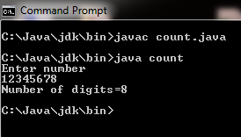

CONCLUSION:

In this program we are learning how to count number of digits.

**9th OBJECTIVE:**

Write a Java program that reads a floating-point number. If the number is zero it prints "zero", otherwise, print "positive" or "negative". Add "small" if the absolute value of the number is less than 1, or "large" if it exceeds 1,000,000.

**PROGRAM # 9:**

SOURCE CODE:

import java.util.Scanner;

public class check

{

public static void main(String args[])

{

float a;

Scanner inp=new Scanner(System.in);

System.out.print("Enetr floating point number=");

a=inp.nextFloat();

if(a==0)

System.out.println("Zero");

if(a>0)

System.out.println("Positive");

if(a<0)

System.out.println("Negative");

if(Math.abs(a)<1)

System.out.println("Small");

if(Math.abs(a)>1000000)

System.out.println("Large");

}}

OUTPUT:

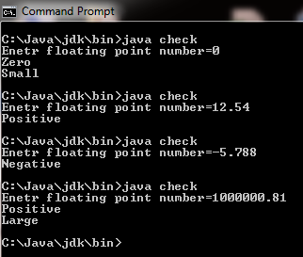

CONCLUSION:

In this program we are learning how to check numbers either zero, positive, negative, small or large.

**10th OBJECTIVE:**

Write a Java program to calculate the revenue from a sale based on the unit price and quantity of a product input by the user .The discount rate is 10% for the quantity purchased between 100 and 120 units, and 15% for the quantity purchased greater than 120 units. If the quantity purchased is less than 100 units, the discount rate is 0%.

**PROGRAM # 10:**

SOURCE CODE:

import java.util.Scanner;

public class unit

{

public static void main(String args[])

{

float unitprice=0f;

float quantity=0;

float revenue=0f;

float disrate=0f,disamount=0f;

Scanner inp=new Scanner(System.in);

System.out.print("Enetr unit price:");

unitprice=inp.nextFloat();

System.out.println("Enter Quantity");

quantity=inp.nextFloat();

if(quantity<100)

revenue=unitprice*quantity;

else if(quantity>=100 && quantity<=120)

{

disrate=(float)10/100;

revenue=unitprice*quantity;

disamount=revenue*disrate;

revenue=revenue-disamount;

}

else if(quantity>120)

{

disrate=(float)15/100;

revenue=unitprice*quantity;

disamount=revenue*disrate;

revenue=revenue-disamount;

}

System.out.println("The revenue from sale:"+revenue+"Rs");

System.out.println("After discount:"+disamount+"Rs("+disrate*100+"%)");

}}

OUTPUT:

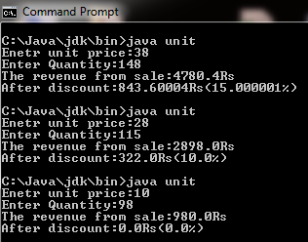

CONCLUSION:

In this program we are learning how to calculate revenue.

**11thOBJECTIVE:**

Write a Java program that accepts two floating­ point numbers and checks whether they are the same up to two decimal places.

**PROGRAM # 11:**

SOURCE CODE:

import java.util.Scanner;

public class test1

{

public static void main(String[] args)

{

Scanner input = new Scanner(System.in);

System.out.print("Input first floating point number: ");

float num1 = input.nextFloat();

System.out.print("Input second floating point number: ");

float num2 = input.nextFloat();

if (Math.abs(num1 - num2) <= 0.01){

System.out.println("These numbers are the same up to Two decimal."); }

else {

System.out.println("These numbers are different."); }

}}

OUTPUT:

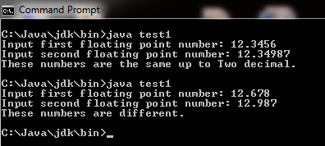

CONCLUSION:

In this program we are learning how to check floating point number whether they are same up to two decimal places or not.