**1st OBJECTIVE:**

Write a program to read n number of values in an array and display it in reverse order.

**PROGRAM # 1:**

SOURCE CODE:

import java.util.Scanner;

public class arrrev{

public static void main(String args[]){

int b,c;

Scanner sc=new Scanner(System.in);

System.out.println("ENTER NUMBER OF ARRAY ELEMENTS");

c=sc.nextInt();

int [] a=new int [c];

System.out.println("ENTER ARRAY ELEMENTS");

for(b=0;b<c;b++){

a[b]=sc.nextInt();

}

System.out.println("NUMBERS IN REVERSE ORDER");

for(b=c-1;b>=0;b--){

System.out.print(a[b]+" ");

}}}

OUTPUT:

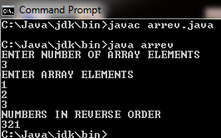

CONCLUSION:

In this program we are learning how reverse number.

**2nd OBJECTIVE:**

Write a program to count a total number of duplicate elements in an array.

**PROGRAM # 2:**

SOURCE CODE:

import java.util.Scanner;

public class arruni{

public static void main(String args[]){

int a,c,d=0,e=0,f=0,g,h;

Scanner sc=new Scanner(System.in);

System.out.println("ENTER NUMBER OF ARRAY ELEMENTS");

g=sc.nextInt();

int [] b=new int [g];

System.out.println("ENTER ARRAY ELEMENTS");

for(h=0;h<g;h++){

b[h]=sc.nextInt();

}

System.out.println("UNIQUE ELEMENTS ARE ");

for(a=0;a<g;a++){

for(c=0;c<a;c++){

if(b[a]==b[c])

break;

}

if(a==c)

System.out.print(b[a]+" ");

}}}

OUTPUT:

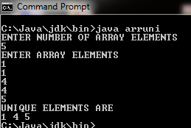

CONCLUSION:

In this program we are learning how to check unique number.

**3rd OBJECTIVE:**

Write a program to count a total number of duplicate elements in an array.

**PROGRAM # 3:**

SOURCE CODE:

import java.util.Scanner;

public class arrdup

{

public static void main(String args[])

{

int a,c=0,d=0,e=0,f=0,g,h;

Scanner sc=new Scanner(System.in);

System.out.println("ENTER NUMBER OF ARRAY ELEMENTS");

g=sc.nextInt();

int [] b=new int [g];

System.out.println("ENTER ARRAY ELEMENTS");

for(h=0;h<g;h++){

b[h]=sc.nextInt();

}

for(a=e;a<5;a++)

{

d=b[a];

for(c=a+1;c<5;c++)

{

c=b[c];

if(d==c)

{f++;

break;

}

}}

System.out.println("DUPLICATE ELEMENTS ARE "+f);

}}

OUTPUT:

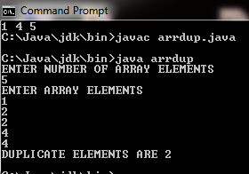

CONCLUSION:

In this program we are learning how to check duplicate number.

**4th OBJECTIVE:**

Write a program to merge two arrays of same size sorted in descending order.

**PROGRAM # 4:**

SOURCE CODE:

import java.util.Scanner;

public class arrsort{

public static void main(String args[]){

Scanner sc=new Scanner(System.in);

int [] a=new int[6];

int [] b=new int[6];

int [] e=new int[20];

int c,d,f,g,i,n=10,step,temp;

System.out.println("ENTER 1st ARRAY ELEMENTS");

for(c=0;c<5;c++)

{a[c]=sc.nextInt();}

System.out.println("ENTER 2nd ARRAY ELEMENTS");

for(d=0;d<5;d++)

{b[d]=sc.nextInt();}

for(f=0;f<5;f++){

e[f]=a[f];

}

for(g=5;g<10;g++){

e[g]=b[g-5];

}

for(step=0;step<n-1;++step)

for(i=0;i<n-step-1;++i)

{

if(e[i]<e[i+1])

{

temp=e[i];

e[i]=e[i+1];

e[i+1]=temp;

}}

System.out.println("ARRAY MERGED IN DESCENDING ORDER ARE");

for(i=0;i<n;++i)

System.out.print(e[i]+" ");

}}

OUTPUT:

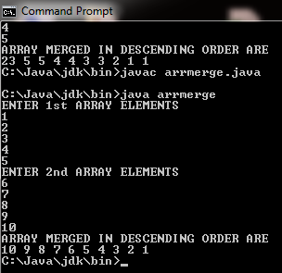

CONCLUSION:

In this program we are learning how to merge two arrays in descending order.

**5th OBJECTIVE:**

Write a program to insert New value in the array (sorted list ).

**PROGRAM # 5:**

SOURCE CODE:

import java.util.Scanner;

public class arrnew

{

public static void main(String args[])

{

Scanner sc=new Scanner(System.in);

int []a={9,7,5,3,5,4,2,4};

int size=7,pos,b,d;

System.out.println("ARRAY ELEMENTS ARE");

for(d=0;d<size;d++)

System.out.println(a[d]+" ");

System.out.println("ENTER POSITION WHERE YOU WANT TO INSERT NEW ELEMENT");

pos=sc.nextInt();

if(pos>=0&&pos<size)

{

for(b=size;b>pos;b--)

{

a[b]=a[b-1];

}

int c;

System.out.println("ENTER ELEMENT THAT IS TO INSERT");

c=sc.nextInt();

a[pos]=c;

size++;

System.out.println("ARRAY ELEMENT AFTER INSERTION OF NEW ELEMENT");

for(b=0;b<size;b++)

{

System.out.println(a[b]);

}

}

else

{

System.out.println("POSITION DOES NO EXISTS");

}

}}

OUTPUT:

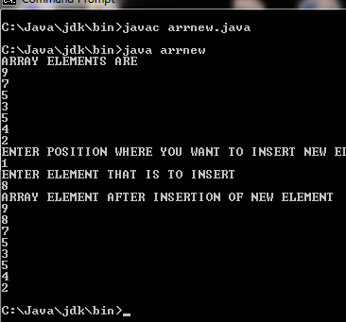

CONCLUSION:

In this program we are learning how to insert new value in array.

**6th OBJECTIVE:**

Write a program to delete an element at desired position from an array.

**PROGRAM # 6:**

SOURCE CODE:

import java.util.Scanner;

public class arrdel

{

public static void main(String args[])

{

Scanner sc=new Scanner(System.in);

int []a=new int[100];

int b,c,d;

System.out.println("ENTER NUMBER OF ELEMENTS IN ARRAY");

d=sc.nextInt();

System.out.println("Enter "+d+" Element:");

for(c=0;c<d;c++)

a[c]=sc.nextInt();

System.out.println("enter the locatiom where you wish to delete element");

b=sc.nextInt();

if(b>=d+1)

System.out.println("Deletion not possible.");

else

{

for(c=b-1;c<d-1;c++)

a[c]=a[c+1];

System.out.println("resultant array is");

for(c=0;c<d-1;c++)

System.out.println(a[c]);

}}}

OUTPUT:

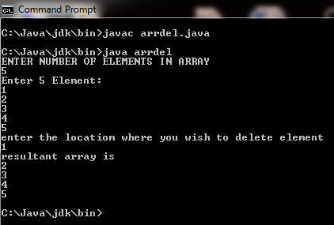

CONCLUSION:

In this program we are learning how to delete an element at desired position from an array.

**7th OBJECTIVE:**

Write a program to find the second largest element in an array.

**PROGRAM # 7:**

SOURCE CODE:

import java.util.Scanner;

public class arrsec{

public static void main(String args[]){

Scanner sc=new Scanner(System.in);

int [] a=new int[100];

int i,n=5,b,temp;

int d=3;

System.out.println("ENTER 5 NUMBERS");

for(i=0;i<n;++i)

{

a[i]=sc.nextInt();

}

for(b=0;b<n-1;++b)

for(i=0;i<n-b-1;++i)

{

if(a[i]>a[i+1])

{

temp=a[i];

a[i]=a[i+1];

a[i+1]=temp;

}}

System.out.println("THE SECOND LARGEST NUMBER IS");

System.out.println(a[d]);

}}

OUTPUT:

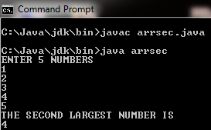

CONCLUSION:

In this program we are learning how to identify the second largest number in array.

**8th OBJECTIVE:**

You are given a two-dimensional 3*3 array starting from A [0][0]. You should add the alternate elements of the array and print its sum. It should print two different numbers the first being sum of A 0 0, A 0 2, A 1 1, A 2 0, A 2 2 and second being sum of A 0 1, A 1 0, A 1 2, A 2 1.

**PROGRAM # 8:**

SOURCE CODE:

import java.util.Scanner;

public class arradd

{

public static void main(String args[])

{

Scanner sc=new Scanner(System.in);

int [][] a=new int[4][4];

int b,c,d,e;

for(b=0;b<3;b++)

{

for(c=0;c<3;c++)

{System.out.println("ARRAY ["+b+"]["+c+"] ");

a[b][c]=sc.nextInt();

}}

System.out.println("ADDITION");

d=a[0][0]+a[0][2]+a[1][1]+a[2][0]+a[2][2];

e=a[0][1]+a[1][0]+a[1][2]+a[2][1];

System.out.println("SUM 1 ="+d);

System.out.println("SUM 2 ="+e);

}}

OUTPUT:

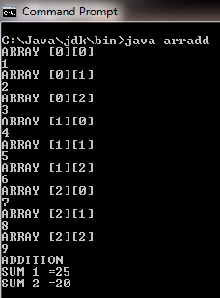

CONCLUSION:

In this program we are learning how the alternate elements of the array and print its sum.

**9th OBJECTIVE:**

Write a program for a 2D array of size MxN and print the matrix and perform multiplication of two Matrices.

**PROGRAM # 9:**

SOURCE CODE:

import java.util.Scanner;

public class matrix

{

public static void main(String[] args)

{

int sum,k,i,j;

int [][] A = new int[3][3];

int [][] B = new int[3][3];

int [][] C = new int[3][3];

Scanner inp=new Scanner(System.in);

System.out.println("Enter 9 number for A matrix");

for(i=0;i<=2;i++)

{ for(j=0;j<=2;j++)

{

A[i][j]=inp.nextInt();

}

}

System.out.println("Enter 9 number for B matrix");

for(i=0;i<=2;i++)

{ for(j=0;j<=2;j++)

{

B[i][j]=inp.nextInt();

}

}

for(i=0;i<=2;i++)

{

for(j=0;j<=2;j++)

{

sum=0;

for(k=0;k<=2;k++)

sum=sum+A[i][k]*B[k][j];

C[i][j]=sum;

} }

System.out.println("After multiplication of amtrix:");

for(i=0;i<=2;i++)

{ for(j=0;j<=2;j++)

{

System.out.print(C[i][j]+"\t");

}

System.out.print("\n");

}}}

OUTPUT:

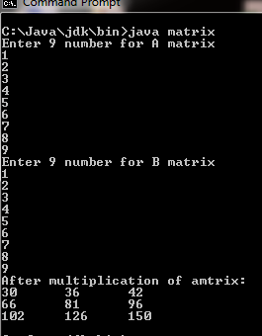

CONCLUSION:

In this program we are learning how to multiply 2D matrix.

**10th OBJECTIVE:**

Write a program that reads student test scores in the range 0 through 100 and print the following statistics to two decimal places:  
  
The average (mean) score.  
The student with the highest score.  
The student with the lowest score.  
The number of students whose score equal or exceed the average.  
  
For each student:  
  
The difference between the average score and the student’s score (this can be either positive or negative).  
The grade letter where  
A is a score of 90 or greater.  
B is a score of 80 through 89.99.  
C is a score of 70 through 79.99  
D is a score of 60 through 69.99  
E is a score of less than 60.

**PROGRAM # 10:**

SOURCE CODE:

import java.util.Scanner;

public class arr2

{

public static void main(String[] args)

{

int i,j,fno,sno,temp,av1;

float b=0,ave;

Scanner inp = new Scanner(System.in);

int [] a1= new int[5];

int [] b1= new int[5];

System.out.println("Enetr 5 students test scores");

for(i=0;i<5;i++)

{a1[i]=inp.nextInt();}

for(i=0;i<5;i++)

{

b+=a1[i];

}

ave=b/5;

System.out.println("average is"+ave);

fno=a1[0];

sno=a1[1];

if(sno>fno)

{

temp=fno;

sno=fno;

}

for(i=2;i<5;i++)

if(a1[i]>fno)

{

sno=fno;

fno=a1[i];

}

else if(a1[i]>sno)

sno=a1[i];

System.out.println("First higest="+fno+"Second higest="+sno);

for(i=0;i<5;i++)

{

if(ave==a1[i])

{

System.out.println("Score"+i+"is equal to average"+sno);

}

else if(ave>a1[i])

{

System.out.println("Score"+i+"is less than to average");

}

else

{

System.out.println("Score"+i+"is exceed to average");

}

}

for(i=0;i<5;i++)

{

if(a1[i]>=90)

System.out.println(i+"Score is Grade is A");

else if(a1[i]>90 && a1[i]<=89)

System.out.println(i+"score is Grade is B");

else if(a1[i]>70 && a1[i]<=79)

System.out.println(i+"score is Grade is C");

else if(a1[i]>60 && a1[i]<=69)

System.out.println(i+"score is Grade is D");

else if(a1[i]<60)

System.out.println(i+"score is Grade is E");

}

}}

OUTPUT:

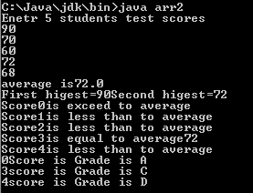

CONCLUSION:

In this program we are learning how to calculate average of score and generate grades.