**1st OBJECTIVE:**

Write a program that extracts username and the domain information from an E-mail address. For example, if the email address is "user@mydomain.com", your program will print

                    User name        = user

                    Domain             = mydomain

                    Extension          = com

**PROGRAM # 1:**

SOURCE CODE:

import java.util.Scanner;

import java.lang.String;

public class string1{

public static void main(String args[]){

Scanner sc=new Scanner(System.in);

String a=new String();

System.out.println("ENTER E-MAIL ADDRESS");

a=sc.next( );

int d=a.indexOf('@');

int e=a.indexOf('.');

int f=a.indexOf('m');

System.out.print("user name =");

System.out.println(a.substring(0,d));

System.out.print("domain =");

System.out.println(a.substring(d+1,e));

System.out.print("extension =");

System.out.println(a.substring(e+1));

}}

OUTPUT:

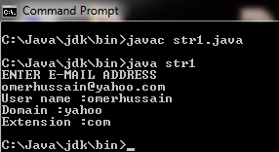

CONCLUSION:

In this program we are learning how to use string classes.

**2nd OBJECTIVE:**

**PROGRAM # 2:**

A PALINDROME is a word which has SAME SPELLING whether it is read from Left to Right or from Right to Left. Example: MOM, DAD, DEED, PEEP and NOON. Other words which are not PALINDROME are HELLO, DOOR and FEET. Write a program that can take a String as user input in Capital Letters and then Print YES as Output if the Input is a PALINDROME otherwise NO.

SOURCE CODE:

import java.util.Scanner;

public class palin{

public static void main (String[] args){

Scanner input=new Scanner(System.in);

String s1 = new String();

String s2= new String();

String s3= new String();

System.out.print("Enter Your PALINDROME : ");

s1=input.nextLine();

for(int i=0; i<s1.length(); i++) {

s3 = s1.substring(((s1.length())-(i+1)),((s1.length())-i));

s2 = s2+s3;

}

if(s1.equals(s2))

System.out.println("YES ITS A PALINDROME");

else

System.out.println("NO IT IS NOT A PALINDROME"); }}

OUTPUT:

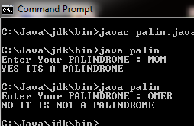

CONCLUSION:

In this program we are learning how to check PALINDROME.

**3rd OBJECTIVE:**

Write a program in to print individual characters of string in reverse order.

**PROGRAM # 3:**

SOURCE CODE:

import java.util.Scanner;

public class reverse

{

public static void main(String[] args)

{

int i;

String org,rev="";

Scanner inp = new Scanner(System.in);

System.out.print("Eneter A string:");

org=inp.nextLine();

for(i=org.length()-1;i>=0;i--)

{

rev=rev+org.charAt(i);

}

System.out.println("Rverse string : "+rev);

}}

OUTPUT:

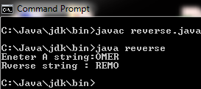

CONCLUSION:

In this program we are learning how to reverse a string.

**4th OBJECTIVE:**

Write a program in to count total number of vowel or consonant in a string.

**PROGRAM # 4:**

SOURCE CODE:

public class countv

{

public static void main(String[] args)

{

String line = "My Name is Omer.";

int vowels = 0, consonants = 0;

line = line.toLowerCase();

System.out.println(""+line);

for(int i = 0; i < line.length(); ++i)

{

char ch = line.charAt(i);

if(ch == 'a' || ch == 'e' || ch == 'i'

|| ch == 'o' || ch == 'u')

{

++vowels;

}

else if((ch >= 'a'&& ch <= 'z'))

{

++consonants;

}

}

System.out.println("Vowels: " + vowels);

System.out.println("Consonants: " + consonants);

}}

OUTPUT:

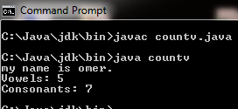

CONCLUSION:

In this program we are learning how to count vowels and consonant.

**5th OBJECTIVE:**

Write a program to check whether a given substring is present in the given string.

**PROGRAM # 5:**

SOURCE CODE:

import java.util.Scanner;

public class strcheck

{

public static void main(String[] args)

{

String str1,str2;

Scanner inp = new Scanner(System.in);

System.out.println("Enter first string");

str1= inp.next();

System.out.println("Enter second string");

str2= inp.next();

int a=str1.indexOf(str2);

if(a==0)

System.out.println("String is present");

else

System.out.println("String is not present");

}}

OUTPUT:

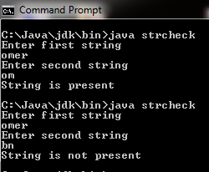

CONCLUSION:

In this program we are learning how to check string is present in a string.

**6th OBJECTIVE:**

Write a program to Find the Frequency of Characters.

**PROGRAM # 6:**

SOURCE CODE:

import java.util.Scanner;

public class freq

{

public static void main(String args[])

{ String str, str1;

char c, ch;

Scanner scan = new Scanner(System.in);

System.out.print("Enter a String : ");

str=scan.nextLine();

i=str.length();

for(c='A'; c<='z'; c++)

{

k=0;

for(j=0; j<i; j++)

{

ch = str.charAt(j);

if(ch == c)

{

k++;

}

}

if(k>0)

{

System.out.println(c + " is " + k + " times");

}

}

}}

OUTPUT:

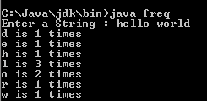

CONCLUSION:

In this program we are learning how to check frequency of characters.