**OBJECTIVE:**

To implement various commands on Linux interface.

1.To make directory, file or folder.

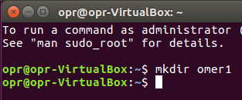

2.To view directory.

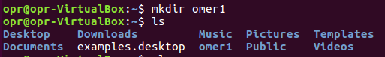

3.To delete the directory.

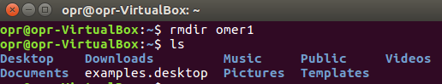

4.To view hidden files.

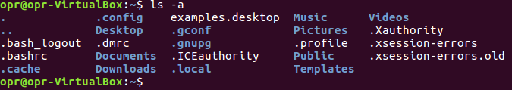

5.To view size, time and date of folder.

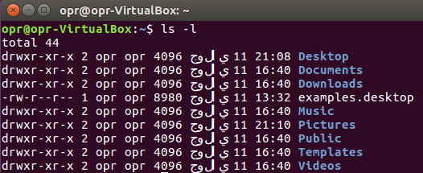

6.To view size, time and date of folder in reverse order.

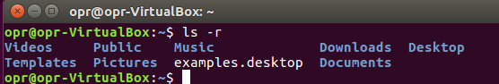

7.To view the subfolder or child folder of a folder.

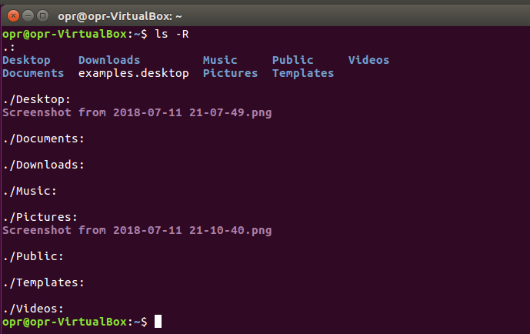

8.To view the size of folder.

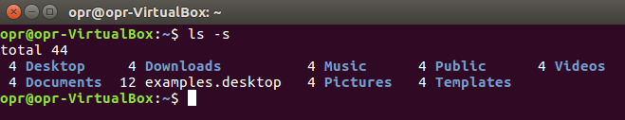

9.To view the file first with bigger size.

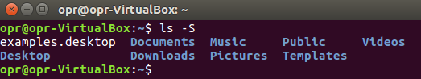

10.To view file in a row form.

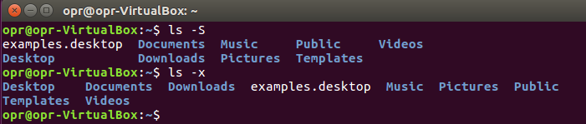

11.To view the sub file with respect to date time and also view hidden files.

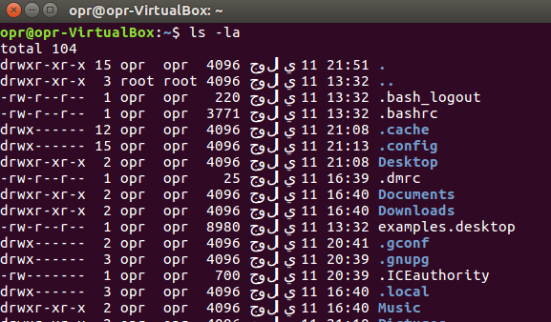

12.To enter in other folders.

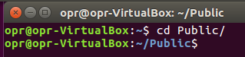

13.To come out from folders.

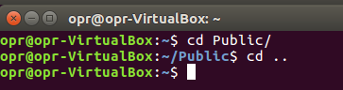

14.To view current path.

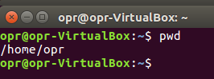

15.To view the running program.

