SOURCE CODE:

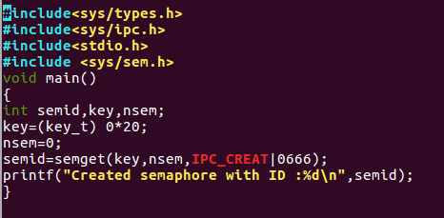

OUTPUT:

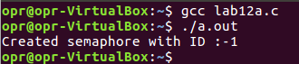

SOURCE CODE:

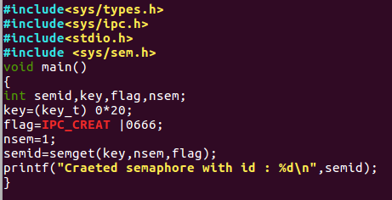

OUTPUT:

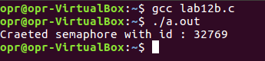

SOURCE CODE:

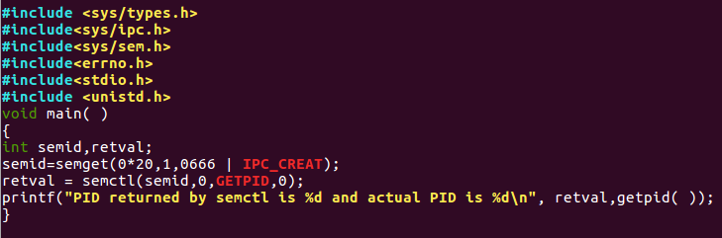

OUTPUT:

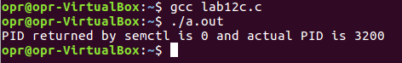

SOURCE CODE:

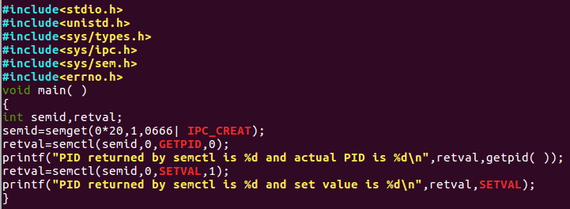

OUTPUT:

