**TASK # 1:**

Write a program by using fork() command.

SOURCE CODE:

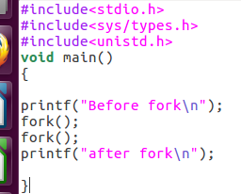

OUTPUT:

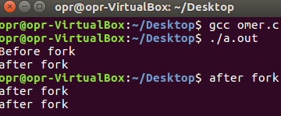

**TASK # 2:**

Write a program by using getpid() command.

SOURCE CODE:

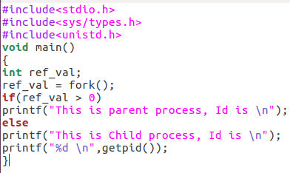

OUTPUT:

