**TASK # 1:**

Write a program by using sleep().

SOURCE CODE:

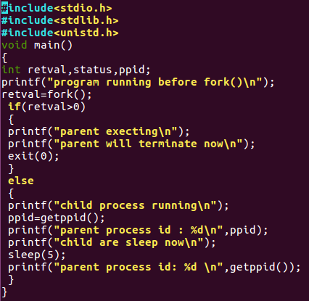

OUTPUT:

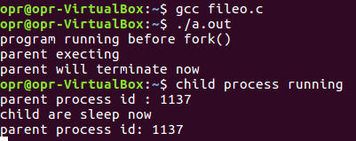

**TASK # 2:**

Write a program by using wait(), execl.

SOURCE CODE:

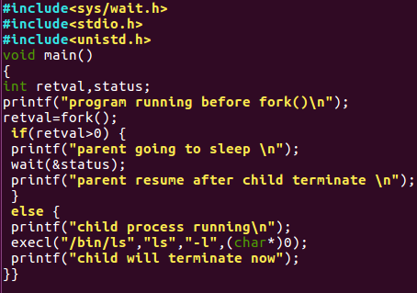

OUTPUT:

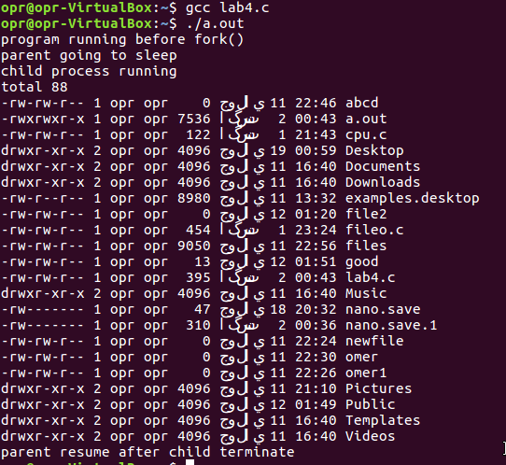

**TASK # 3:**

Write a program by using execlp().

SOURCE CODE:

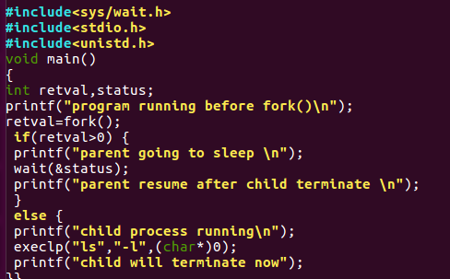

OUTPUT:

