**TASK # 1:**

SOURCE CODE:

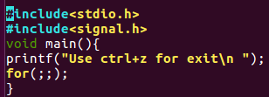

OUTPUT:

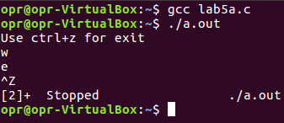

**TASK # 2:**

SOURCE CODE:

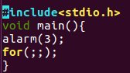

OUTPUT:

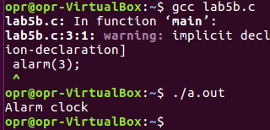

**TASK # 3:**

SOURCE CODE:

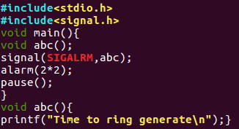

OUTPUT:

