SOURCE CODE:

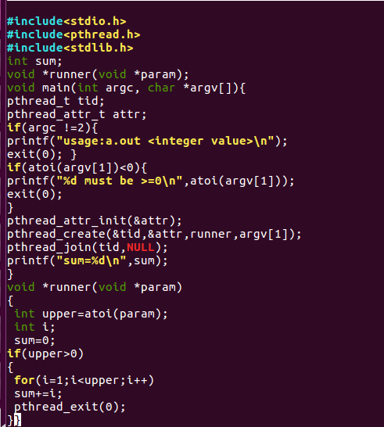

OUTPUT:

