**TASK # 1:**

Draw a “Sequence” diagram for Online Payment System.

**Screen Shot:**

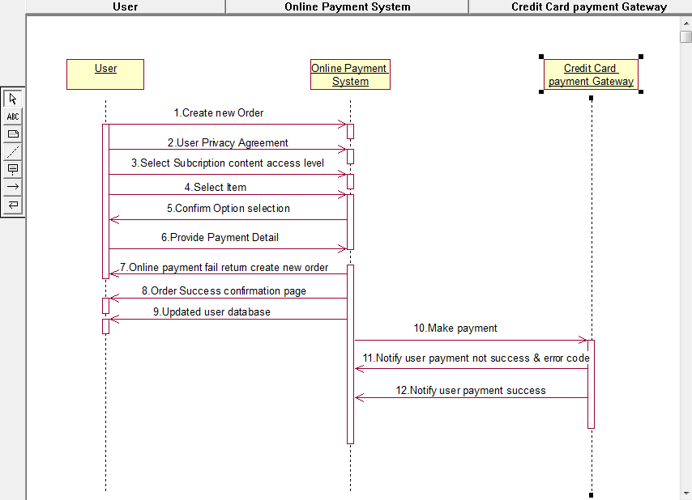

**TASK # 2:**

Draw a “Communication” diagram for Online Payment System.

**Screen Shot:**

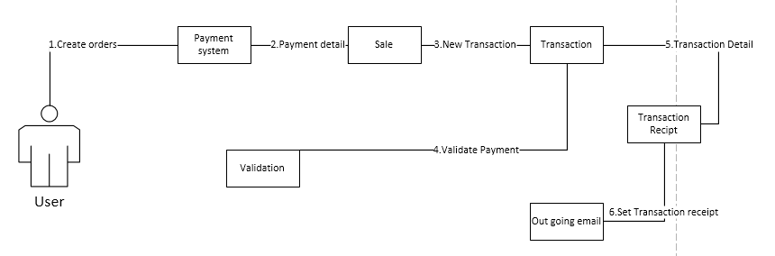

**TASK # 3:**

Draw a “State” diagram for Online Payment System.

**Screen Shot:**

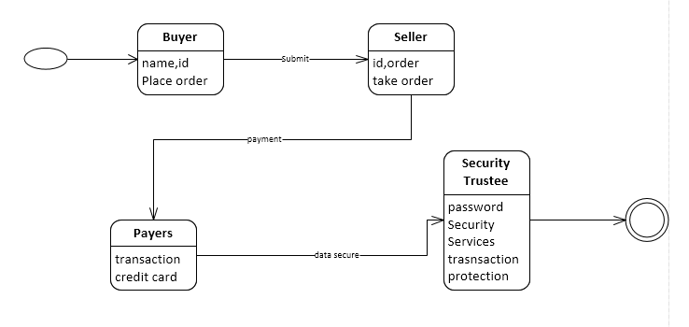

**TASK # 4:**

Draw a “Acticity” diagram for Online Payment System.

**Screen Shot:**

