Lab # 2

**AVM: Physical View and Development View**

**Package Diagram:**

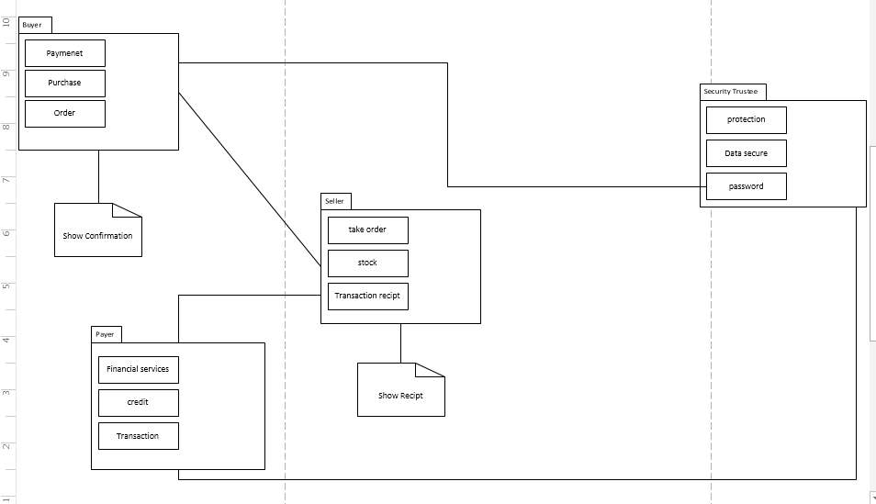

**Deployment Diagram:**

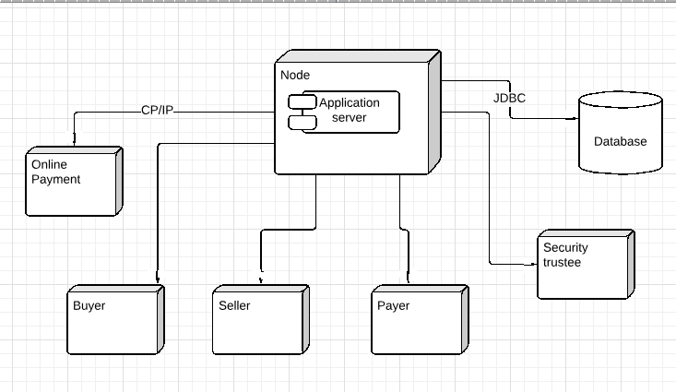

**Component Diagram:**

