Lab # 4

**Design Patterns: Creational Patterns**

**Step 1 :-**

**Create an interface.**

OnlinePayment.java

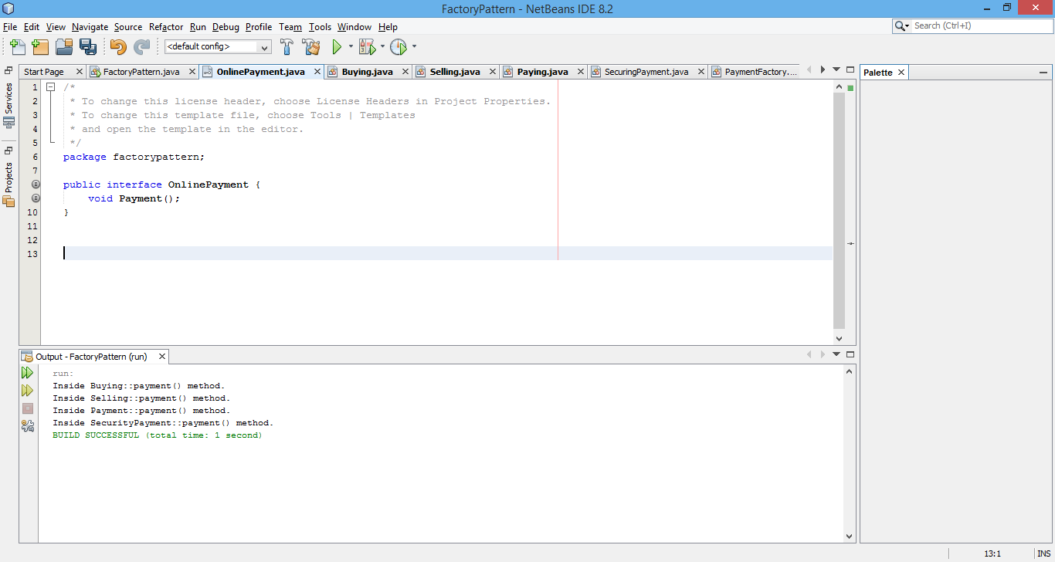

**Step 2-:**

**Create concrete classes implementing the same interface.**

Buying.java

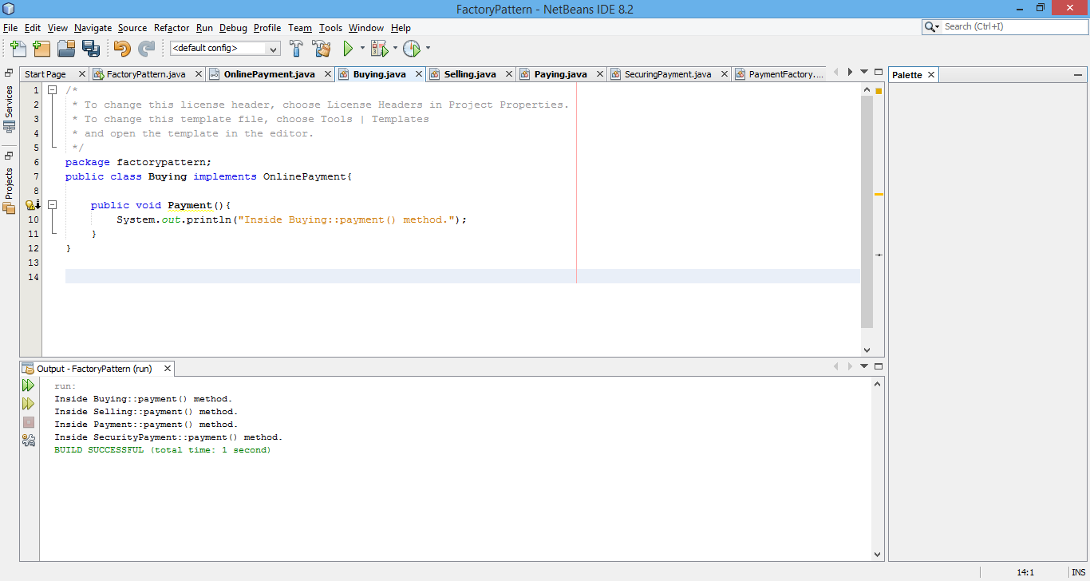

Selling.java

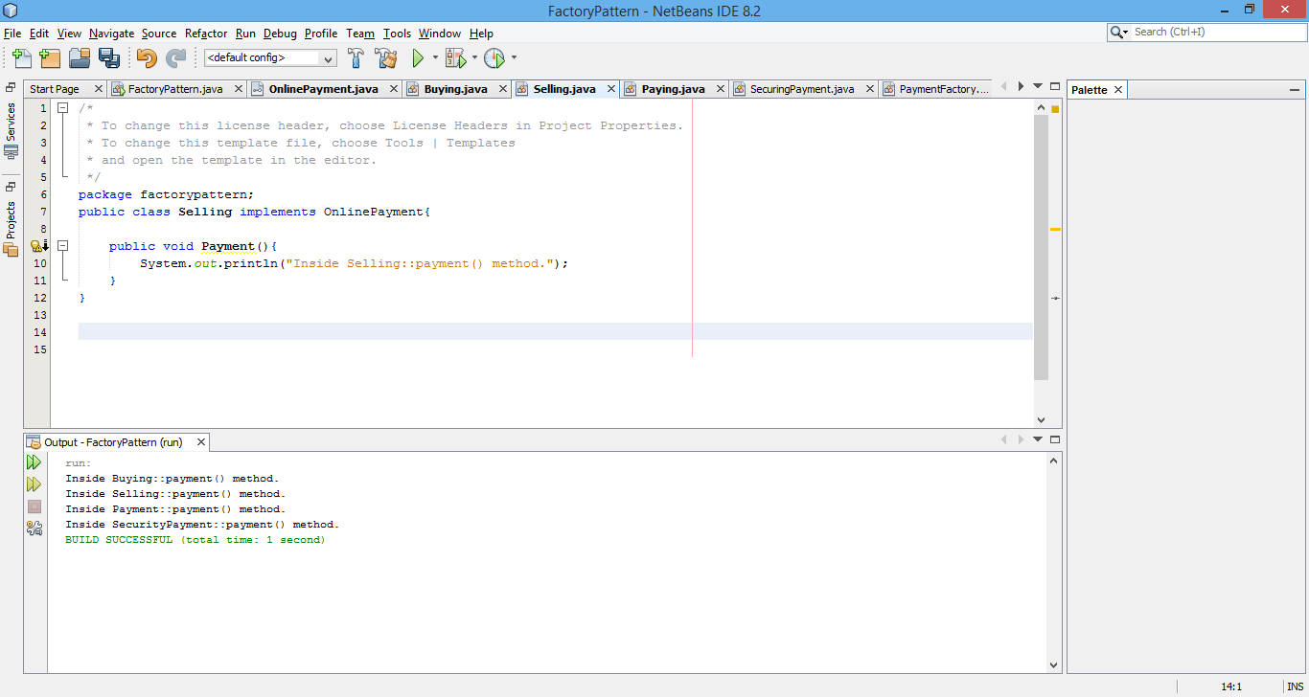

paying.java

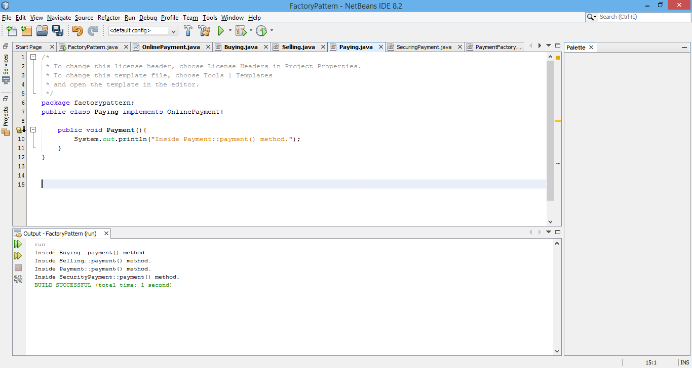

SecurityPayment.java

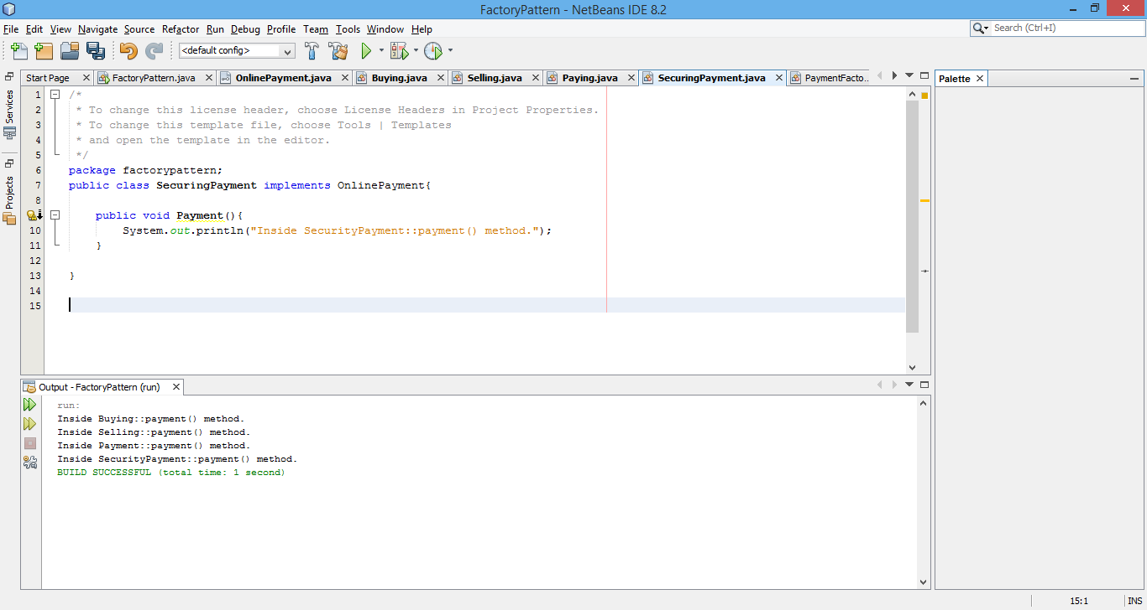

**Step 3**

**Create a Factory to generate object of concrete class based on given information.**

PaymentFactory.java

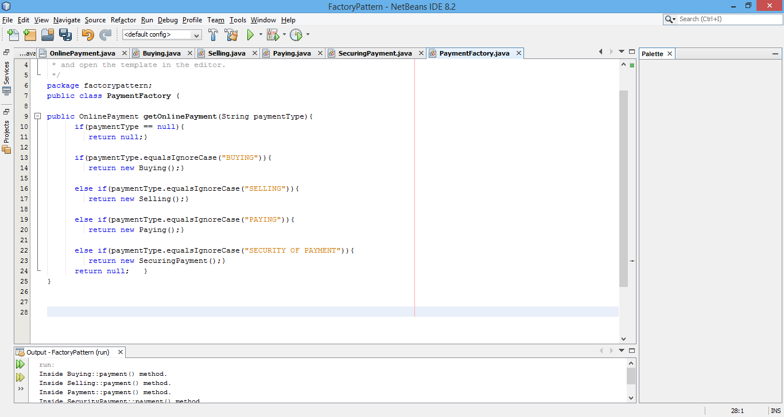

**Step 4 :-**

**Use the Factory to get object of concrete class by passing an information such as type.**

FactoryPatternDemo.java

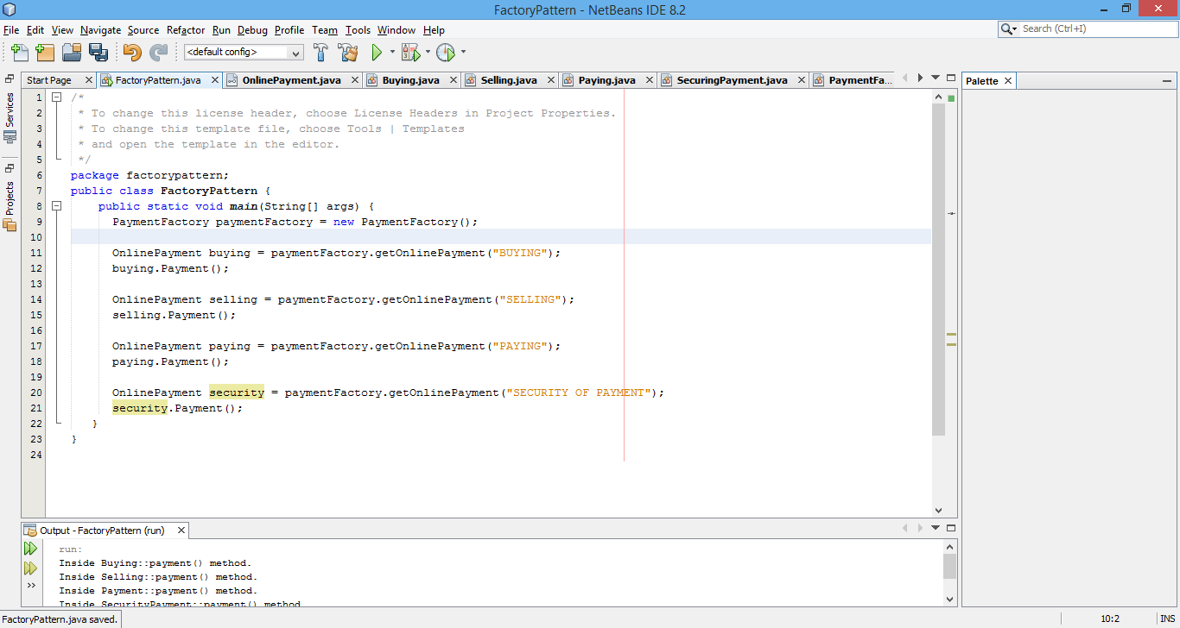

**Step 5 :-**

**Output:**

