Lab # 5

**Creational Patterns: Singleton Pattern**

**SOURCE CODE:**

**Step 1**

**Create a Singleton Class.**

*Buying.java*

**package singlepatterndemo;**

**public class Buying {**

**private static Buying instance = new Buying();**

**private Buying(){}**

**public static Buying getInstance(){**

**return instance;**

**}**

**public void checkCredit(){**

**boolean credit=true;**

**if (credit==true)**

**{**

**System.out.println("Item Purchased Sucssesfully");**

**}**

**}**

**}**

**Step 2**

**Get the only object from the singleton class.**

*SingletonPatternDemo.java*

**package singlepatterndemo;**

**public class SinglePatternDemo {**

**public static void main(String[] args) {**

**Buying object = Buying.getInstance();**

**object.checkCredit();**

**}**

**}**

**OUTPUT:**

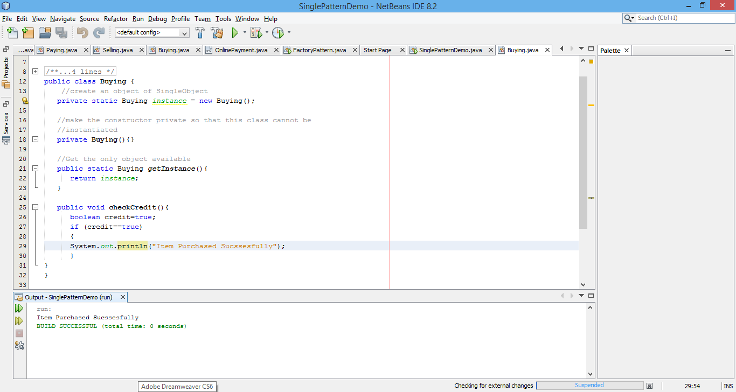

**Creational Patterns: Builder Pattern**

**SOURCE CODE:**

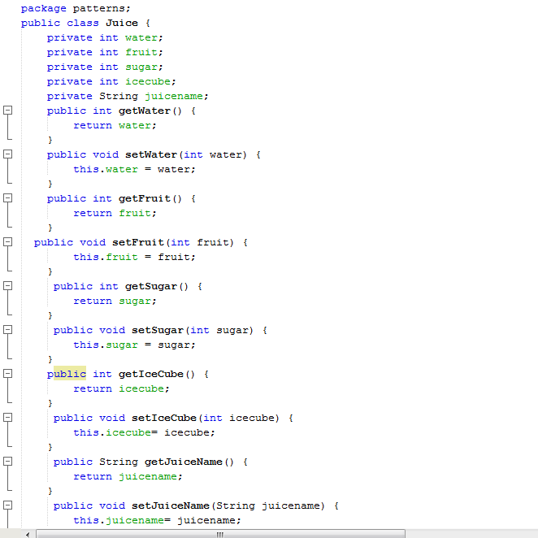

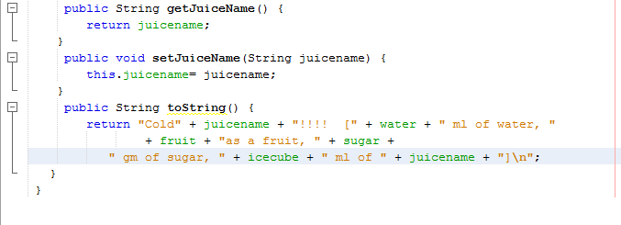

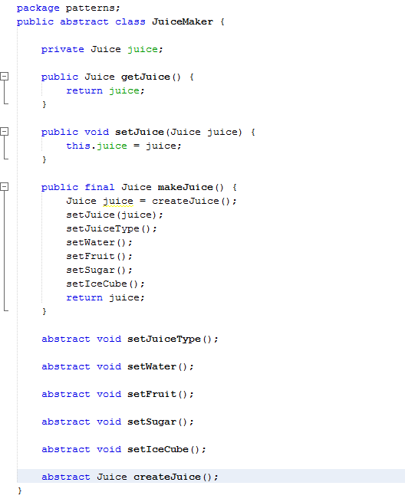

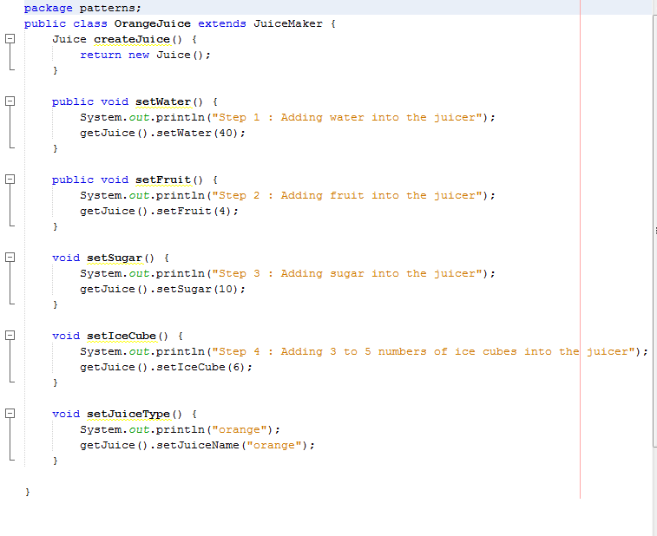

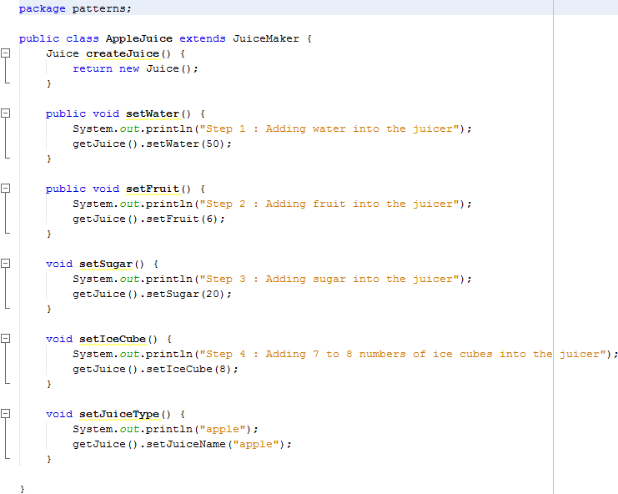

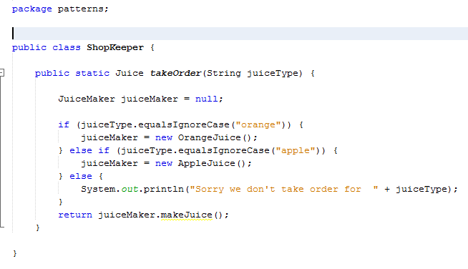

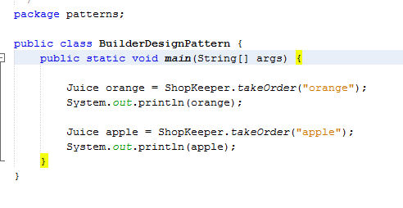

**OUTPUT:**

