Lab # 6

**Design Patterns: Structural Patterns Adapter**

**SOURCE CODE:**

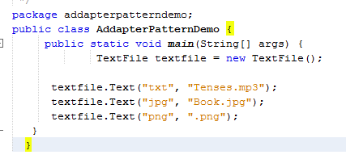

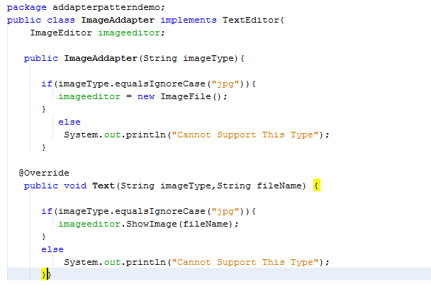

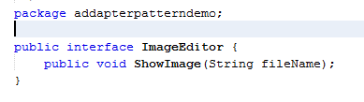

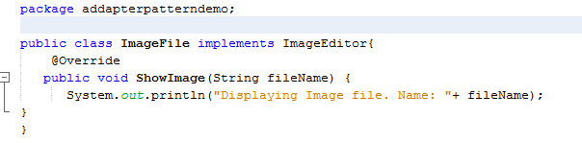

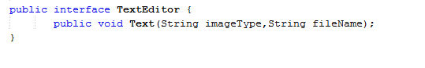

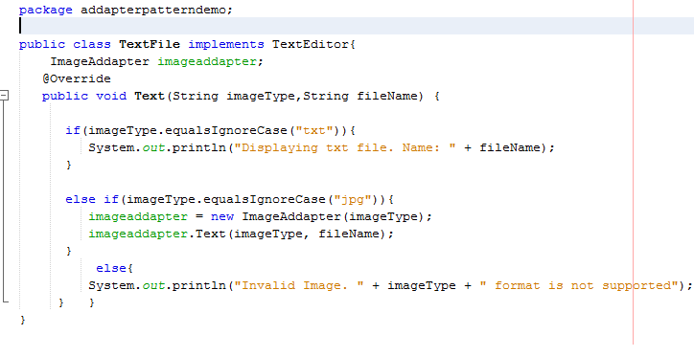**OUTPUT:**

