Lab # 8

**Structural Patterns: Bridge Pattern**

**SOURCE CODE:**

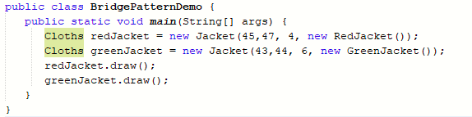

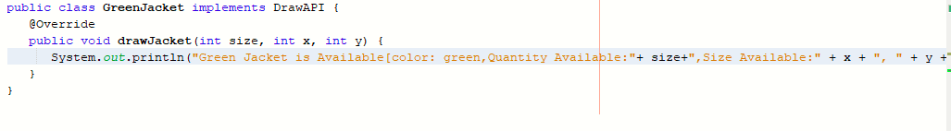

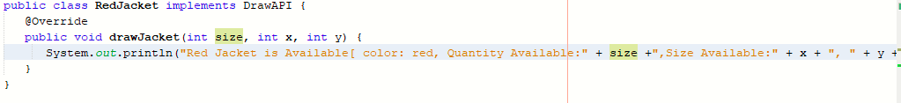

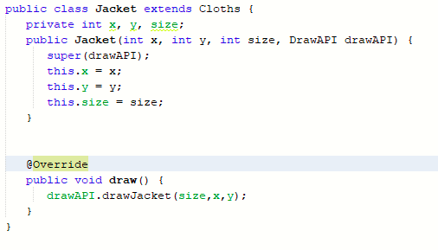

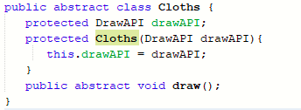



**OUTPUT:**

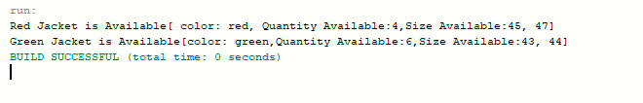**Structural Patterns: Composite Pattern**

**SOURCE CODE:**

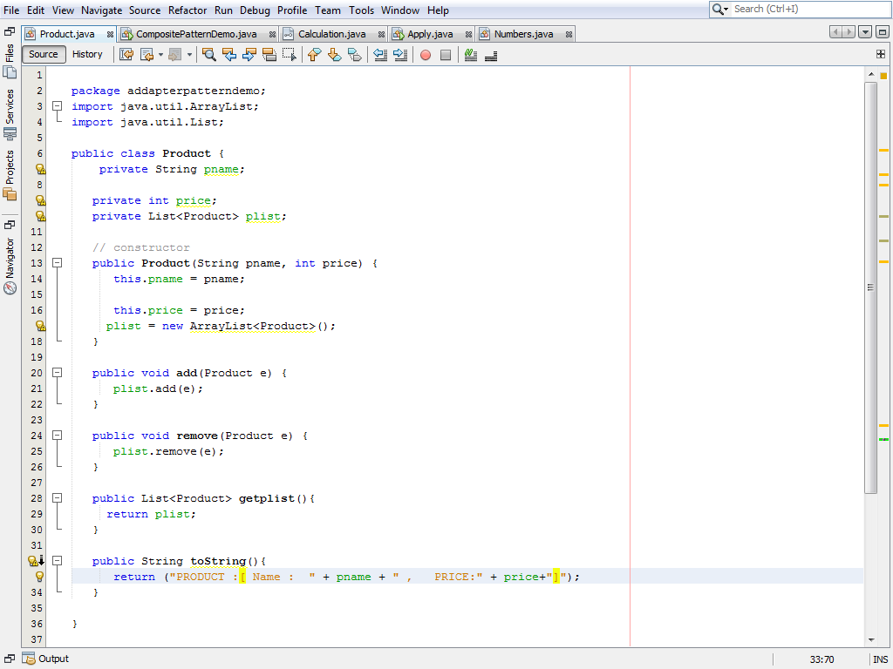

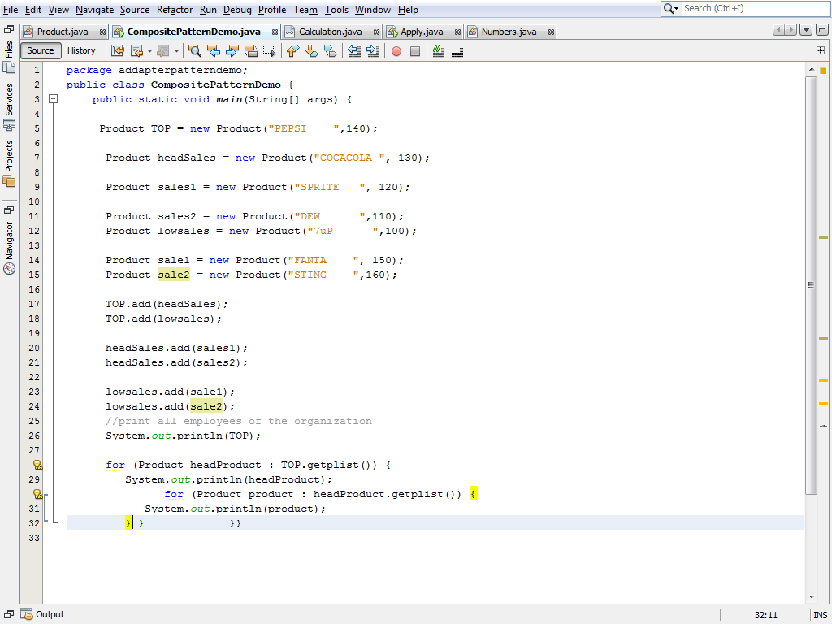

**OUTPUT:**

