**TASK # 1:**

Draw a ‘Gant Char’ and ‘Resource Sheet’ for the Library Management System.

**Step # 1:**

Open MS Project & select Blank Project.

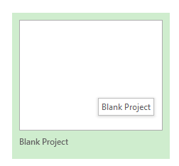

**Step # 2:**

Select Task Mode (Manually Scheduled).

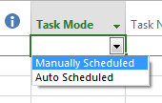

**Step # 3:**

Insert task name.

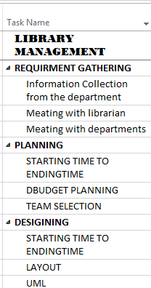

**Step # 4:**

Insert time duration.

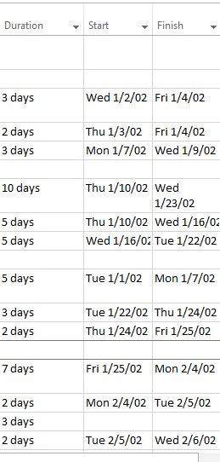

**Step # 5:**

Gant chart.

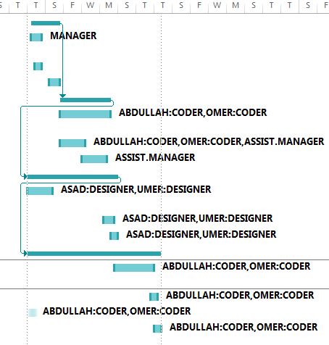

**Step # 6:**

Set predecessors.

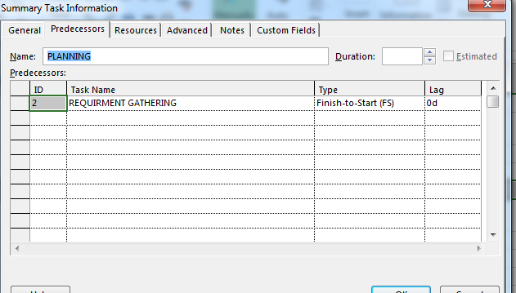

**Step # 7:**

Indent task.

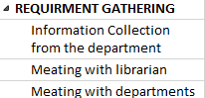

**Step # 8:**

Go to Gent chart and select Resource Sheet.

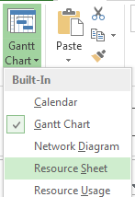

**Step # 9:**

Fill Resource Name (Name, Software Tools, Hardware Device).

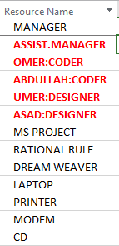

**Step # 10:**

Select type (Person=Work, Tools=Cost, Hardware=Material).

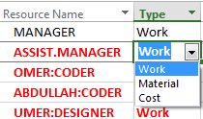

**Step # 11:**

Dedication of the resource towards the project.

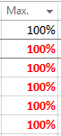

**Step # 12:**

Rate of pay & overtime pay.

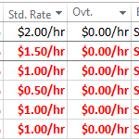

**Step # 13:**

Select Base.

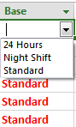

**Step # 14:**

Link to the Resource Sheet.

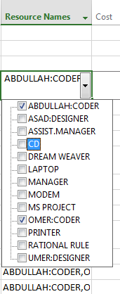

**Step # 15:**

Add new column (cost) in ‘Gant chart’.

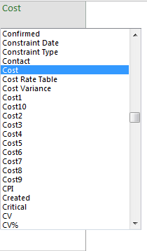

**Step # 16:**

Add new column (cost) in ‘Resource Sheet’. Projected cost for task automatically appear.

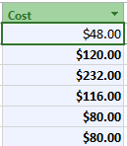

**Step # 17:**

Complete Resource Sheet.

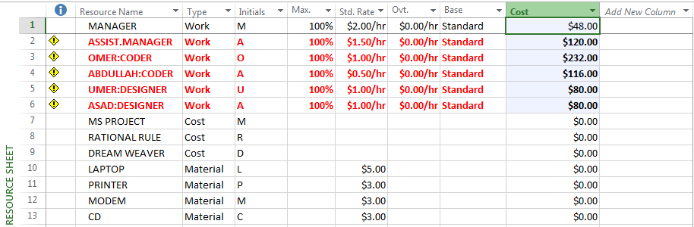

**Step # 18:**

Network Diagram.

