**TASK # 1:**

Draw a “Sequence” diagram for Library Management System.

**Screen Shot:**

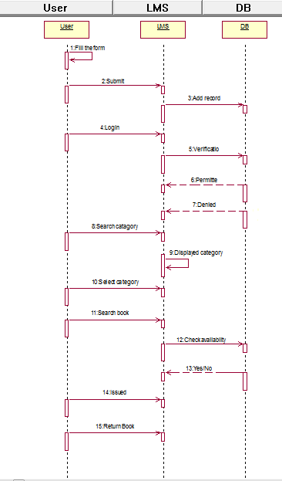

**TASK # 2:**

Draw a “Sequence” diagram for Hospital Management System.

**Screen Shot:**

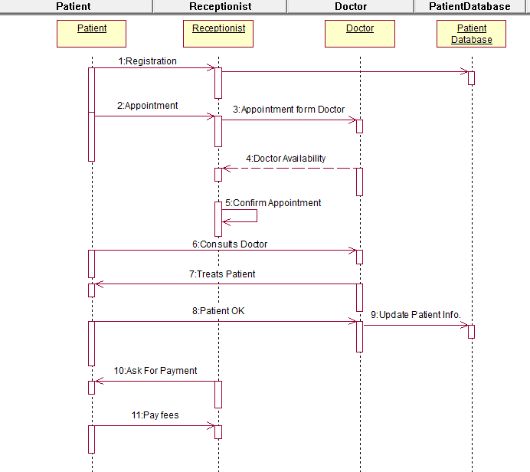

**TASK # 3:**

Draw a “Sequence” diagram for ATM Management System.

**Screen Shot:**

