**TASK # 1:**

Draw class diagram for library management system

**Screen Shot:**

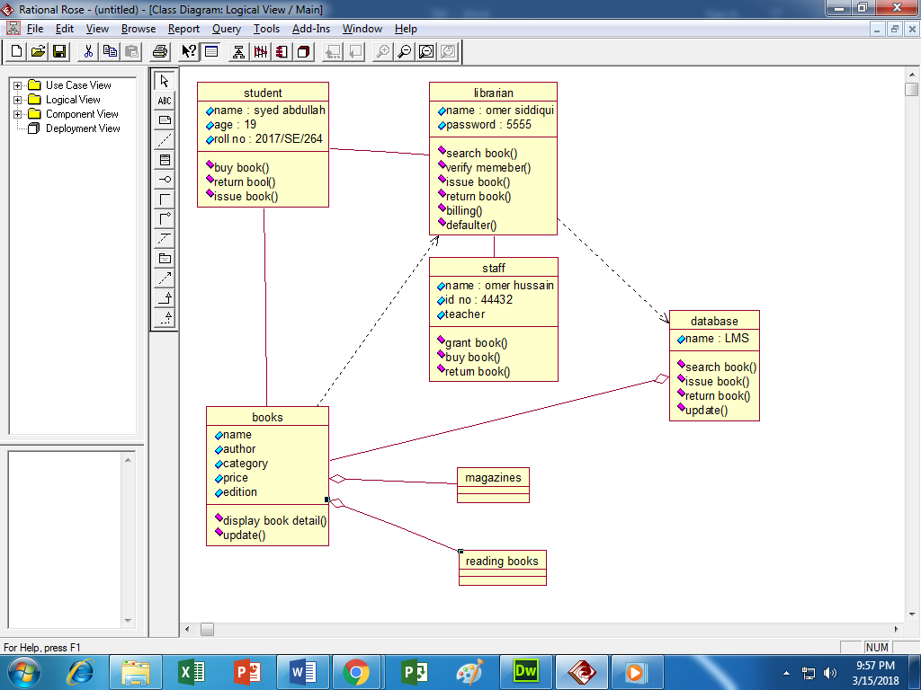

**TASK # 2:**

Draw class diagram on hospital management system

**Screen Shot:**

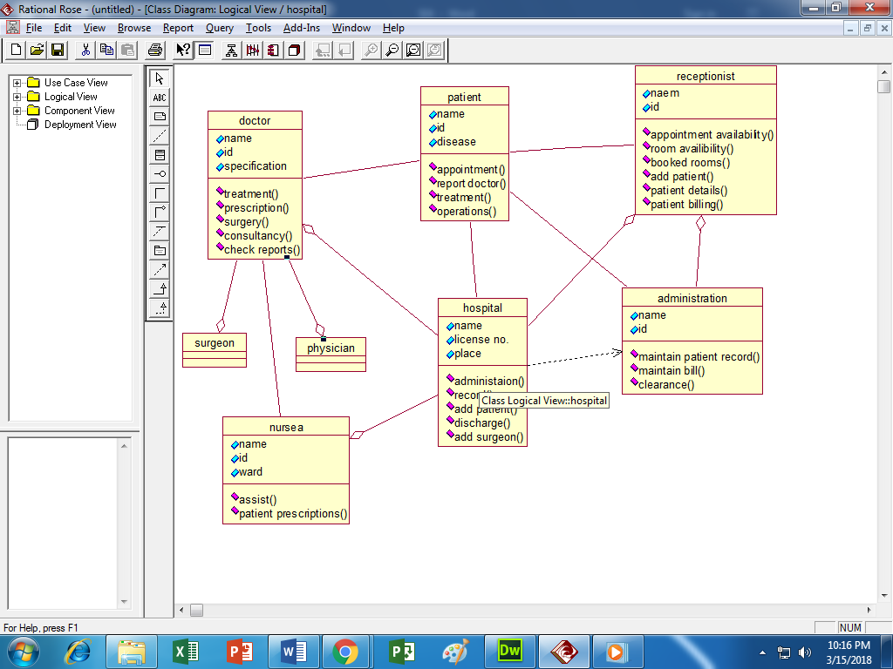

**TASK # 3:**

Draw class diagram for atm management system

**Screen Shot:**

