**TASK # 1:**

Create Login and Registration form.

**Step # 1:**

Open file and select new.

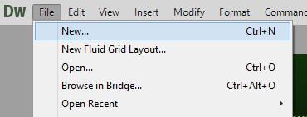

**Step # 2:**

Select html and click on create.

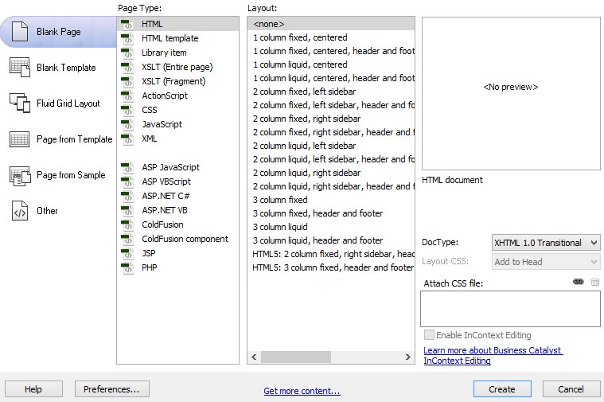

**Step # 3:**

Insert form.

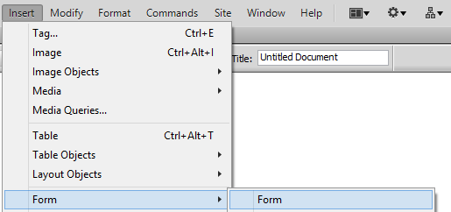

**Step # 4:**

Insert table.

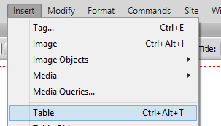

**Step # 5:**

Insert text field.

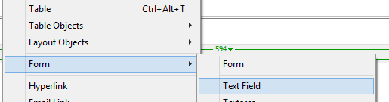

**Step # 6:**

Login form.

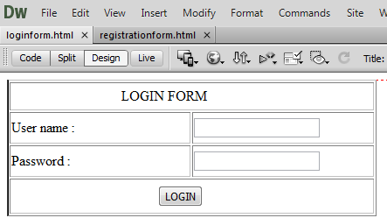

**Step # 7:**

Registration form.

