**TASK # 1:**

Create Login and Registration form using field set, legend, ul, ol, li, div tags.

**Step # 1:**

Open file and select new.

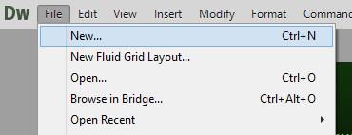

**Step # 2:**

Select html and click on create.

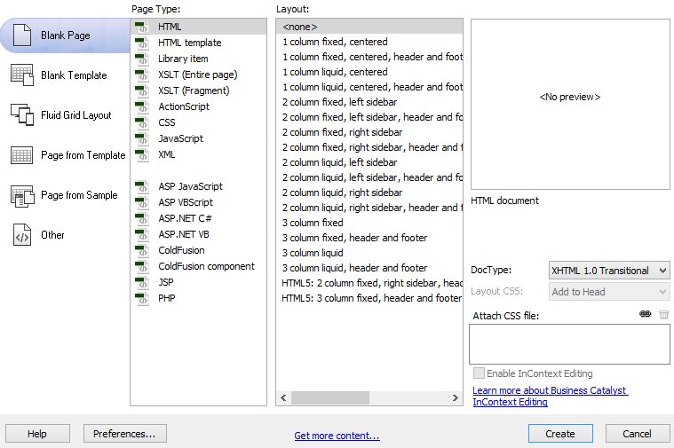

**Step # 3:**

Insert form.

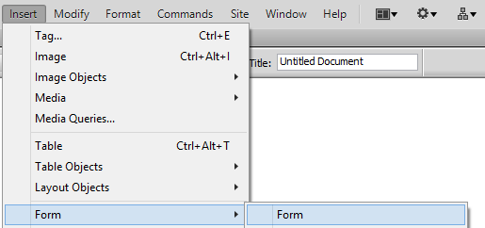

**Step # 4:**

Insert table.

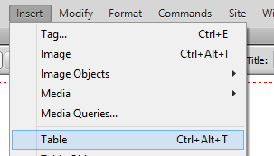

**Step # 5:**

Insert text field.

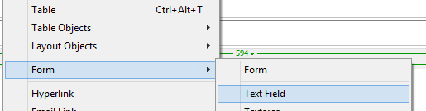

**Step # 6:**

Login form.

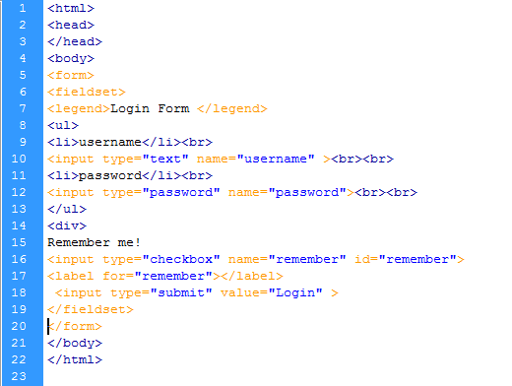

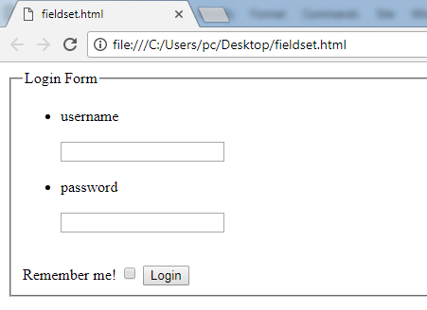

**Step # 7:**

Registration form.

**Source Code:**

<html>head></head>

<body>

<form>

<fieldset>

<legend>Registration Form</legend>

<ol><li>

<p>Name:&nbsp;&nbsp;&nbsp;&nbsp;&nbsp; &nbsp;

<label for="name"></label>

<input type="text" name="name" id="name">

</p></li>

<li><p>Father:&nbsp;&nbsp;&nbsp;&nbsp;&nbsp;&nbsp;&nbsp;

<label for="father"></label>

<input type="text" name="father" id="father">

</p></li>

<li><p>Contact no:

<label for="number"></label>

<input type="text" name="number" id="number">

</p>

</li>

<li><p>Email:&nbsp; &nbsp;&nbsp;&nbsp;&nbsp; &nbsp;

<label for="email"></label>

<input type="text" name="email" id="email">

</p>

</li>

<li><p>Age: &nbsp;&nbsp;&nbsp;&nbsp;&nbsp;&nbsp;&nbsp; &nbsp;&nbsp;

<label for="age"></label>

<input type="text" name="age" id="age">

</p>

</li>

<li> <p>Address:&nbsp; &nbsp;&nbsp;

<label for="address"></label>

<input type="text" name="address" id="address">

</p></li>

<li><p>Gender:&nbsp; &nbsp;&nbsp;&nbsp;

<label for="gender"></label>

<input type="text" name="gender" id="gender">

</p></li>

<li><p>CNIC:&nbsp;&nbsp;&nbsp;&nbsp;&nbsp;&nbsp;&nbsp;

<label for="cnic"></label>

<input type="text" name="cnic" id="cnic">

</p></li>

</ol>

</fieldset>

</form></body></html>

