UML

# Objective:

To create the following UML:

* use-case diagram
* sequence diagram
* class diagram

for a real project or system.

# Software Requirements:

**CASE Tool:**

* MS Word
* MS Visio

# Theory:

**UML (UNIFIED MODELING LANGUAGE):**

**UML** (Unified Modeling Language) is a modeling language used by software developers. UML can be used to develop diagrams and provide users with ready-to-use, expressive modeling examples. Some UML tools generate program language code from UML. UML can be used for modeling a system independent of a platform language. UML is a graphical language for visualizing, specifying, constructing, and documenting information about software-intensive systems. UML gives a standard way to write a system model, covering conceptual ideas. With an understanding of modeling, the use and application of UML can make the software development process more efficient.

There are two categories of UML:

* behavior diagrams
* use case diagram
* sequence diagram
* structured diagrams
* class diagram
* **USECASE DIAGRAM:**

A use case diagram at its simplest is a representation of a user's interaction with the system that shows the relationship between the user and the different use cases in which the user is involved. A use case diagram can identify the different types of users of a system and the different use cases and will often be accompanied by other types of diagrams as well.

 A use case diagram contains four components.

The boundary, which defines the system of interest in relation to the world around it.

* The actors, usually individuals involved with the system defined according to their roles.
* The use cases, which are the specific roles played by the actors within and around the system.
* The relationships between and among the actors and the use cases.

**COMPONENTS in A Use Case Diagrams**

There are five types of relationships in a use case diagram. They are:

* Association between an actor and a use case
* Generalization of an actor
* Extend relationship between two use cases
* Include relationship between two use cases
* Generalization of a use case

**How to Create a Use-Case Diagram**

We are taking banking system as an example.

##### Identifying Actors

Actors are external entities that interact with your system. It can be a person, another system or an organization. In a banking system, the most obvious actor is the customer. Other actors can be bank employee or cashier depending on the role you’re trying to show in the use case.

An example of an external organization can be the tax authority or the central bank. The loan processor is a good example of an external system associated as an actor.

##### Identifying Use Cases

Now it’s time to identify the use cases. A good way to do this is to identify what the actors need from the system. In a banking system, a customer will need to open accounts, deposit and withdraw funds, request check books and similar functions. So all of these can be considered as use cases.

Top level use cases should always provide a complete function required by an actor. You can extend or include use cases depending on the complexity of the system.

Once you identify the actors and the top level use case you have a basic idea of the system. Now you can fine tune it and add extra layers of detail to it.

##### Look for Common Functionality to use Include

Look for common functionality that can be reused across the system. If you find two or more use cases that share common functionality you can extract the common functions and add it to a separate use case. Then you can connect it via the include relationship to show that it’s always called when the original use case is executed. ( see the diagram for an example ).

##### Is it Possible to Generalize Actors and Use Cases

There may be instances where actors are associated with similar use cases while triggering few use cases unique only to them. In such instances, you can generalize the actor to show the inheritance of functions. You can do a similar thing for use case as well.

One of the best examples of this is “Make Payment” use case in a payment system. You can further generalize it to “Pay by Credit Card”, “Pay by Cash”, “Pay by Check” etc. All of them have the attributes and the functionality of a payment with special scenarios unique to them.

##### Optional Functions or Additional Functions

There are some functions that are triggered optionally. In such cases, you can use the extend relationship and attach an extension rule to it. In the below banking system example “Calculate Bonus” is optional and only triggers when a certain condition is matched.

Extend doesn’t always mean it’s optional. Sometimes the use case connected by extend can supplement the base use case. The thing to remember is that the base use case should be able to perform a function on its own even if the extending use case is not called.

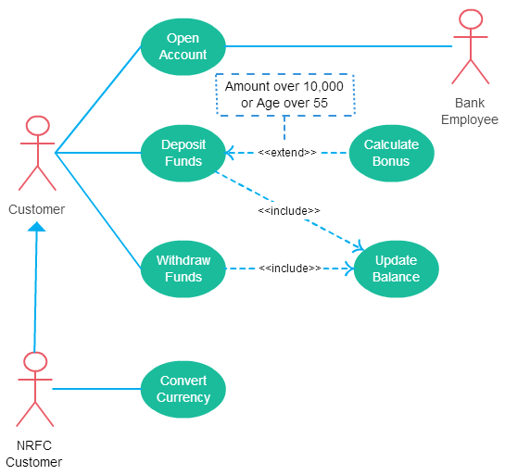

* **Sequence diagram:**

A sequence diagram shows object interactions arranged in time sequence. It depicts the objects and classes involved in the scenario and the sequence of messages exchanged between the objects needed to carry out the functionality of the scenario. Sequence diagrams are typically associated with use case realizations in the Logical View of the system under development. Sequence diagrams are sometimes called **event diagrams** or **event scenarios**.

**COMPONENTs OF A SEQUENCE DIAGRAM:**

* Class Roles or Participants. Class roles describe the way an object will behave in context.
* Activation or Execution Occurrence. Activation boxes represent the time an object needs to complete a task.
* Messages.
* Lifelines.
* Destroying Objects.
* Loops.

**HOW TO CREATE A SEQUENCE DIAGRAM:**

Sequence diagramming really is visual coding, even when you are modeling a usage scenario via a system-level sequence diagram.

While creating a sequence diagram, start by identifying the scope of what you are trying to model. You should typically tackle small usage scenarios at the system level or a single method/service at the detailed object level.

You should then work through the logic with at least one more person, laying out classifiers across the top as you need them. . The heart of the diagram is in the messages, which you add to the diagram one at a time as you work through the logic. You should rarely indicate return values, instead you should give messages intelligent names which often make it clear what is being returned.

It is interesting to note that as you sequence diagram you will identify new responsibilities for classes and objects, and, sometimes, even new classes. The implication is that you may want to update your class model appropriately, agile modelers will follow the practice Create Several Models in Parallel, something that CASE tools will do automatically. Remember, each message sent to a class invokes a static method/operation on that class each message sent to an object invokes an operation on that object.

Regarding style issues for sequence diagramming, prefer drawing messages going from left-to-right and return values from right-to-left, although that doesn’t always work with complex objects/classes. Justify the label on messages and return values, so they are closest to the arrowhead. Also prefer to layer the sequence diagrams: from left-to-right. indicate the actors, then the controller class(es), and then the user interface class(es), and, finally, the business class(es). During design, you probably need to add system and persistence classes, which you should usually put on the right-most side of sequence diagrams. Laying your sequence diagrams in this manner often makes them easier to read and also makes it easier to find layering logic problems, such as user interface classes directly accessing persistence.

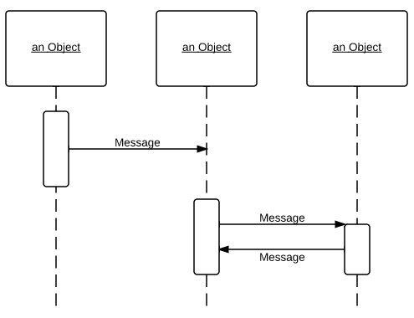

* **CLASS DIAGRAM:**

A **class diagram** is an illustration of the relationships and source code dependencies among **classes** in the Unified Modeling Language (UML). In this context, a **class** defines the methods and variables in an object, which is a specific entity in a program or the unit of code representing that entity.

**COMPONENTS OF A CLASS DIAGRAM:**

The standard class diagram is composed of three sections:

* **Upper section:**Contains the name of the class. This section is always required, whether you are talking about the classifier or an object.
* **Middle section:**Contains the attributes of the class. Use this section to describe the qualities of the class. This is only required when describing a specific instance of a class.
* **Bottom section:**Includes class operations (methods). Displayed in list format, each operation takes up its own line. The operations describe how a class interacts with data.

**HOW TO CREATE A CLASS DIAGRAM:**

The term "interactions" refers to the various relationships and links that can exist in class and object diagrams. Some of the most common interactions include:

* **Inheritance:** The process of a child or sub-class taking on the functionality of a parent or superclass, also known as generalization. It's symbolized with a straight connected line with a closed arrowhead pointing towards the superclass.
* **Bidirectional association:** The default relationship between two classes. Both classes are aware of each other and their relationship with the other. This association is represented by a straight line between two classes.
* **Unidirectional association:** A slightly less common relationship between two classes. One class is aware of the other and interacts with it. Unidirectional association is modeled with a straight connecting line that points an open arrowhead from the knowing class to the known class.

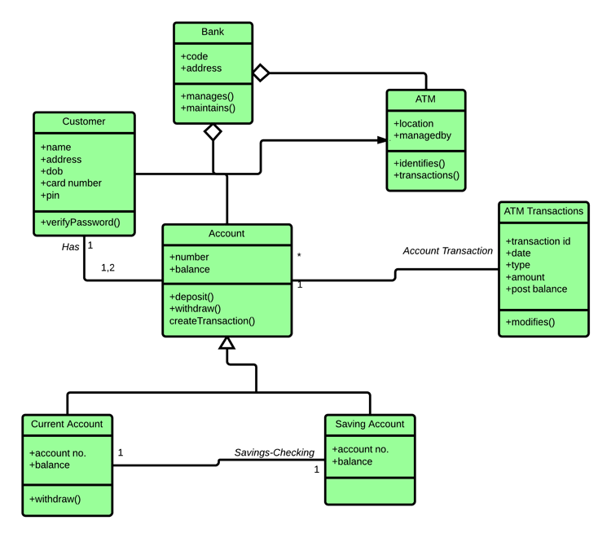

**Exercise**

Draw use-case, sequence and class diagram for the following scenario:

* Hotel management system

**Problem statement:**

A hotel has various types of rooms Dimensions of various: price, number of single beds, number of double beds. A database with a listing of all the rooms of the hotel is supplied. This database includes when the rooms have been booked.

People can look for availability on a website for certain types of room (room price), for a certain time of span. The systems check availability and returns the proposition that fits the reservation. If no exact match is found, something similar is proposed with at least the same person capacity.

* Airline reservation system

**Problem Statement:**

To develop a computerized meeting, the rising customer interest in booking online air travel reservations. The system should be convenient, user friendly and available via the internet.

The system should allow the users to view entire flights information of the airline, book tickets, view or, if required cancel current reservations and create member login for standalone users as well as agents.