**OBJECTIVE:**

To understand problem statement and draw.

**PROBLEM DEFINITION:**

The library management system is a software, which works as a librarian. The user can search a particular book by entering card no and author. If the particular book available then he/she can issue a book.

When user wants to issue/return a book. He must provide the card number, which is unique to each other, then user must provide the author name of book, then he/she will get all necessary information about the book, the user can then select addition of book and can issue that book. The user can view different historical books by entering card number.

**PRODUCT FUNCTION:**

* The main purpose of the system to reduce the manual work
* This software is capable of managing book issue, return and calculating and managing file. Generating various reports for record keeping according to end user requirement.

**USER CHARACTERISTICS:**

We have two levels of user:

1. User Module: In user module user will check the availability of the book.

* Book return

1. Administrator module: Following are the sub modules in administrator module

* Register user
* Entry book
* Issue book

**CONSTRAINTS:**

Any update regarding the book from the library is to be recorded is to have update & correct value.

USECASE DIAGRAM:

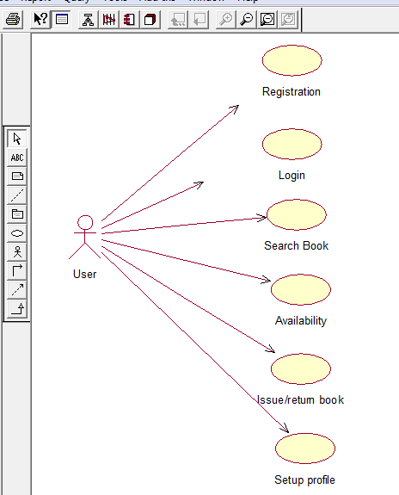

SEQUENCE DIAGRAM:

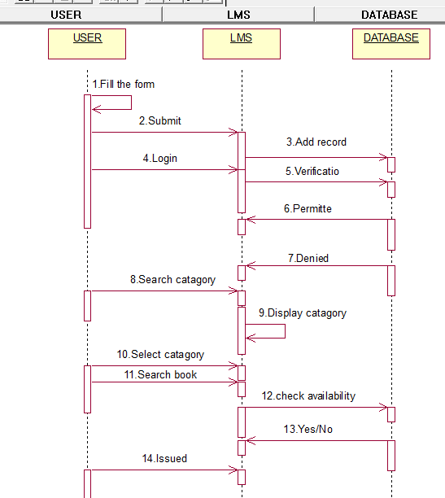

CLASS DIAGRAM:

