**OBJECTIVE # 1:**

To draw all the form of Library management System.

Login form:

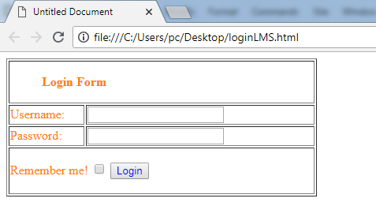

Registration form:

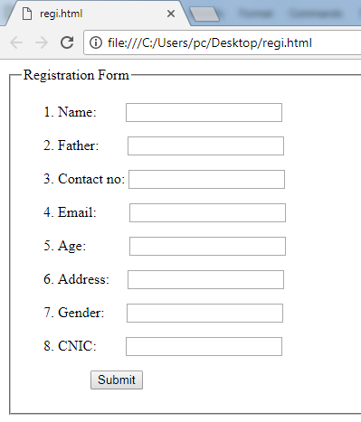

Issue Book:

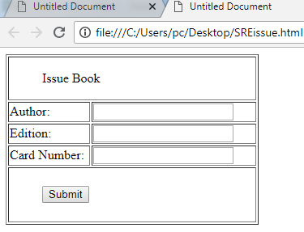

Return Book:

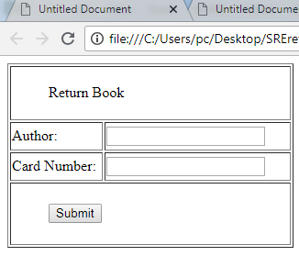

**OBJECTIVE # 2:**

To draw all the form of Library management System.

Login form:



Guest Information:

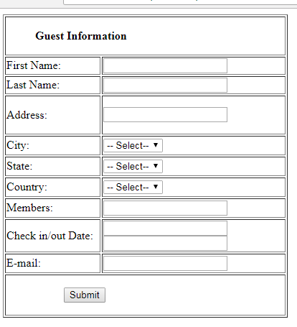

Room Information:

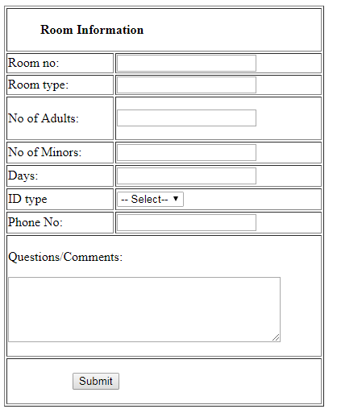

Payment Information:

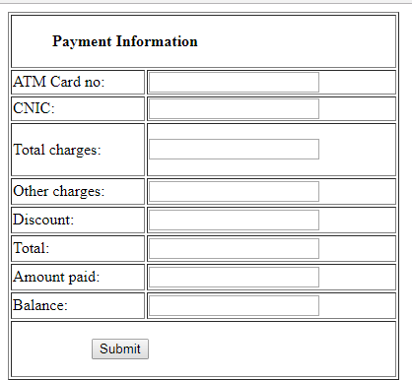

Cancel Booking:

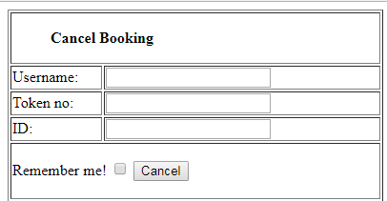

**OBJECTIVE # 3:**

To draw all the form of Airline Reservation System.

Login form:



Registration form:



Passenger Details:

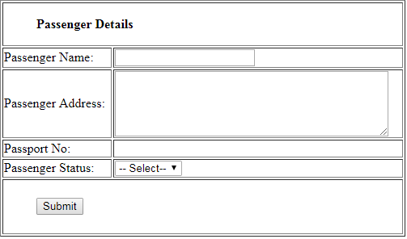

Reservation Details:

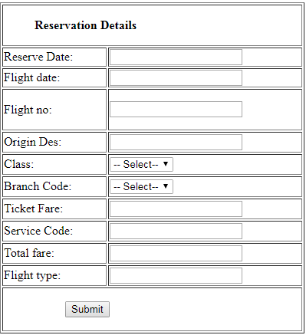

Flight Information:

