**OBJECTIVE # 1:**

1. Write the problem statement of Hotel Management System.
2. What are the functional and nonfunctional requirement of Hotel Management System.
3. What are the interfaces of the system.
4. Prototype.

**PROBLEM DEFINITION:**

The hotel management system is a software. The user can search a particular hotel by entering hotel name in the search bar. If the particular hotel available then he/she can enter the system.

* When user enter in the system he/she will first fill the registration form and then login a system.
* The system will record reservation.
* The system will generate a unique confirmation number for each reservation.
* The system will display the amount owed by the customer.
* The system will record the payment.
* The system will display the hotel occupancy for a specified period of time.
* Cancel booking
* Manager access.
* Performance Required.
* Logical database.
* Food service.
* Availability.
* Security.
* Portability.
* Flexibility.

**Functional Requirement:**

When user enter in the system he/she will first fill the registration form and then login a system.

The system will record reservation.

The system will generate a unique confirmation number for each reservation.

The system will display the amount owed by the customer.

The system will record the payment.

The system will display the hotel occupancy for a specified period of time.

Cancel booking.

Manager access.

**Non-Functional Requirement:**

Performance Required.

Logical database.

Food service.

Availability.

Security.

Portability.

Flexibility.

**Interface:**

The software provides good graphical interface.

**Hardware**:

Operating system; Windows.

Harddisk:40 GB.

Ram: 3 GB.

Processor: Core i5.

**Software:**

Dreamweaver.

Html/CSS.

MySQL.

**Prototype:**

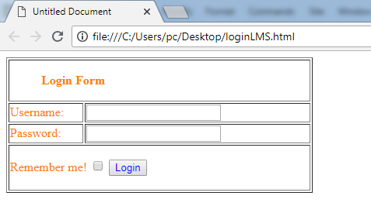

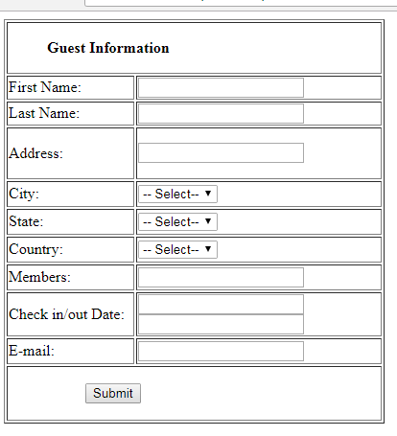

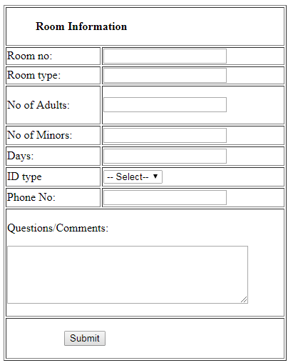

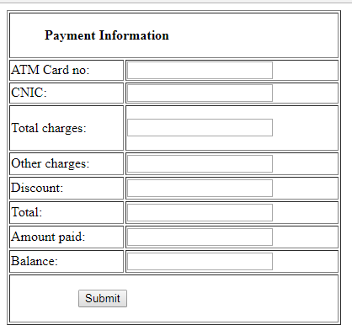

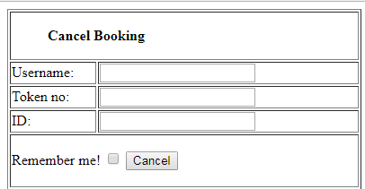

**OBJECTIVE # 2:**

1. Write the problem statement of Library Management System.
2. What are the functional and nonfunctional requirement of Library Management System.
3. What are the interfaces of the system.
4. Prototype.

**PROBLEM DEFINITION:**

The library management system is a software, which works as a librarian. The user can search a particular book by entering card no and author. If the particular book available then he/she can issue a book.

* When user enter in the system he/she will first fill the registration form and then login a system.
* The system will allow member to be able to search for available resource by title, resource ID, Author name.
* The system will display the search result with the details of preferred resource.
* The system will allow member to renew within 70 hours before due date.
* The system will display the due payment, description and deadline to the customer.
* The system will allow add, delete or edit resource with their details such as resource id, name, location, category, author.
* Check in / Check out Details.
* Database should be updated within a second.
* Log in should be validated within seconds.
* Payment information/ Personal information are protected and encrypted.
* Capacity.

**Functional Requirement:**

When user enter in the system he/she will first fill the registration form and then login a system.

The system will allow member to be able to search for available resource by title, resource ID, Author name.

The system will display the search result with the details of preferred resource.

The system will allow member to renew within 70 hours before due date.

The system will display the due payment, description and deadline to the customer.

The system will allow add, delete or edit resource with their details such as resource id, name, location, category, author.

Check in / Check out Details.

**Non-Functional Requirement:**

Database should be updated within a second.

Log in should be validated within seconds.

Payment information/ Personal information are protected and encrypted.

Capacity.

**Interface:**

The software provides good graphical interface.

**Hardware**:

Operating system; Windows.

Harddisk:40 GB.

Ram: 3 GB.

Processor: Core i5.

**Software:**

Dreamweaver.

Html/CSS.

MySQL.

**Prototype:**



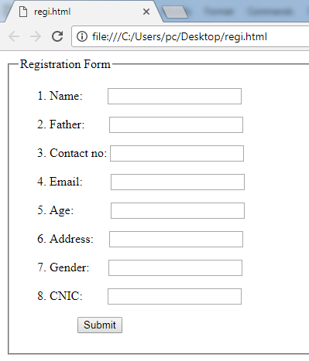

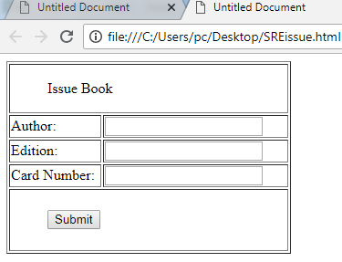

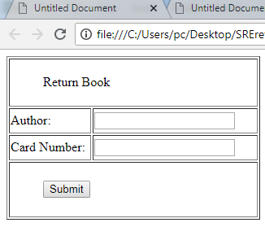

**OBJECTIVE # 3:**

1. Write the problem statement of Airline Reservation System.
2. What are the functional and nonfunctional requirement of Airline Reservation System.
3. What are the interfaces of the system.
4. Prototype.

**PROBLEM DEFINITION:**

The System will allow the user to view entire flight information of the airline ,book tickets, view or record cancel reservation.

* When user enter in the system he/she will first fill the registration form and then login a system.
* The customer looks up the information related to various airlines and check the availability of seats on flights.
* Book flights.
* Add delete or modify customer details.
* The system should be able to respond to the queries submitted by the customer without much delay.
* The system should be able to display the application result at a time on a page.
* The user searches for a flight the application should not take much time to return the result.

**Functional Requirement:**

When user enter in the system he/she will first fill the registration form and then login a system.

The customer looks up the information related to various airlines and check the availability of seats on flights.

Book flights.

Add delete or modify customer details.

**Non-Functional Requirement:**

The system should be able to respond to the queries submitted by the customer without much delay.

The system should be able to display the application result at a time on a page.

The user searches for a flight the application should not take much time to return the result.

**Interface:**

The software provides good graphical interface.

**Hardware**:

Operating system; Windows.

Harddisk:40 GB.

Ram: 3 GB.

Processor: Core i5.

**Software:**

Dreamweaver.

Html/CSS.

MySQL.

**Prototype:**





