**Airline Reservation System**

Problem Definition:

The system should get the passenger details such as name age address, passport number, which plane he/she want to travel and destination point. The software should provide search options. If the source /Destination points are entered, then all the planes travelling between these planes with arrival and departure time should be displayed for the sake of passengers. The software should have option of checking availability of the tickets. If the ticket is not available a short message will appear as “Ticket unavailable” will be displayed to passenger. The software should have facility to cancel the reservation of the ticket and also can modify the changes if the customer has some changes in his reserved ticket.

A small statement regarding cancellation should be displayed to passenger after cancellation of their tickets. The ticket which is cancelled is than added up to the available ticket column. The airline software should have the facility to print the ticket with all the details such as data, name of the plane, destination with timings and the class along with the passenger details. The price list of the ticket is also put up according to the class the passenger prefers to travel.

SRS DOCUMENT FOR AIRLINE RESERVATION SYSTEM:

INTRODUCTION:

* PURPOSE:

The main purpose of this system is to reduce manual errors involved in the airline reservation process and make it convenient for the customers to book the flights as when they require such that they can utilize this system to make reservations, modify reservations or cancel a particular reservation.

* SCOPE:

The name of the system is “AIRLINE RESERVATION SYSTEM”. This system provides options for viewing different flights available with different timings for a particular date and provides customers with the facility to book a ticket, modify or cancel a particular reservation but it does not provide a customer with detail of cost of the ticket and it does not allow the customer to modify a particular part of his reservation and he/she can modify all his details.

* DEFINATIONS ACRONYMS AND ABREVIATIONS:

ARS : Airline Reservation System

LAN : Local Area Network

GUI : Graphical User Interface

OS : Operating System

RAM : Random Access Memory

MB : Mega Byte

Gb : Giga Byte

MBPS : Mega Byte Per Second

HDD : Hard Disk Drive

* References:

The books and material referred during the pre-development stages of the project includes

* Software Engineering –A Practitioners Approach By Roger S. Pressman
* Software Engineering –By James Peters
* OVERVIEW:

The rest of the document deal about all the main feature of this software each will its purpose and its main functions. It also gives details about the interface with other products and relative functionality of each product

THE OVER ALL DESCRIPTION:

PRODUCT PRESPECTIVES:

The “ARS” is an independent application. It is a self-contained product. The system interfaces, user interfaces, and hardware interfaces related with this system are defined as follows.

* SYSTEM INTERFACES:

The client systems should be able to share the data available in the data base through the network connections.

* USER INTERFACES:

The screen format and menu structure should be in such a way that even have users will find it easy to use. The product must be user friendly and very interactive. The functionality provided by the system like error messages should adopt itself in the different users of the software.

* HARDWARE INTERFACE:

Nil.

* SOFTWARE INTERFACES:

Name of the language: Dreamweaver.

* OPERATIONS:

The user can first make a reservation in a particular flight for a particular date and time. The system provides the customer with a pin code which gives him access to either make any changes in his reservation or cancel his reservation. These must also be backup of data to enable any easy recovery from any features.

PRODUCT FUNCTIONS:

The major functions include:

* Providing Flight Details.
* Flight booking for a particular destination, Date and Time and also providing with a pin code.
* Allowing the customer to modify or cancel his reservation provided the correct pin code is given.
* Displaying a report of the member of people flying in a particular flight.

User Characteristics:

* The intended user of this software needed not have specific knowledge as to what is the internal operation of the system. Thus the end user is at high level of abstraction that allows easier, faster operation and reduces the knowledge requirement of end user.
* The product is absolutely user friendly, so the intended users can be the native users.
* The product does not expect the user to possess any technical background. Any person who knows to use the mouse and the keyboard can successfully use the product.

Constraints:

* Regulatory policies: It is mandatory that no text box must be left empty or contain insufficient data.
* Hardware limitations: There must be a 64 MB on board memory.
* Control functions: The software must be very user-friendly and display appropriate error messages.
* Interface to other applications: Not applicable.
* Parallel operations: It must support many users simultaneously.
* Reliability Requirements: Data redundancy and use of Special/Blank characters must be avoided.
* Safety/Security Considerations: The application must be exited always normally.
* Higher order language requirements: *VB*

SPECIAL REQUIREMENTS:

* LOCAL DATABASE REQUIREMENTS:

The system requires the use of the text files to maintain the customer personal details and his booking details. An entity must be used to specify the various departments and the seats available in them. This information will be used frequently by authorities for verification.

Front-End description:

The front-end end for the Airline Reservation System (ARS) is designed using Adobe Dreamweaver CS6. The front end contains a user friendly interface. The first form contains a welcome screen that provide an option for the user to select one of the following.

Enquiry

Reservation

Booking details

Cancellation

In the enquiry form the user can get details of the flight by means of either flight name, destination, date of journey. In the reservation form user can book details by entering the personal details. The ticket is display with detail about the flight name and number, number of passengers, Ticket number, sex and age. The cancelation form helps the user to cancel a ticket which he had booked earlier.

Back-End description:

The Airline Reservation System consist of two tables. One contains the flight details such as flight name, flight number, destination, date of journey, and seats available in each class that is referred to during enquiry. The other table has the passenger details such as name, age, sex, credit card no, and the bank name. This table is referred to at the time of reservation or cancelation.

DATA STRUCTURES:

* FLIGHT DETAILS:

|  |  |  |
| --- | --- | --- |
| FLIGHT NAME | TYPE | CONSTRAINTS |
| ROUTE NAME | TEXT | NOT NULL |
| FLIGHT NO. | NUMBER | NOT NULL |
| SEAT AVAILABLE | NUMBER |  |
| JOURNEY DATE | DATE/TIME |  |
| DEPARTURE TIME | DATE/TIME |  |
| ARRIVAL TIME | DATE/TIME |  |
| COST | NUMBER |  |

PASSENGER DETAILS

|  |  |  |
| --- | --- | --- |
| **FIELD NAME** | **TYPE** | **CONSTRAINTS** |
| TICKET NO | AUTONUMBER | NOT NULL |
| NAME | TEXT | NOT NULL |
| GENDER | TEXT |  |
| ADDRESS | TEXT |  |
| CC_NO | NUMBER | NOT NULL |
| BANK NAME | TEXT |  |
| NO OF TICKETS | NUMBER |  |

DATA FLOW DIAGRAM

Passenger

Operator

database

USECASE DIAGRAM

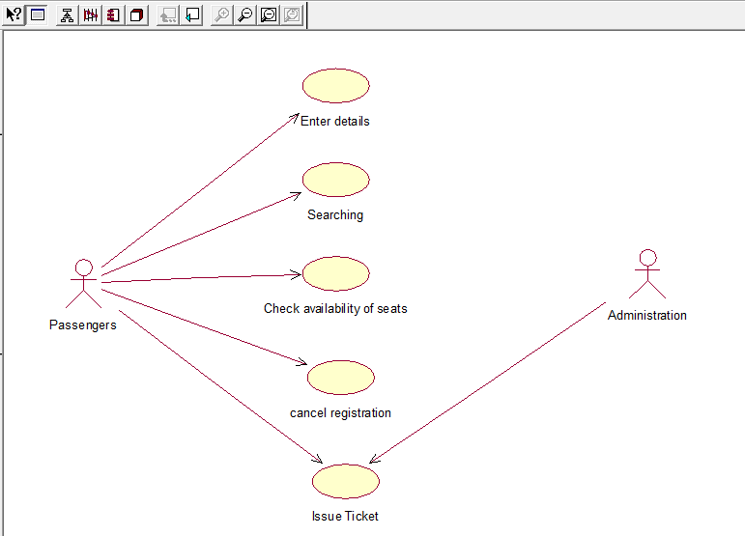

SEQUENCE DIAGRAM

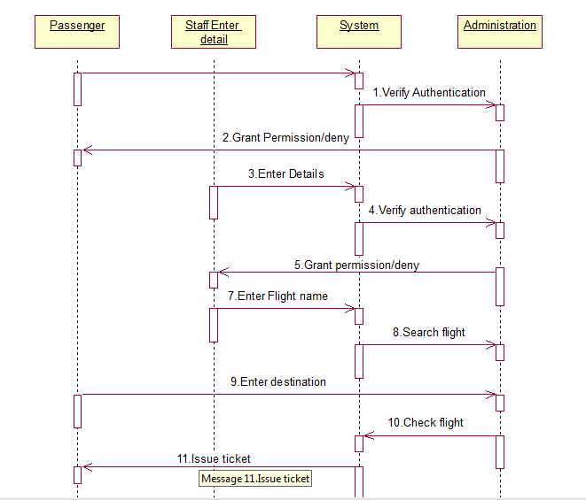

DEPLOYMENT DIAGRAM

Web server

Client server

COMPONENT DIAGRAM

Data base of flight

User interface

TESTING

|  |  |  |  |  |
| --- | --- | --- | --- | --- |
| FORM NAME | INPUT | EXPECTED OUTPUT | ACTUAL OUTPUT | STATUS |
| MAIN MENU FORM | Menu Option | Required form must be displayed | Required form was displayed | Pass |
| TICKET AVAILABILITY FORM | Flight route or Flight name | Flight seats availability must be displayed | Flight seats availability are displayed | Pass |
| RESERVATION FORM | Personal details were entered | Ticket must be booked and database must be updated | Ticket was booked and database was updated | Pass |
| CANCELLATION FORM | Ticket number was entered | Ticked must be cancelled and database must be updated | Ticket was cancelled and database was updated | Pass |

**SAMPLE FORMS:**

* MAIN MENU FORM

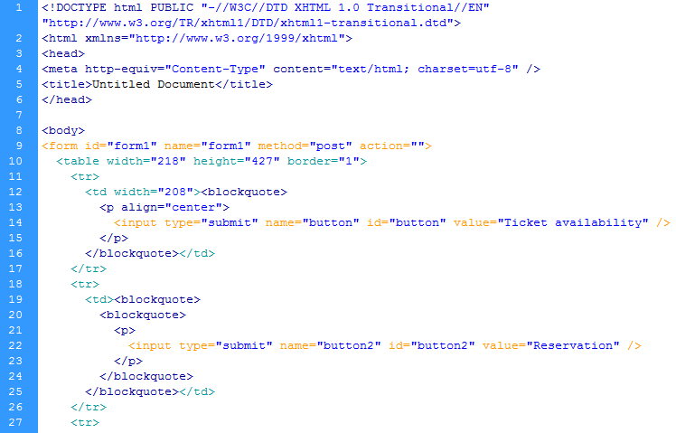

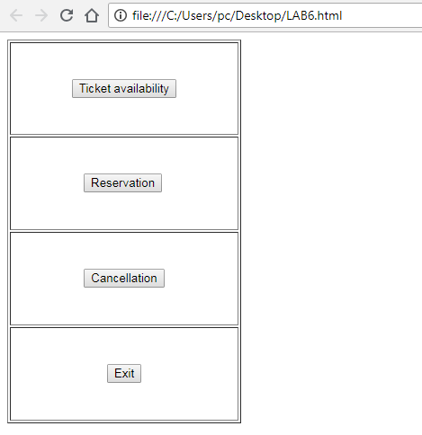

* TICKET AVAILABILITY:

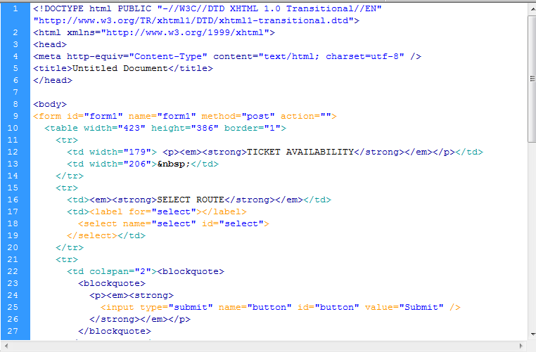

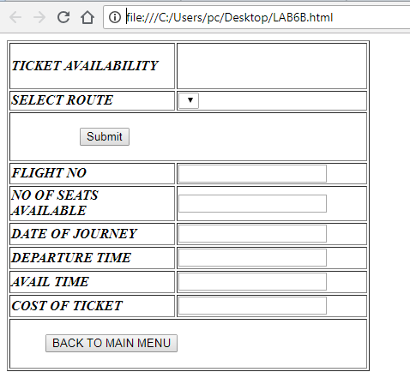

* CANCELLATION

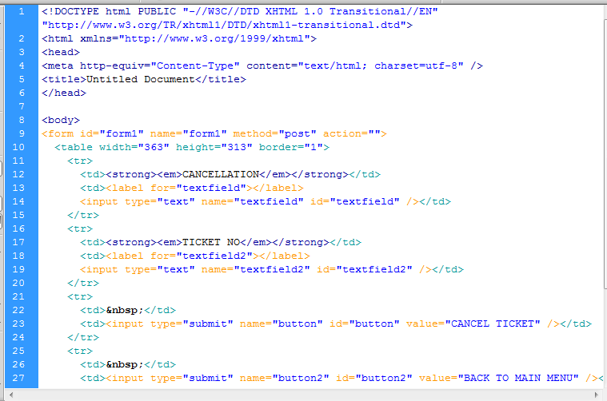

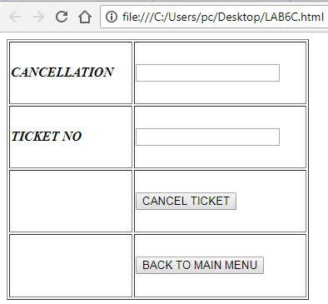

RESULT:

Thus the Airline Reservation System was implemented using the specified front end and back end tools.