**LAB # 6**

**File Uploading and Email system using PHP**

**TASK 1:**

Create a PHP Code to Upload Different types of files.

**Source Code:**

<?php

if(isset($_FILES['image'])){

$errors= array();

$file_name = $_FILES['image']['name'];

$file_size =$_FILES['image']['size'];

$file_tmp =$_FILES['image']['tmp_name'];

$file_type=$_FILES['image']['type'];

$file_ext=strtolower(end(explode('.',$_FILES['image']['name'])));

$extensions= array("jpeg","jpg","png");

if(in_array($file_ext,$extensions)=== false){

$errors[]="extension not allowed, please choose a JPEG or PNG file.";

}

if($file_size > 2097152){

$errors[]='File size must be exactly 2 MB';

}

if(empty($errors)==true){

move_uploaded_file($file_tmp,"images".$file_name);

echo "Success";

}else{

print_r($errors);

} }

?>

<html>

<body>

<form action="" method="POST" enctype="multipart/form-data">

<input type="file" name="image" />

<input type="submit"/>

</form>

</body>

</html>

**Output:**

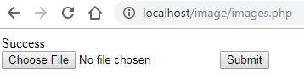



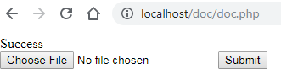

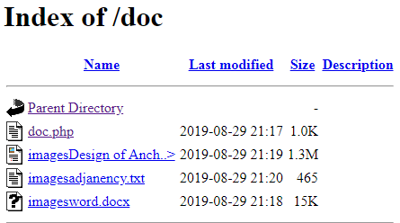

**TASK 2:**

Create a PHP Code to Send An Email to [Pbhatti@ssuet.edu.pk](mailto:Pbhatti@ssuet.edu.pk).

<html>

<head>

<title>Sending HTML email using PHP</title>

</head>

<body>

<?php

$to = "Pbhatti@ssuet.edu.pk";

$subject = "This is subject";

$message = "<b>This is HTML message.</b>";

$message .= "<h1>This is headline.</h1>";

$header = "From:omerhussain850@yahoo.com \r\n";

$header .= "Cc:afgh@somedomain.com \r\n";

$header .= "MIME-Version: 1.0\r\n";

$header .= "Content-type: text/html\r\n";

$retval = mail ($to,$subject,$message,$header);

if( $retval == true ) {

echo "Message sent successfully...";

}else {

echo "Message could not be sent..."; }

?>

</body>

</html>

**Output:**

