# Department of Computer Science

**CS220: Database Systems**

**End Semester Project Report**

**Group Members:**

**Momin Rauf (366523)**

**Ahsan Ullah (368319)**

**Jazib (394006)**

**Class: BESE 12-A**

**Instructor: Sir Shah Khalid**

# Date: January-5th-2023

**FIFA Management System**

***Abstract***

*The purpose of this project is the development of the FIFA World Cup Management system. This system provides Flight Reservation System and Accommodation reservation system for the football fans and stores the information of the fans who purchase Accommodation and Flight Tickets through this Portal during the global event. The system has three modules i.e., Accommodation Reservation, Flight Reservation and FIFA Store Management.*

*The technologies used during the development of this project are PYQT Creator for the Front End, Python and PYQT5 at the backend and MySQL for Database.*

***Introduction***

*The objective of this Management system is to assist and facilitate the Football Fans all over the world by providing them a well-structured Accommodation and flight system along with FIFA store which helps the enthusiasts to support their team with the Merchandise and all Related Stuff. In this Era where time is the most precious asset it is quite hectic for the football fans to search and reserve accommodation and flights according to their needs. This platform Assists them to save their valuable time and get the best suitable deals on a single platform.*

***Proposed Methodology***

1. ***Tools***

* *PYQT5 creator*
* *MySQL workbench*
* *Vs Code*

***b) Technologies***

* *PyQT5*
* *SQL*
* *CSS*

***Reasons for using these tools:***

*PYQT5 creator provide user friendly interface for the front-end because of its in-built GUI builder. Also, it provides an easy-to-use Back end with python programming language.*

*We had prior experience and Skills in these tools so tried to extract best from it.*

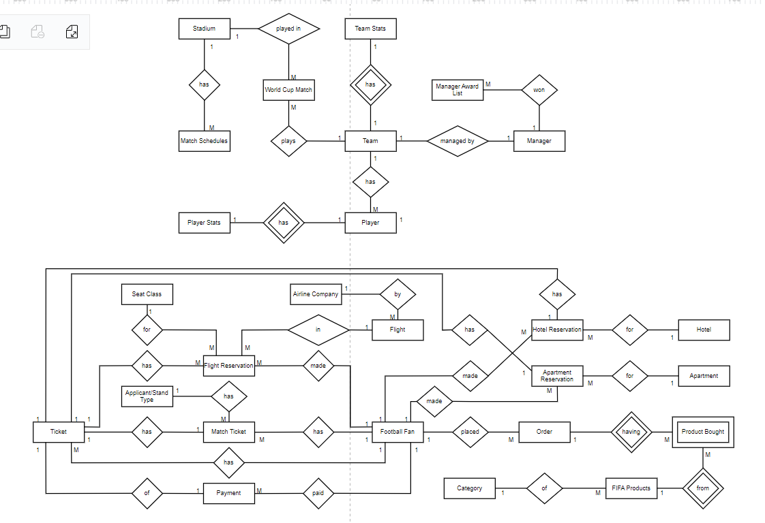***Hand-drawn ERD***

ERD

*NOTE: source file of ERD is attached*

***System-generated ERD (From workbench)***

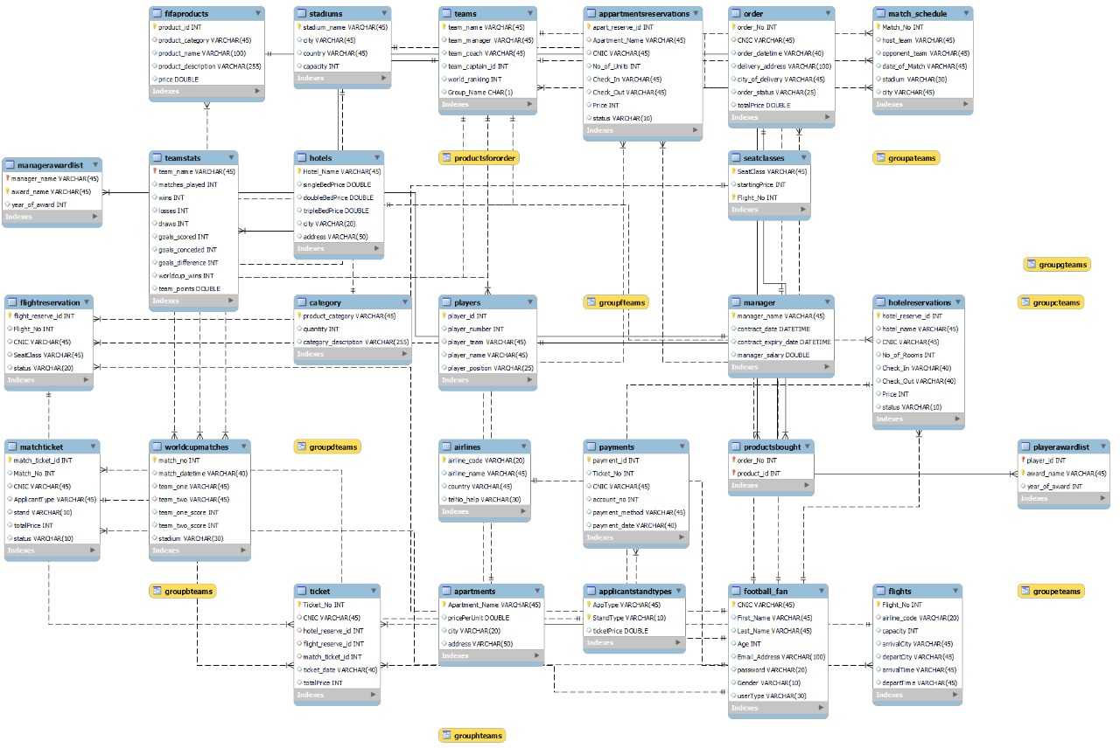

*NOTE: source file of ERD is attached*

***Database Statistics***

* ***Tables:*** *26*
* ***Views:*** *9*
* ***Stored procedures:*** *8*
* ***Triggers:*** *2*
* ***Users****: 4*

***Usage of database***

*A database was created with 26 number of tables to store the data for three of our main modules i.e., Accommodation Reservation System, Flight Reservation System and FIFA Store Management. Almost all the data that appeared on the interface of Customers, Accommodation Managers, Flight Managers, FIFA Store Managers was taken from the database.*

*Further Usage Includes:*

* *Customers*
  + *Can create accounts and log into their accounts through authentication from database entries*
  + *Can only reserve those flights and accommodation which are currently available, and these available flights are shown to him/her through database.*
  + *Can order any accessory from FIFA Store based on what is available. His/her confirmed and unconfirmed orders can be shown to him/her based on whether manager has approved it or not. This all is done through checks (attributes) in tables of the database.*
* *Accommodation Mangers*
  + *Can view the current hotel or apartment reservation requests and can approve and discard the requests, this all is done through the checks (attributes) in the tables of database.*
  + *Can add new hotels and apartments and those hotels and apartments will be shown to the customers. This all is done through the different operations of the database at the backend.*
* *Flight Managers*
  + *Can view the current flight reservation requests and can approve and discard the requests, this all is done through the checks (attributes) in the tables of database.*
  + *Can add new flights and airlines and all the added entries will be available to customers too. This all is done through the different operations of the database at the backend.*
* *FIFA Store Manager*
  + *Can view the current order of customers and can approve and discard the orders based on if it is available or not.*
  + *Can add new store items or products, and the added products will be available to customers too. This all is done through the different operations of the database at the backend.*

***Maintenance***

*Keeping in mind the maintenance of project, we have made our project in a well-organized and simple way, with all the necessary comments added so that we can avoid any kind of ambiguity in the future during maintenance procedure. Also, the database scripts for DDL, DML, Views, Authorization, Triggers, Stored Procedures have been kept separate.*

***Conclusion***

*After going through all the processes with proper teamwork we made a complete project with all the objectives required. All the Functional and Non-Functional requirements were integrated in it. This project made us grow in different academic and non-academic aspects.*

*The Project improved our Database Designing Capabilities, the programing logic and the debugging instincts by tackling a lot of bugs.*

*We got to learn how the things get managed in a massive event like FIFA world cup, The protocols Required after each Step in making a proper Management System at a large scale.*