CS436: Computer Vision Fundamentals

3D Scene Reconstruction and Virtual Tour

Group 33
Momin Fahed Khan 27100082
Rayan Kamran 27100039

Abstract
This project implements a three–phase Structure-from-Motion pipeline followed by an interactive “Photosynth-style” virtual tour. The system reconstructs camera poses and a sparse 3D point cloud from a sequence of images using feature correspondences, epipolar geometry, triangulation, and incremental pose estimation. Although the pipeline produced correct two-view geometry, the incremental SfM output was highly sparse due to texture deficiencies and low correspondence density across the datasets. After three rounds of data acquisition—including a tabletop scene, a full room, and finally a corner-of-room dataset—the sparse reconstruction remained insufficient for visualization. Therefore, a dense point cloud was generated using Agisoft Metashape and integrated into the final Three.js viewer. The viewer performs smooth transitions between camera poses using interpolated motion and cross-faded imagery, supported by a view graph describing camera connectivity.

GitHub Repository: https://github.com/Momin-fahed/CV_Project

1 Introduction
Estimating 3D structure from 2D photographs is a central task in computer vision and forms the basis of systems such as Google Street View, Matterport, and Microsoft Photosynth. Structure-from-Motion reconstructs camera poses along with scene geometry by exploiting multiview constraints.
This project uses a complete SfM pipeline divided into three phases:
1. Two-view geometry (feature matching, Essential matrix estimation, pose recovery, triangulation)
2. Incremental multiview SfM using 2D–3D correspondences and PnP
3. Development of a virtual interactive tour in Three.js
Although two-view results behaved as expected, the incremental SfM pipeline produced extremely sparse point clouds. A dense reconstruction was therefore generated using Agisoft Metashape and used as the geometric scaffold in the viewer.

2 Methodology
This section describes the mathematical formulation behind the reconstruction pipeline, including feature detection, two-view geometry, incremental SfM, and virtual tour implementation.

2.1 Feature Detection and Matching
Keypoints were detected using a scale- and rotation-invariant detector. Each keypoint x = (u, v) was assigned a descriptor d ∈ Rⁿ. Matches between images Iᵢ and Iⱼ were computed via nearest-neighbor search.

Lowe’s ratio test:
‖dᵢ − d₁‖ / ‖dᵢ − d₂‖ < 0.75
A mutual check enforced symmetric correspondences.
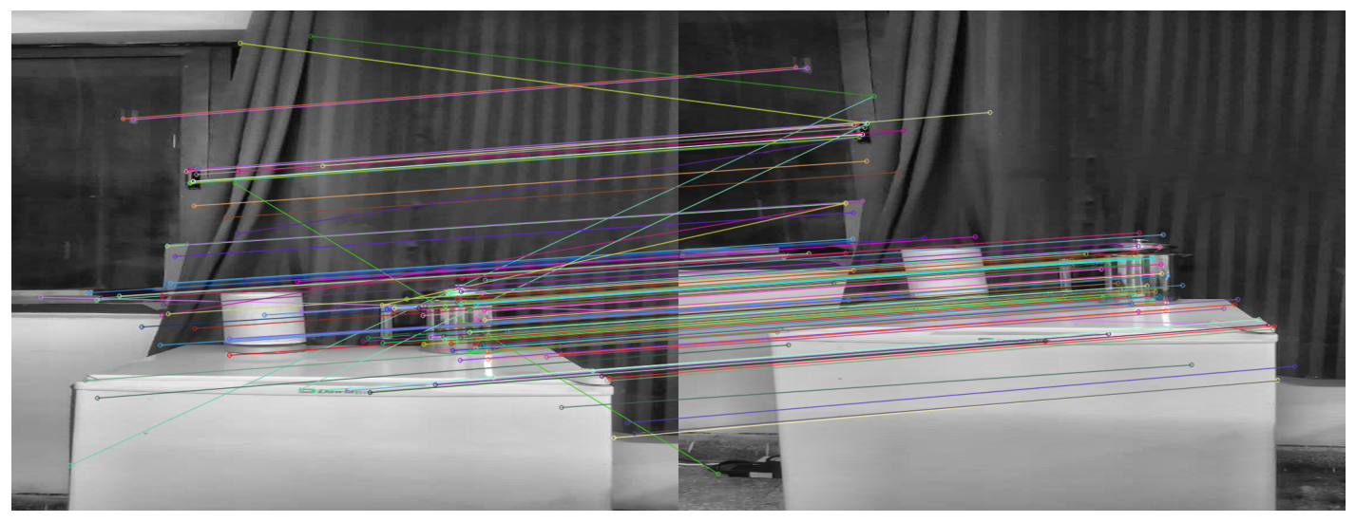
[Figure 1: Feature Matches for Phase 1 (using the original dataset)]

2.2 Phase 1: Two‑View Reconstruction
The Essential Matrix E was estimated from normalized coordinates. The epipolar constraint:
x̃ⱼᵀ E x̃ᵢ = 0
Pose was recovered from the decomposition E = [t]×R, selecting the solution satisfying the cheirality condition. Triangulation produced an initial sparse point cloud.

2.3 Phase 2: Incremental SfM
New views observed existing 3D points Xᵢ, forming 2D–3D correspondences:
xᵢⱼ ∼ K [Rⱼ | tⱼ] Xᵢ

PnP minimized reprojection error:
Σ ‖ xᵢⱼ − π(Rⱼ Xᵢ + tⱼ) ‖²

New points were triangulated and filtered by:
• High reprojection error
• Low parallax
• Negative depth
To refine the reconstruction and correct for drift, Bundle Adjustment (BA) was applied, simultaneously optimizing all camera poses and 3D point locations to minimize overall reprojection error.
Despite correct pose recovery, reconstructions remained extremely sparse.
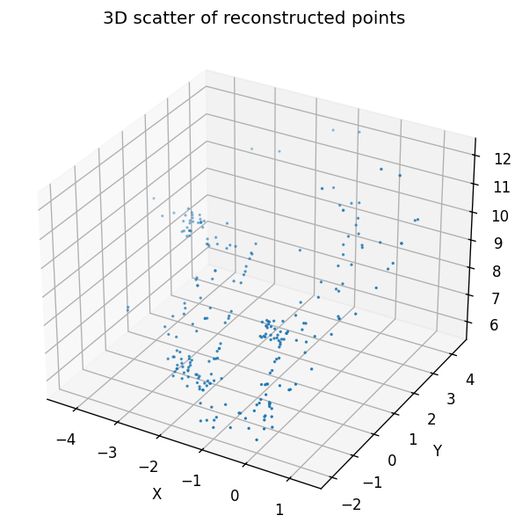
[Figure 2: Sparse Map Output in Phase 2 using Incremental SFM]

2.4 Phase 3: Photosynth‑Style Viewer
The final phase involved creating an interactive virtual tour using the reconstructed sparse map. To enhance visual fidelity, we generated a dense 3D point cloud from our images using Agisoft Metashape, which computes per-image depth maps to densify the scene. The dense point cloud provided a richer geometric structure, allowing us to extract textures directly from the original images, which were then applied to the reconstructed geometry.
Using this textured dense model, we built a Photosynth-style viewer where camera poses from the SfM pipeline were used as navigation nodes. The viewer interpolates camera positions (via linear interpolation, lerp) and orientations (via spherical linear interpolation, slerp) for smooth animated transitions between views. The dense, textured point cloud was rendered during navigation to provide a realistic sense of depth and 3D motion.

3 Experiments and Results
We iteratively captured and tested three datasets:
1. Tabletop Dataset — Good two-view results but too little parallax for incremental SfM.
2. Full-Room Dataset — Mostly textureless, leading to near-total feature loss.
3. Corner-of-Room Dataset — Best performance but still too sparse for visualization.
Across all datasets, the pipeline computed correct geometry and poses but produced point clouds too sparse for a virtual tour. This motivated the shift to Agisoft Metashape for dense reconstruction.

4 Discussion
Sparse reconstruction failed due to:
• Textureless planar surfaces
• Repetitive patterns
• Insufficient parallax
• Accumulated PnP drift

Metashape succeeded because it uses:
• Dense multiview stereo
• Patch‑based depth expansion
• Depth‑map fusion
This allowed recovery of continuous surfaces missing in our sparse reconstruction.

5 Conclusion

The project implemented a complete SfM pipeline and an interactive virtual tour. Although two-view geometry and pose estimation were accurate, sparse point clouds remained insufficient for visualization even after multiple dataset iterations. A dense point cloud generated via Agisoft Metashape was integrated into the viewer, enabling smooth navigation with interpolated pose transitions and cross‑faded imagery. The final system demonstrates a hybrid approach: algorithmic camera pose recovery combined with dense geometry from an external MVS engine.

