**FORMAN CHRISTIAN COLLEGE (A CHARTERED UNIVERSITY)**

**COMP421: Information Security**

**Section B**

**Assignment-1**

**List of Running Processes**

**Momina Binte Asad 251694202**

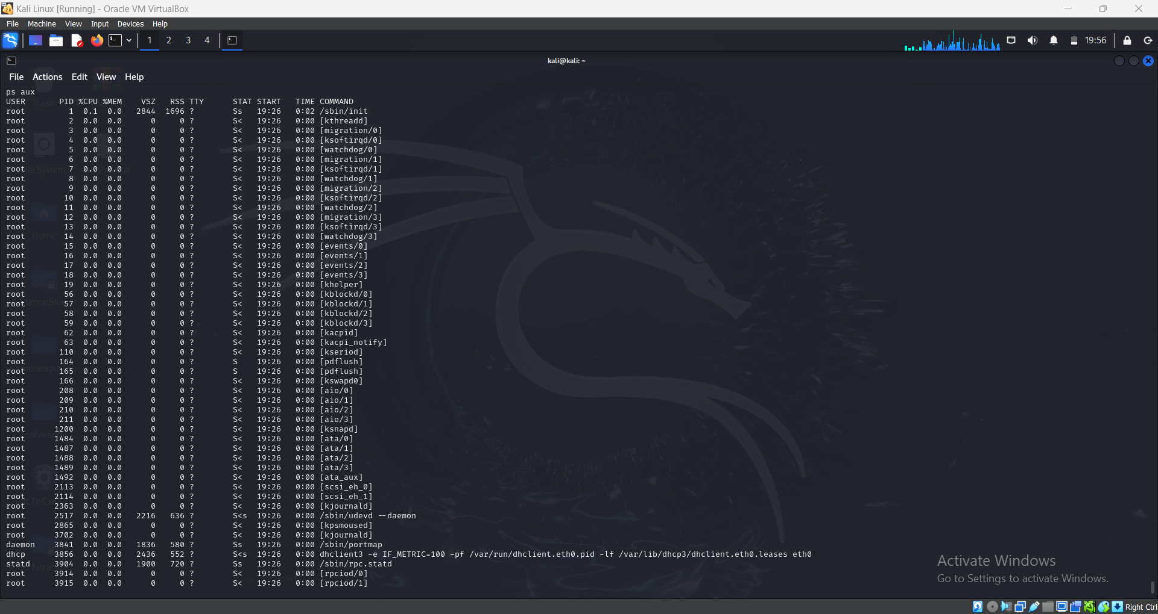**List of processes on METASPLOITABLE 2:**

