**FORMAN CHRISTIAN COLLEGE (A CHARTERED UNIVERSITY)**



**Comp 421(B)**

**Fall 2024**

**Assignment 2**

**Information Security**

**Screenshots of Outputs**

**Momina Binte Asad 251694202**

1. Generate a private and public key

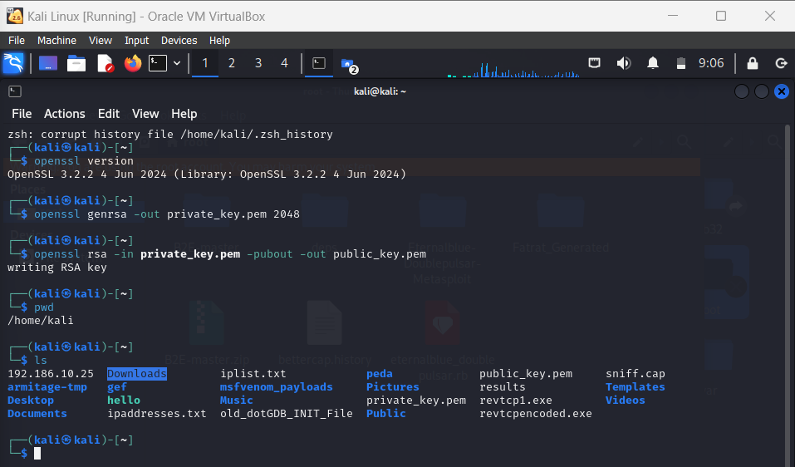

NOTE: the commands pwd and ls and were used to verify if the keys were generated.

1. Generate a Certificate Signing Request (CSR)

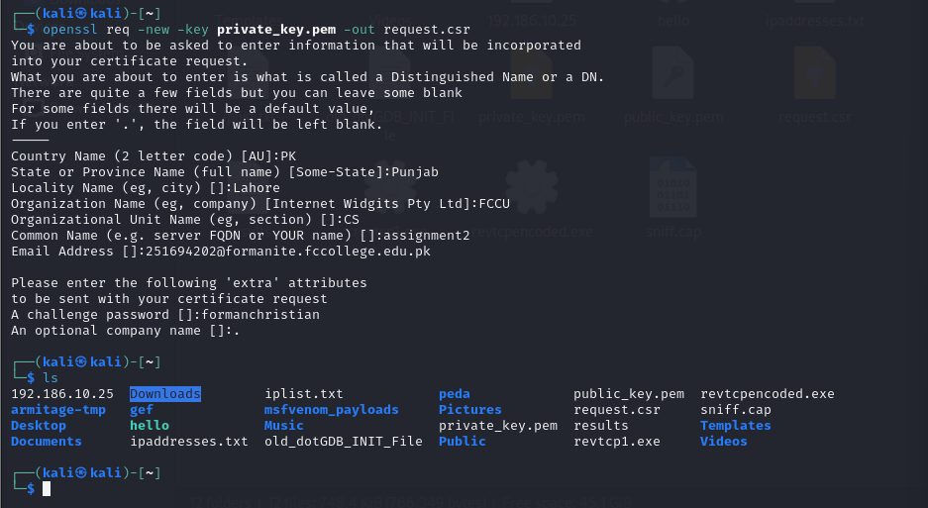

1. Create a self-signed certificate

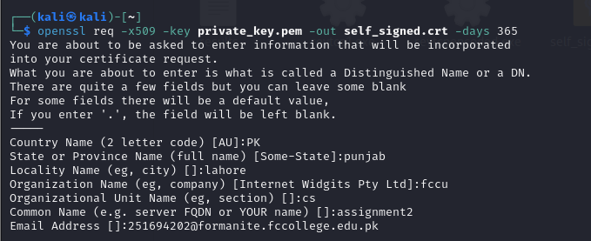

1. Act as a Certification Authority (CA) to issue certificates.

