***CS221033 | ILF ALI MOMIN | BSCS-2D***

***LAB WORK***

*Demo1*

import java.lang.Exception;

public class Demo {

public static void main(String[] args) {

int nums[] = new int[4];

try {

System.out.println("Before Exception is generated.");

nums[7] = 10;

System.out.println("This won't be displayed");

}

catch (ArrayIndexOutOfBoundsException exc){

System.out.println("Index out of bounds!");

}

System.out.println("After catch statement.");

}

}

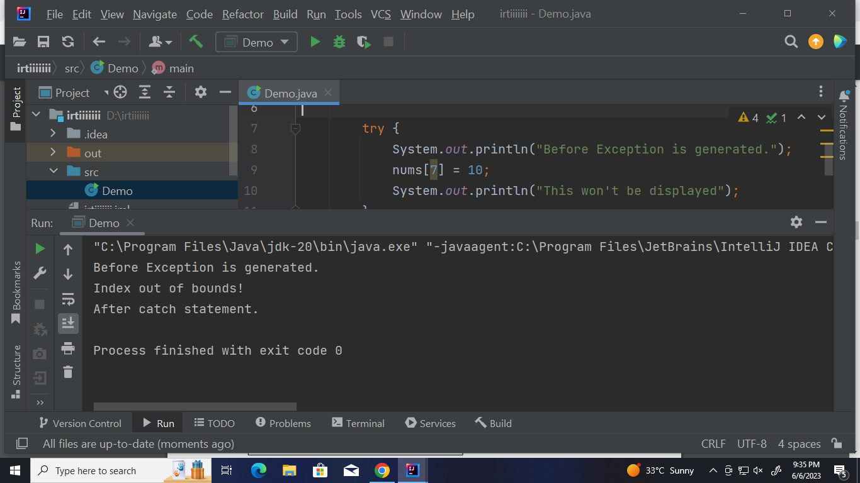

*Demo2*

import java.lang.Exception;

public class Demo1 {

public static void main(String[] args) {

int numer[] = {4, 8, 16, 32, 64, 128, 256, 512};

int denom[] = {2, 0, 4, 4, 0, 8};

for (int i = 0; i < numer.length; i++) {

try {

System.out.println(numer[i] + "/" + denom[i] + "is" + numer[i] / denom[i]);

} catch (ArithmeticException exc) {

System.out.println("Can't divide by zero");

} catch (ArrayIndexOutOfBoundsException exc) {

System.out.println("No matching element found");

}

}

}

}

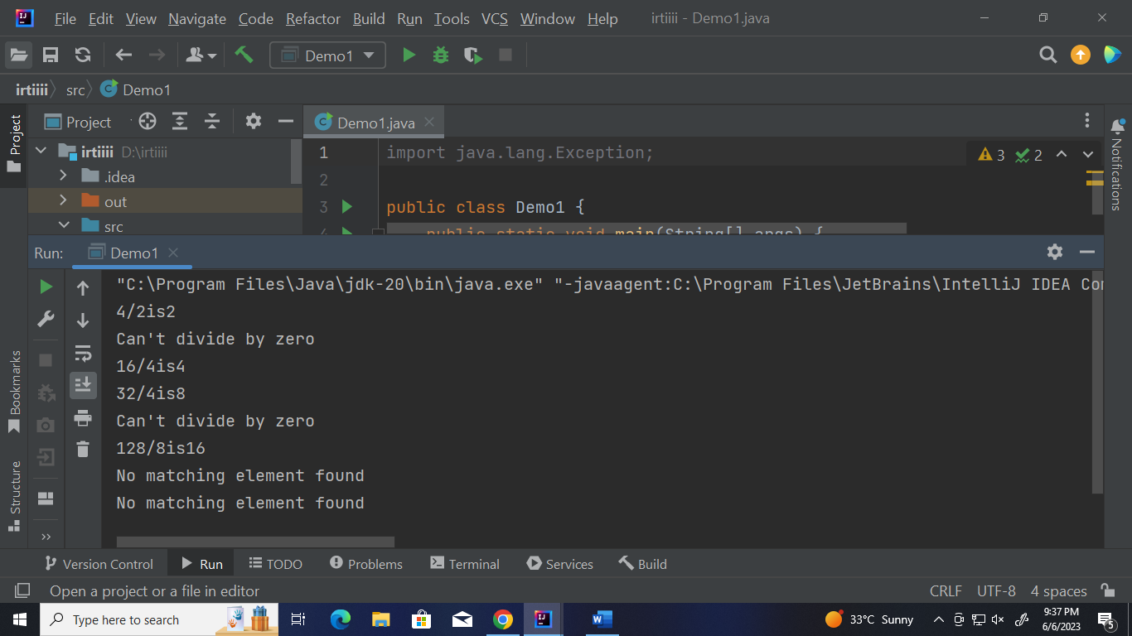

*Demo3*

import java.lang.Exception;

public class Demo3 {

public static void main(String[] args) {

int numer[] = {4, 8, 16, 32, 64, 128, 256, 512};

int denom[] = {2, 0, 4, 4, 0, 8};

try{

for (int i = 0; i < numer.length; i++) {

try {

System.out.println(numer[i] + "/" + denom[i] + "is" + numer[i] / denom[i]);

} catch (ArithmeticException exc) {

System.out.println("Can't divide by zero");

}}} catch (ArrayIndexOutOfBoundsException exc) {

System.out.println("No matching element found");

System.out.println("Fatal error - program terminated.");

}}}

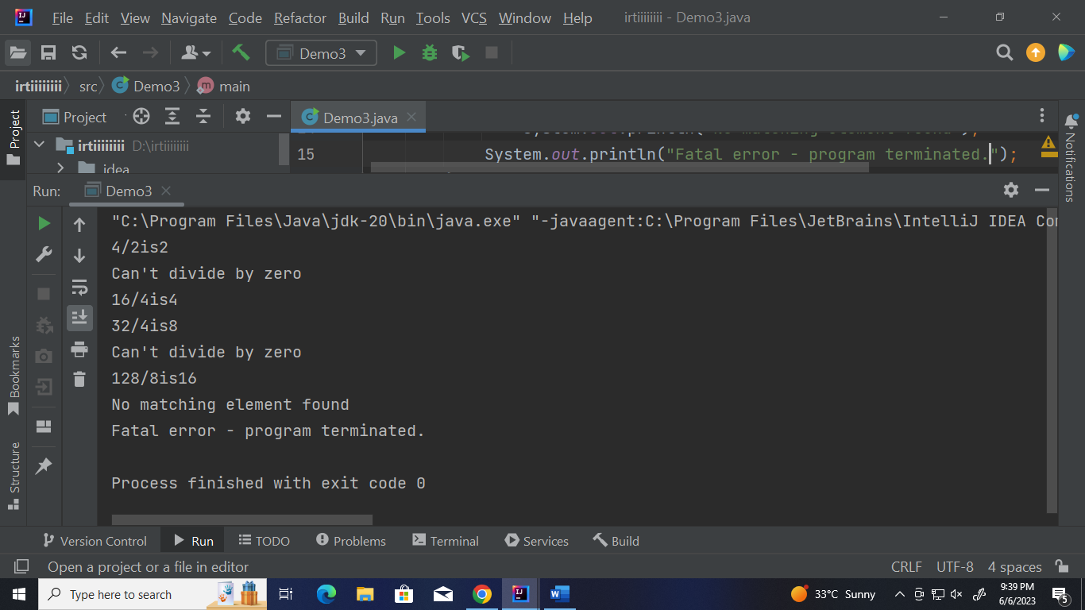

*TestThrown1*

import java.lang.Exception;

public class TestThrow1 {

public static void validate(int age) {

if (age < 18) {

throw new ArithmeticException("Person is not eligible to vote.");

}

else{

System.out.println("Person is eligible to vote.");

}

}

public static void main(String[] args)

{

validate(13);

System.out.println("rest of the code .. . . .");

}

}

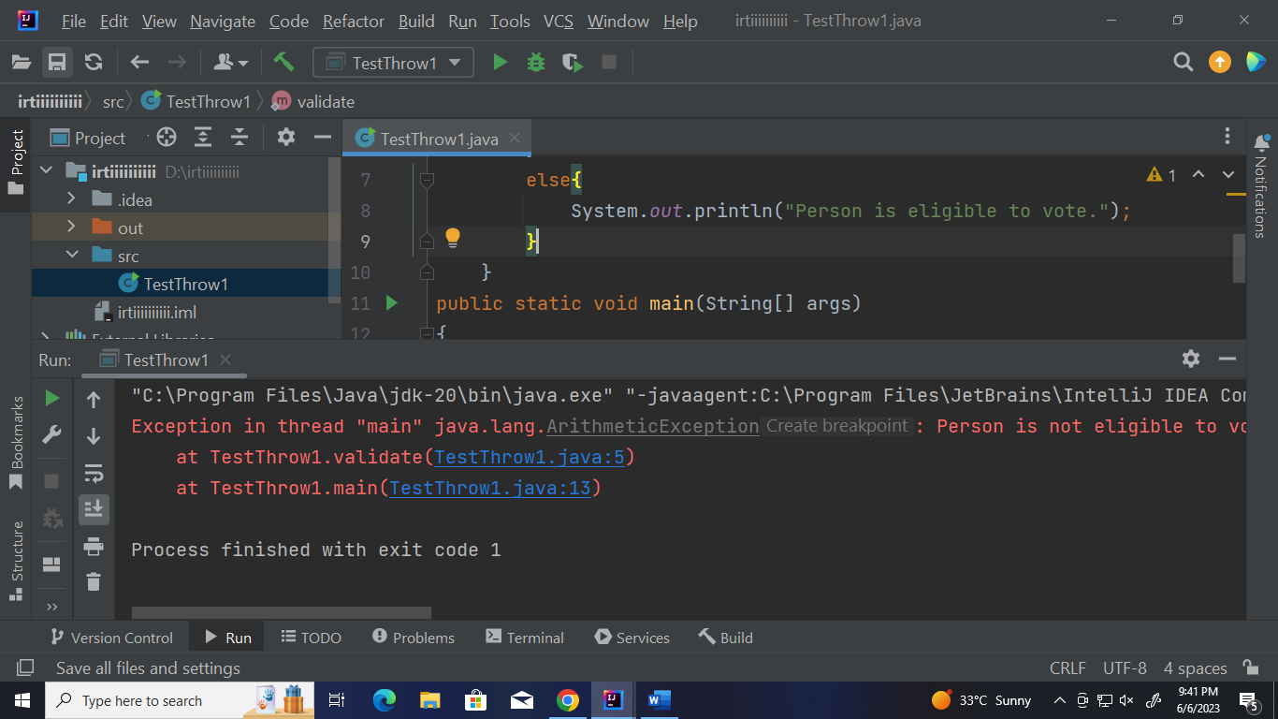

*TestThrown2*

import java.io.BufferedReader;

import java.io.FileNotFoundException;

import java.io.FileReader;

import java.lang.Exception;

public class TestThrow2 {

public static void method() throws FileNotFoundException{

FileReader file = new FileReader("D:\\abc.txt");

BufferedReader fileInput = new BufferedReader(file);

throw new FileNotFoundException();

}

public static void main(String[] args)

{

try{

method();

}

catch (FileNotFoundException e) {

e.printStackTrace();

}

System.out.println("rest of the code. . . . . ");

}

}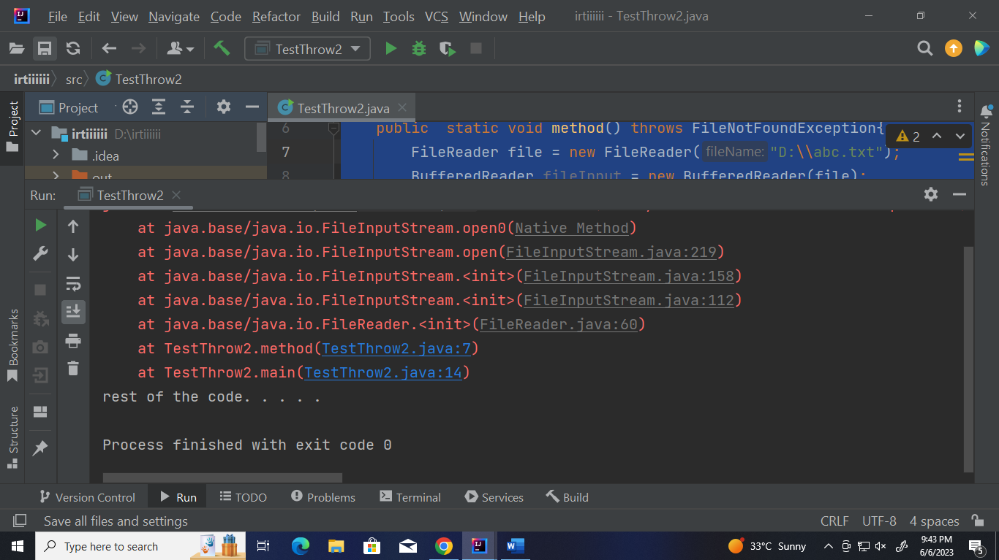

*Example 6*

import java.io.FileWriter;

import java.io.IOException;

import java.io.File;

public class CreateFile {

public static void main(String[] args) throws IOException

{

FileWriter f1 = new FileWriter("D:\\file1.txt");

f1.write("Hello world");

f1.close();

}

}

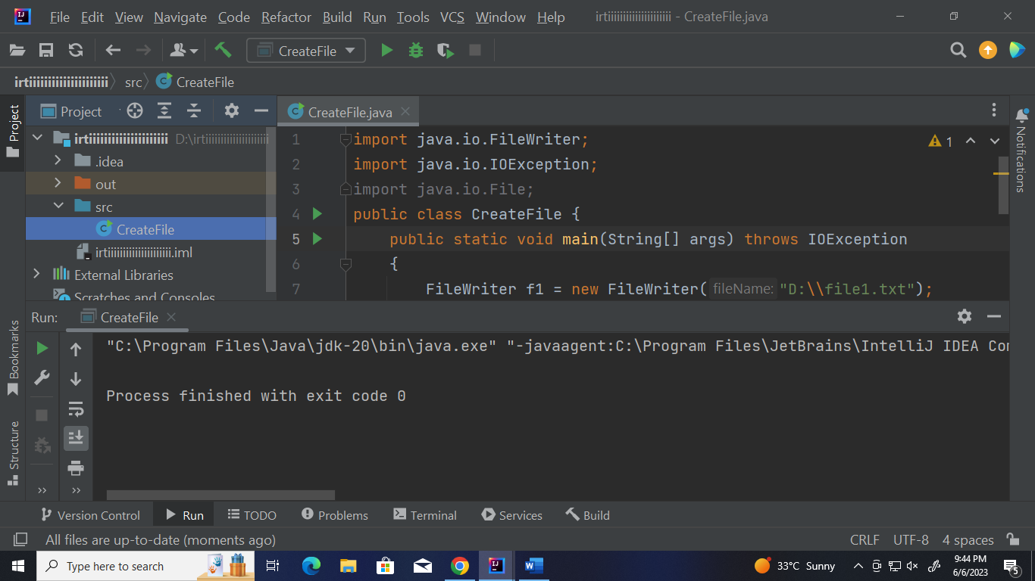

*Demo 5*

public class Demo5 {

public static void main(String[] args)

{

try{

int[] myNumbers = {1,2,3};

System.out.println(myNumbers[10]);

}

catch (Exception e){

System.out.println("Something went wrong");

}

finally {

System.out.println("The 'try catch' is finished.");

}

}

}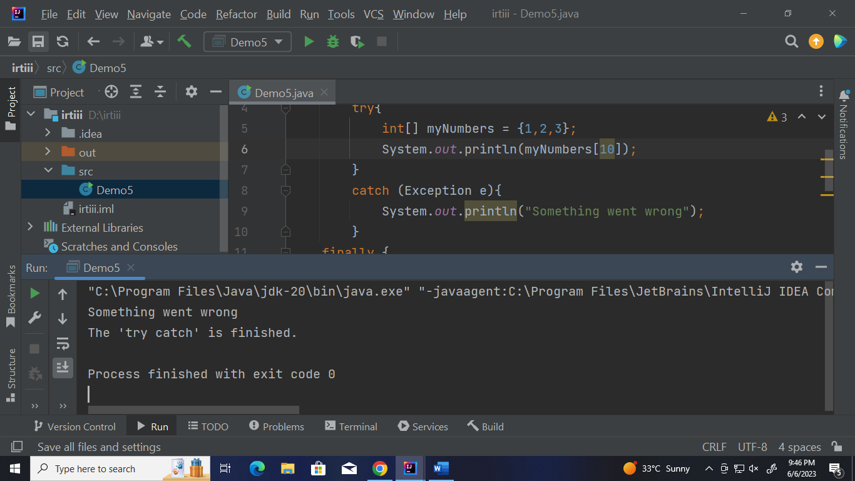

*CUSTOM EXCEPTION METHOD*

import java.lang.Exception;

public class TestThrow0 {

public static void validate(int age) {

if (age < 18) {

throw new ArithmeticException("Person is not eligible to Drive.");

}

else{

System.out.println("Person is eligible to Drive.");

}

}

public static void main(String[] args)

{

validate(19);

System.out.println("wrooom wroom wrommmmmmmmmmmmmmmmmmm");

}

}

