# LAB TASKS(OOP LAB )

# ILF ALI MOMIN

# CS221033

# **EXAMPLE 1**

import java.util.ArrayList;

public class GenericsImplementation { public static void main(String[] args) { ArrayList a1 = new ArrayList<>();

a1.add("Ali");

a1.add("Ahmed"); a1.add(10);

String s1 =(String)a1.get(0); String s2 =(String)a1.get(1); try {

String s3 = (String)a1.get(2);

}

catch (Exception e) { System.out.println("Exception: " + e);

}

}

}

**OUTPUT**

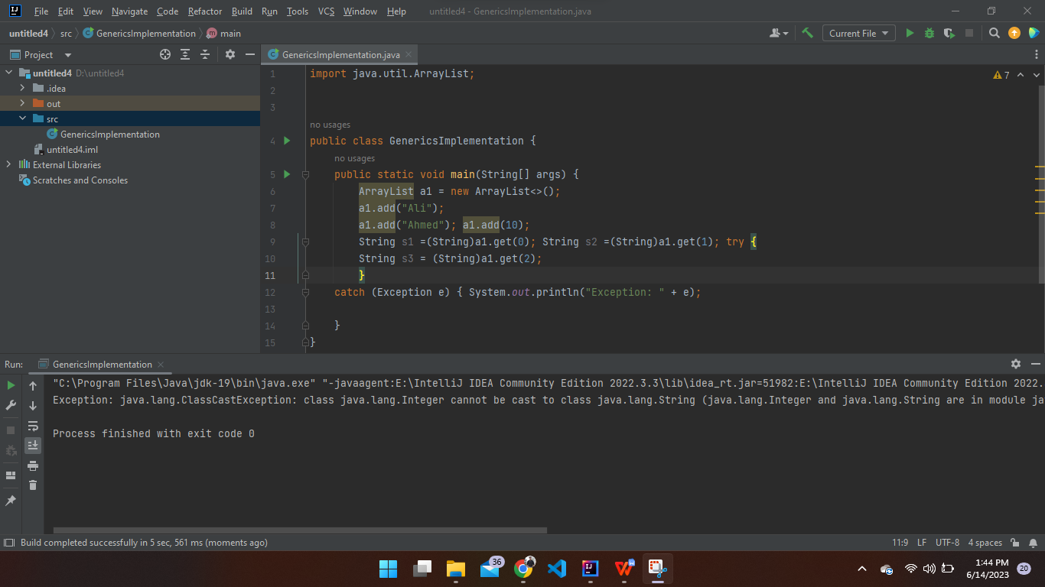

# **EXAMPLE 2**

public class GenericTest {

public static void main(String [] args) { ArrayList<String> a1 = new ArrayList<>();

a1.add("Ali");

a1.add("Ahmed");

a1.add(10);

a1.add("Hadi"); String s1 = a1.get(0); String s2 = a1.get(1); String s3 = a1.get(2);

System.out.println(a1); System.out.println(s1+ " " + s2+" "+s3);

}

}

**OUTPUT**

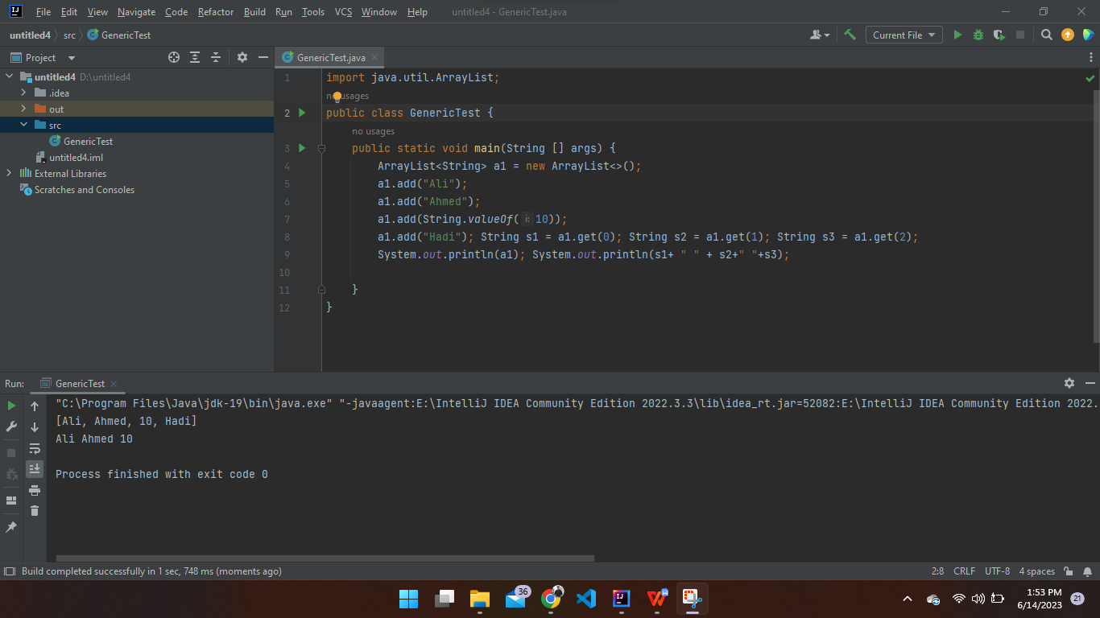

# **Lab task**

import java.util.LinkedList;

import java.util.List;

public class CustomerList {

public static void main(String[] args) {

// Create a list of 5 customers

List<Customer> customers = new LinkedList<>();

// Add customers to the list

customers.add(new Customer("Ilf Ali Momin", "momin@example.com"));

customers.add(new Customer("Mahir", "mahir@example.com"));

customers.add(new Customer("Taseeb", "taseeb@example.com"));

customers.add(new Customer("Mazhar", "mazhar@example.com"));

customers.add(new Customer("Yameen", "yameen@example.com"));

// Iterate over the list and display name and email of each customer

for (Customer customer : customers) {

System.out.println("Name: " + customer.getName());

System.out.println("Email: " + customer.getEmail());

System.out.println();

}

}

}

class Customer {

private String name;

private String email;

public Customer(String name, String email) {

this.name = name;

this.email = email;

}

public String getName() {

return name;

}

public String getEmail() {

return email;

}

}

**OUTPUT**

