**AGRICULTURE**

AGRICULTURE is the science which deals with the production, processing, improvement, protection, marketing and extention of crops, livestock and fishes by the proper utilization of natural resources for the benefit of mankind.



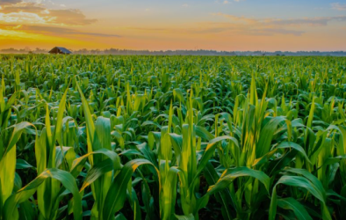

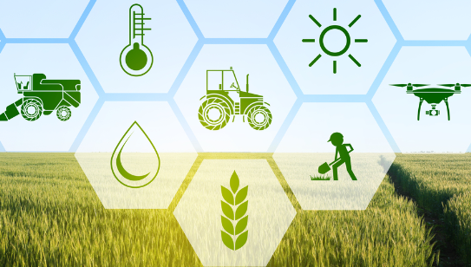

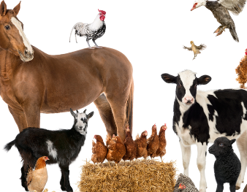

The agriculture sector is one of the key economic pillars of Bangladesh. Just after liberation in 1971,it’s contribution in GDP was around 60%.It is the most important sector in Bangladesh that helps with peoples livelihood, employment, and contributes to GDP, we all know that.

