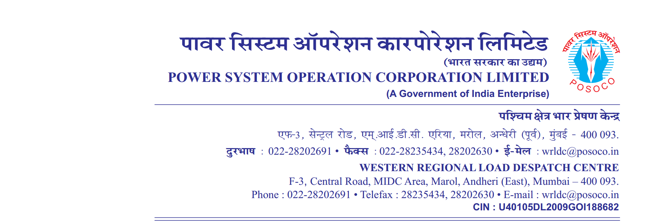

**साप्ताहिक विवरण**

Weekly Report वर्ष 2020-21/ सप्ताह संख्या 18 अवधि 01.Aug.2020 से 08.Aug.2020

Year 2020-21 / Week No 18 Period from 01.Aug.2020 to 08.Aug.2020

**C**. **मुख्य उत्पादक इकाइयों की अनुपलब्धता** Major Generating unit outages:

| **अनु क्रमांक**  **Sr. No** | **युनिट**  **Unit** | **संघटक**  **Constituent/**  **IPP** | **क्षमता Capacity**  **MW** | **से**  **From**  **समय दिनांक** | | **तक**  **To**  **समय दिनांक** | | **कारण**  **Reason** |
| --- | --- | --- | --- | --- | --- | --- | --- | --- |
|  |  |  |  | **Time** | **Date** | **Time** | **Date** |  |
|  | unit_name1 | owner1 | Capacity1 | 12:09 | 01-Aug-2020 | 15:38 | 06-Aug-2020 | REASON 1 |
|  | unit_name2 | owner2 | Capacity2 | 22:09 | 02-Aug-2020 | 25:28 | 06-Aug-2020 | REASON 2 |
|  | unit_name3 | owner3 | Capacity3 | 21:09 | 03-Aug-2020 | 03:38 | 06-Aug-2020 | REASON 3 |

**Note: Units out for more than 72 hrs are only included.**

D. परागमन का प्रतिबंध (यदि कोई हो) Transmission Constraints IEGC 5.5.1.C (D) (IF ANY) : Annexure-I

E. Instances of Persistent / Significant Non-Compliance of IEGC 5.5.1.C (E) : Annexure-II

F. Instances of Congestion In Transmission System IEGC 5.5.1.C (F) (IF ANY) : Annexure-III -NIL

G.कोणीय विभाजन उल्लंघन की रिपोर्टAngular separation violation **:** Annexure-IV

H**.** साप्ताहिक विद्युत दाब विचलन सूचकांकWeekly VDI From **:** Annexure-V



**( ABCD )**

**महाप्रबंधक**