Project Report
- One library function from src/simpl/interpreter/lib
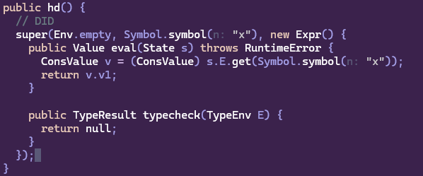

HD’s extends FunValue. So the constructor looks up ‘x’ in the environment that is being passed in. In the eval(), Consvalue v is pulled from memory using symbol x, and it returns v1 from the Consvalue(v1, v2) as the hd. A runtime error will get produced on the cast so it meets the spec.
It important to note that all of this is wrapped in super() because new Expr needs to be an anonymous object, it serves as a lambda essentially. This allows x to be binded by the interpreter and then evaluated later with this code. That x needs to be evaluated and bound to a ConsValue within the interpreter before the final evaluation to cast and retrieve v.v1 can occur.

TypeResult() just returns null, because the environment types it, not the expression itself, like it should already be typed in the typing environment.

- One function from src/simpl/interpreter/pcf
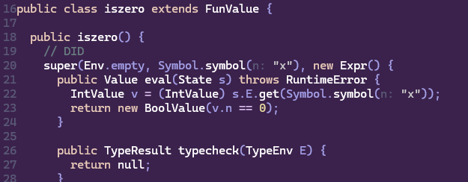

isZero extends FunValue again. Similar to hd, isZero uses an anonymous object new Expr() that allows the binding of the x before running an evaluation at a later time. But it actually follows the same flow, it just looks into the environment for x’s binding and casts it as an IntValue. That cast will error and cause the RuntimeError to be thrown per the spec and TypeResult() will return null as well.
The PCF classes were the building blocks of the arithmetic operations in the interpreter.

- Three values from src/simpl/interpreter
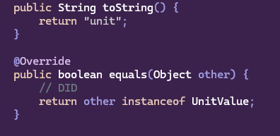
The unit class is about as simple as it gets but is also super important to the function of the program. The toString() simply returns unit, as per the spec. The equals() just check is other is instance of UnitValue bc any 2 UnitValues are the same.
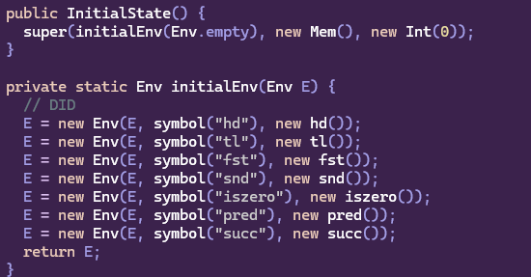
For InitialState class which extends State, the constructor just calls super() with the result of initEncv() method and a fresh Mem() and n=0. The InitialEnv simply created new environment with 7 names prebound in the environment. This is what allows you to just call iszero 5 without defining them. It also sort of goes back to my explanation of why pcf’s needed anonymous objects. These objects are created first into empty environments.
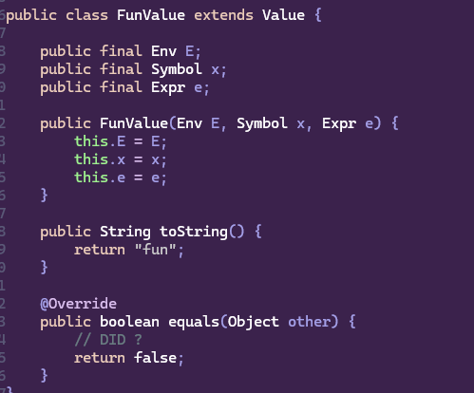
FunValue extends value. It has 3 fields and environment E,a symbol x,and an expression e. This is the closure representation. The toString() simply returns “fun” as per the project spec. The equals doesn’t need to evaluate anything. The way I look at it was that if 2 functions were equal then for what input? Id either have to prove that for any input they are equal, or for a specific input which is just eval() at that point. This returns false because equality is undecidable in general.
- Four expressions from src/simpl/parser/ast, including at least two from pure lambda calculus
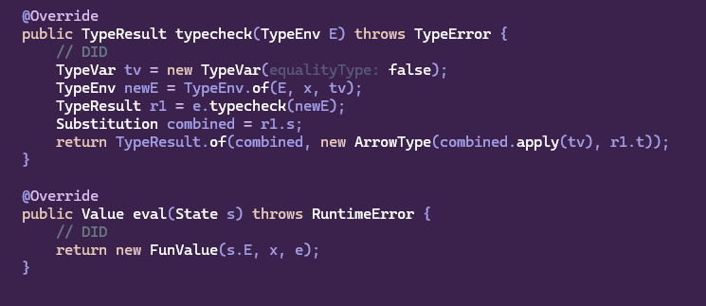
From Lambda Calculus we have Fn.java. Starting with eval(), it is really elegant and simple. It just returns the current environment plus the parameter and body and forms the closure.
Typecheck is a bit more involved. Typecheck created a fresh type variable tv to represent the unknown parameter x. we then extend the type environment with x:tv. We then typecheck the expression e with x now in the environment, creating a substitution r1. We then apply the substitution to tv to get a fully resolved type. And finally return an arrow type.
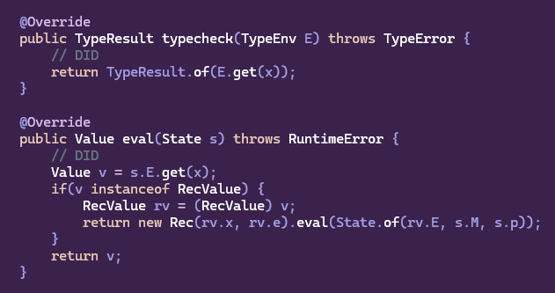
The second class from lambda calculus is Name.java. The typecheck() method is very simple. It just looks up x in the environment and returns its type.
Eval() is more interesting. We have 2 rules, and the simplest one is E(x)=v->v. You notice that if v is not a revord value it simply returns the v gather from the environment. Corresponding to Ename2, if v is a RecValue, Then we cast it as such, and return a new Rec. This return is recursive that when it triggers it will reevaluate the state.
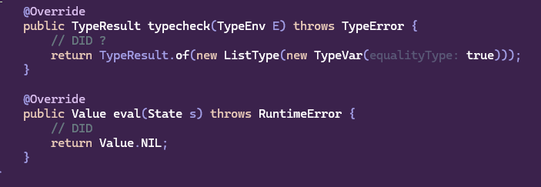
Nil.java is a simple one too. As far as typecheck() goes, it returns the typeresult of new ListType with a fresh TypeVar that is passed the true arg. This is necessary so that nil can be compared with ‘=’. And it is also a list type. Eval() simple return the NIL value.
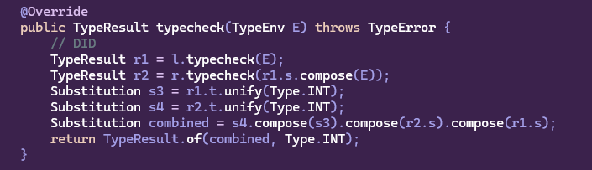
This is ArithExpr.java. An important note is that .unify() will TypeMismatch error meeting or project spec. I used that fact a lot during the project. But typecheck simply checks left. Then checks right within the context of the typresult from left. We then unify both as Type.INT, and creating substations in the process. And from there we combine them , and return a Type.INT as a result.
- Four types from src/simpl/typing
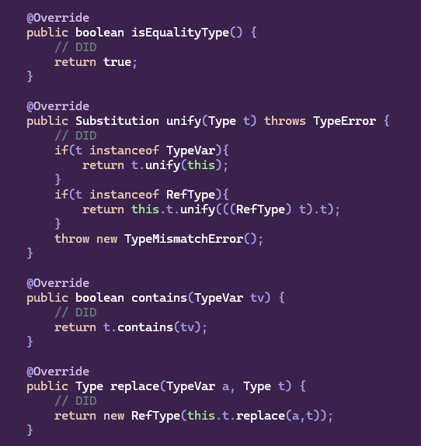
The above snippets are form RefType.java. Equality returns true as references can be compared. Unify will check if the inner type is a TypeVar. If it is then it bind that type to the ref to get ref t. If t is another ref type, then if tries to unify both inner types so ref int and ref int would be ok but ref int and ref bool for example would fail. Contains checks if a type variable appear inside the reference type. Replace just substitutes t with a inside the reference returning a new RefType.
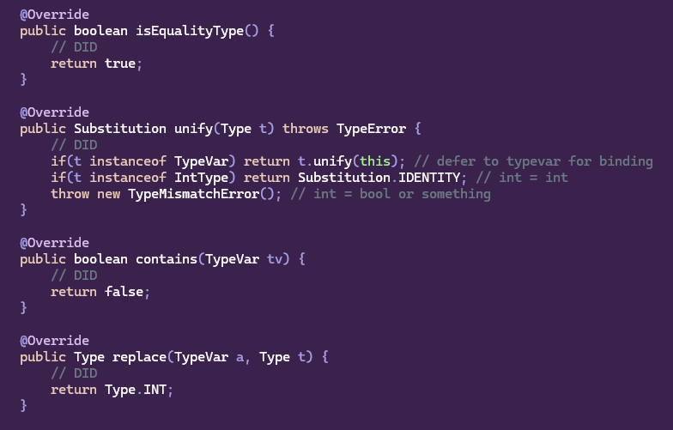
Next is a code snipper from IntType.java. isEquality() returns true because IntTypes are comparable with ‘=’. Next, Unify() will check if argument t is a TypeVar. If it is then is bind that to the current object. If t is an int, then it returns the identity substitution int = int. anything else is a TypeMismatchError as per the spec.

Contains() returns false because IntType is a concrete type. For the same reasons replace return Type.INT because there is no TypeVariables to replace.

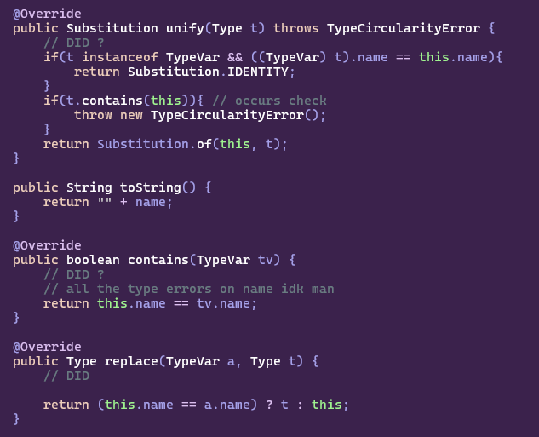
The next to snippet is from TypeVar.java. This one is really important. Starting with the unify() method, it checks 3 cases:
If t is the same TypeVar by name and type then return IDENTITY.
If t.contains(this) – our occurs check. Throws a TypeCircularityError()
Otherwise it substitute this with t actually performing the type inference step.
Contains just checks if the variables name matches the type variables name.
Replace checks f this variable's name matches a, return the replacement type t, otherwise return this unchanged. This is how substitutions get applied.
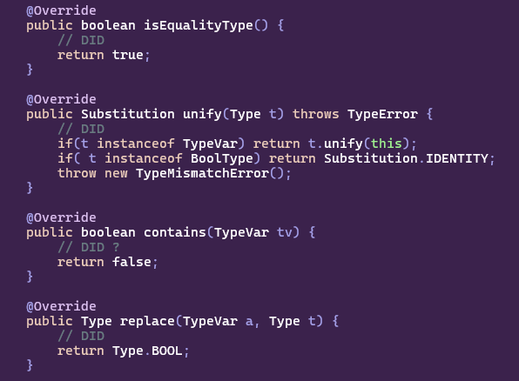
This snippet is from BoolType.java. It follows a similar patter to IntType. It is an equality type so isEqualitytype() returns true.
The unify() method checks if t is a TypeVar, if yes then is bind it the current object.
If t is a BootType it returns the IDENTITY, as bool = bool. Anything else will be a TypeMisMatchError().
Booleans are a concrete type so they do not by nature contain any type variables.
Therefor contains returns false. Replace has nothing to substitute so it always returns Type.BOOL.

