E-Commerce Database System Project Report
Introduction
This report details the implementation of an SQL database for a simplified e-commerce system. The database structure supports core functionalities and efficiently handle data related to customers, orders, products, categories, inventory, and suppliers. The interrelation between these tables is crucial for the system's performance and is represented in the schema.
Database Schema Overview
The schema comprises seven key tables:
- customers: Contains customer information.
- orders: Records details of customer orders.
- order_details: Manages individual items within an order.
- products: Catalogs products available for sale.
- categories: Categorizes products.
- inventory: Tracks product quantities and supplier relationships.
- suppliers: Lists suppliers and their contact information.
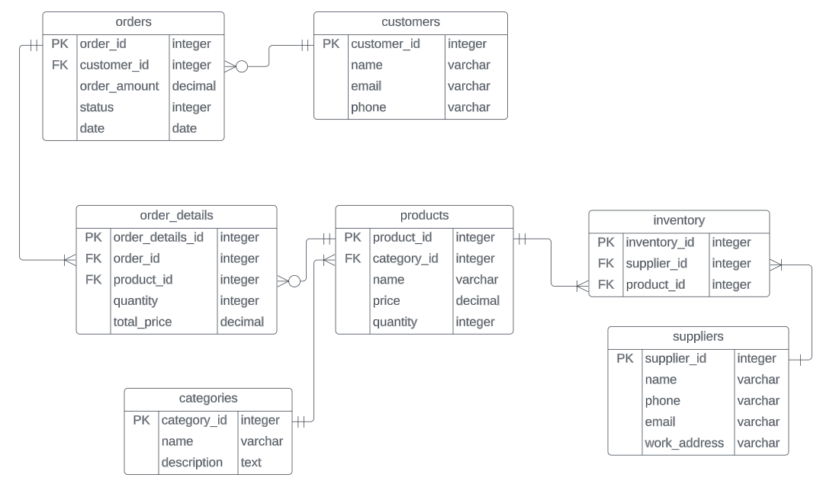
SQL Query Implementations
- Insert Data Queries:
Each insert statement adds data into the respective tables.
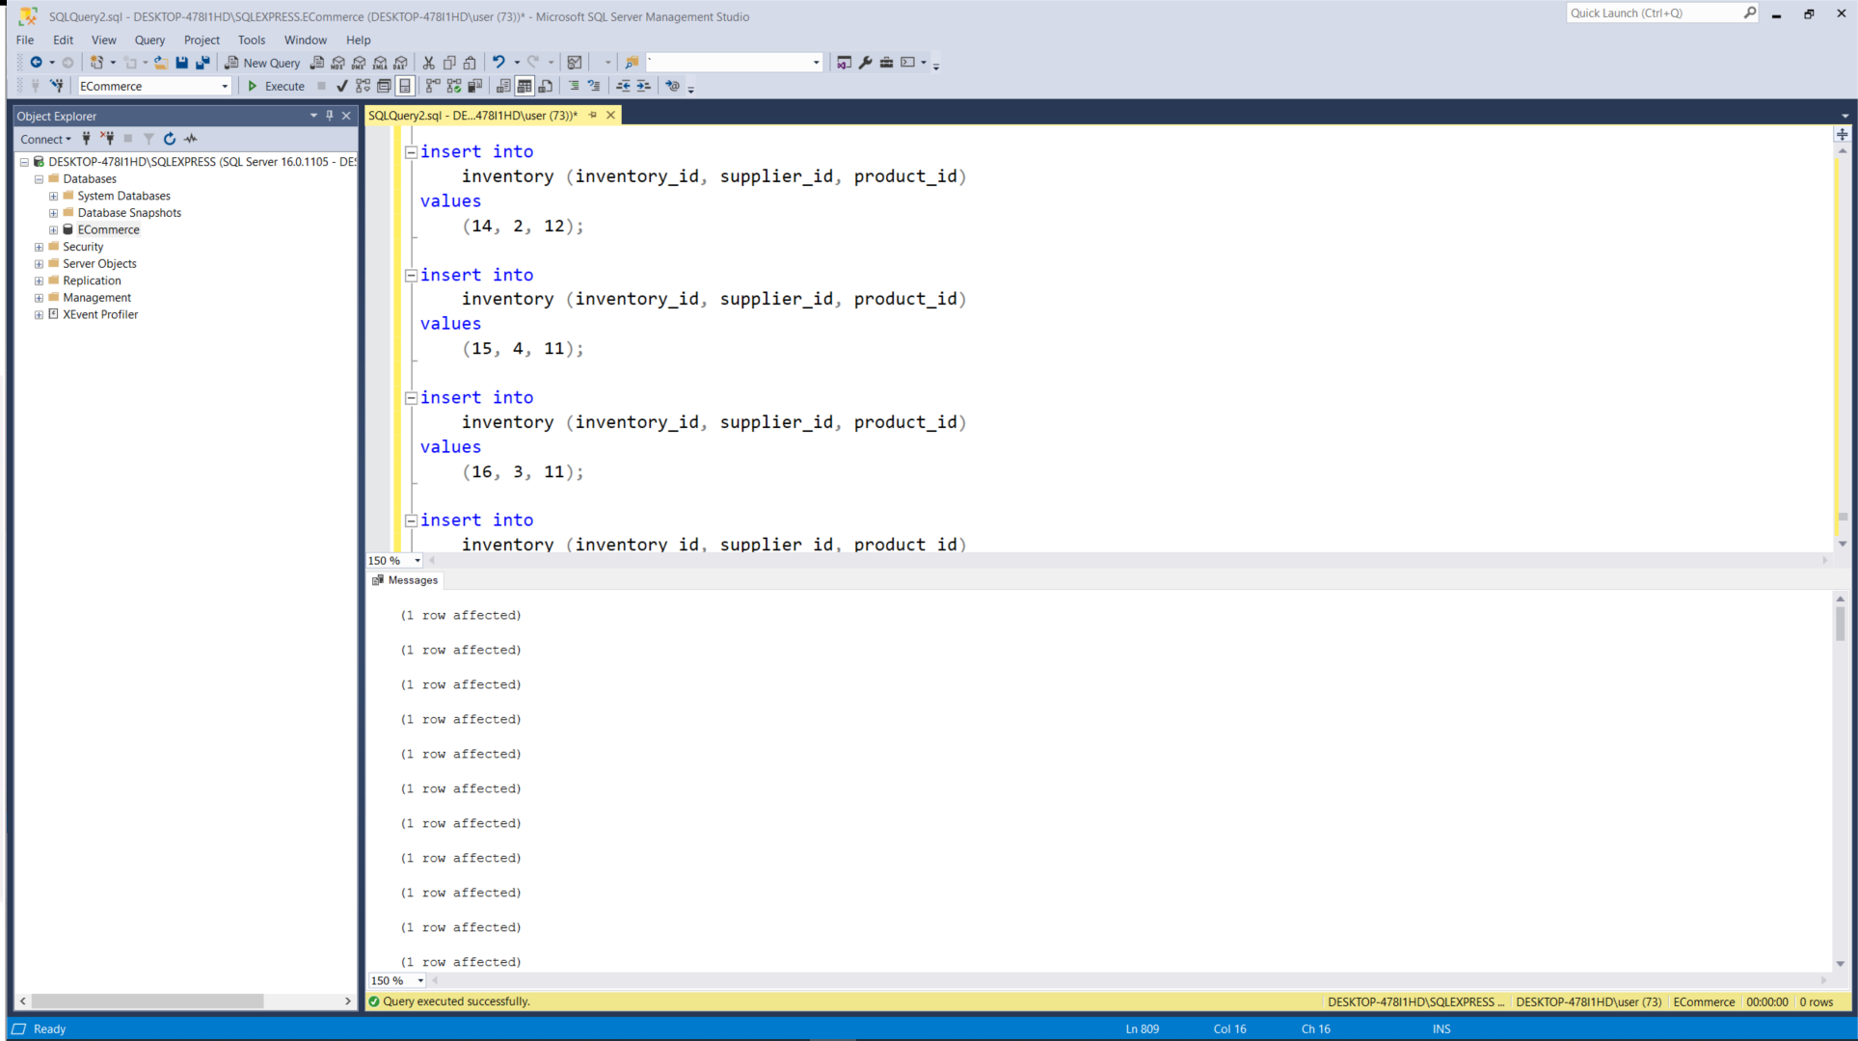
- Select Data Queries:
These queries retrieve all records from the tables.
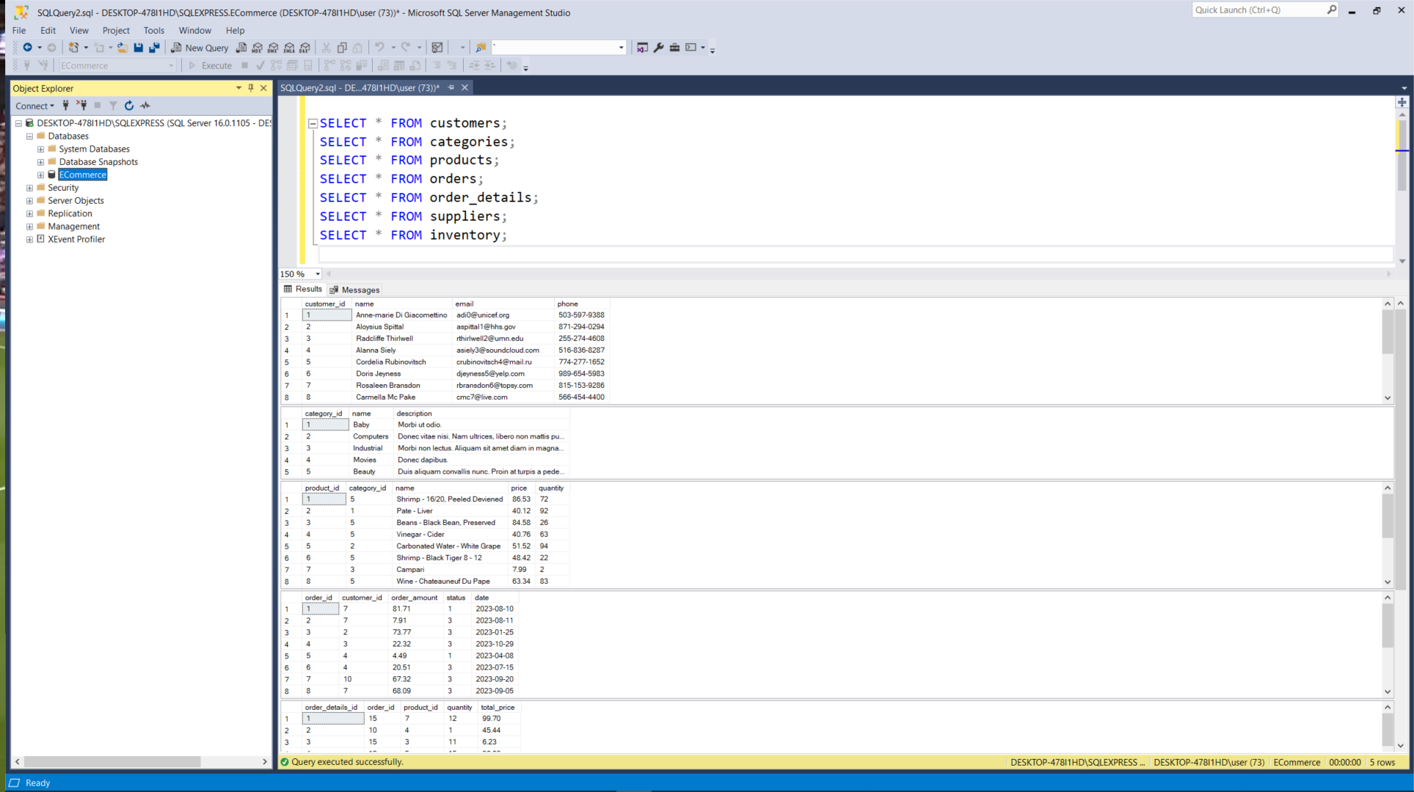
- Update and Delete Commands:
The first query updates the status of an order, and the second deletes a customer record.
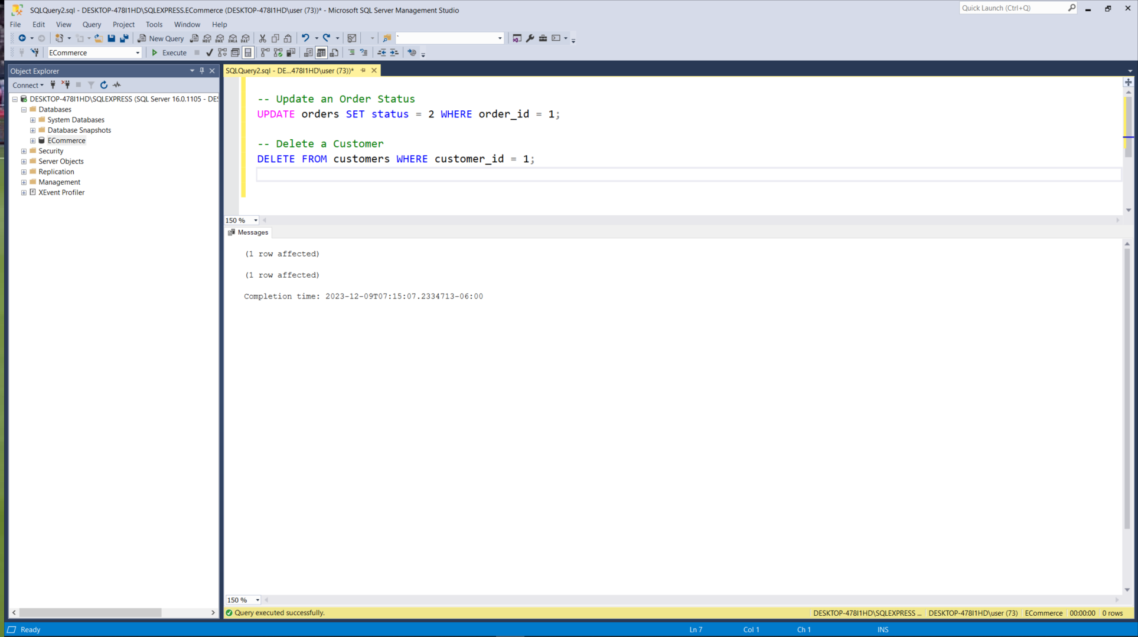
- Where, Order By, And, Or Commands:
Retrieves products with a price between 50 and 100 or any product whose quantity is less than 20, sorted alphabetically by name.
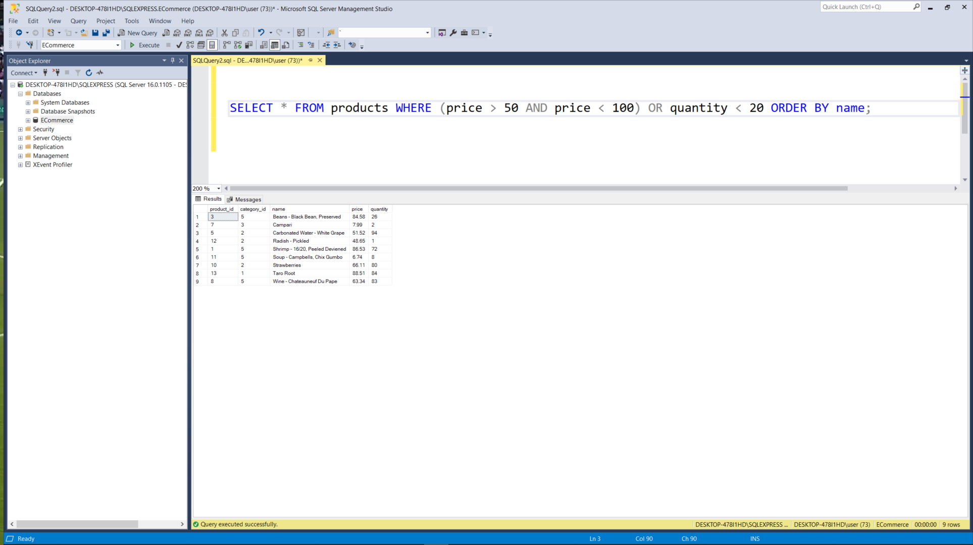
- Min, Max, Count, Sum, Avg Commands:
Calculates the minimum, maximum, total count, sum, and average of order amounts.
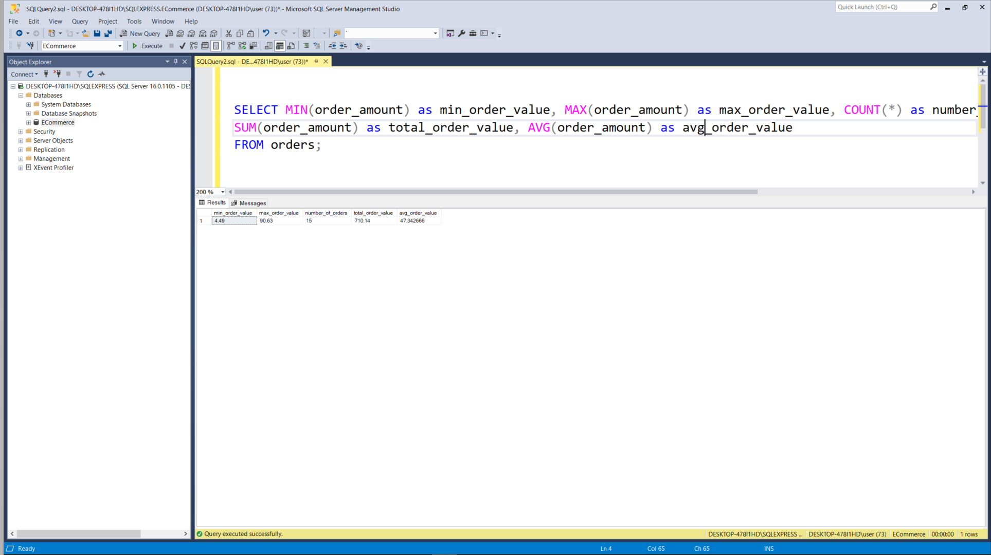
- Like Command:
Searches for customers whose names start with 'A'.
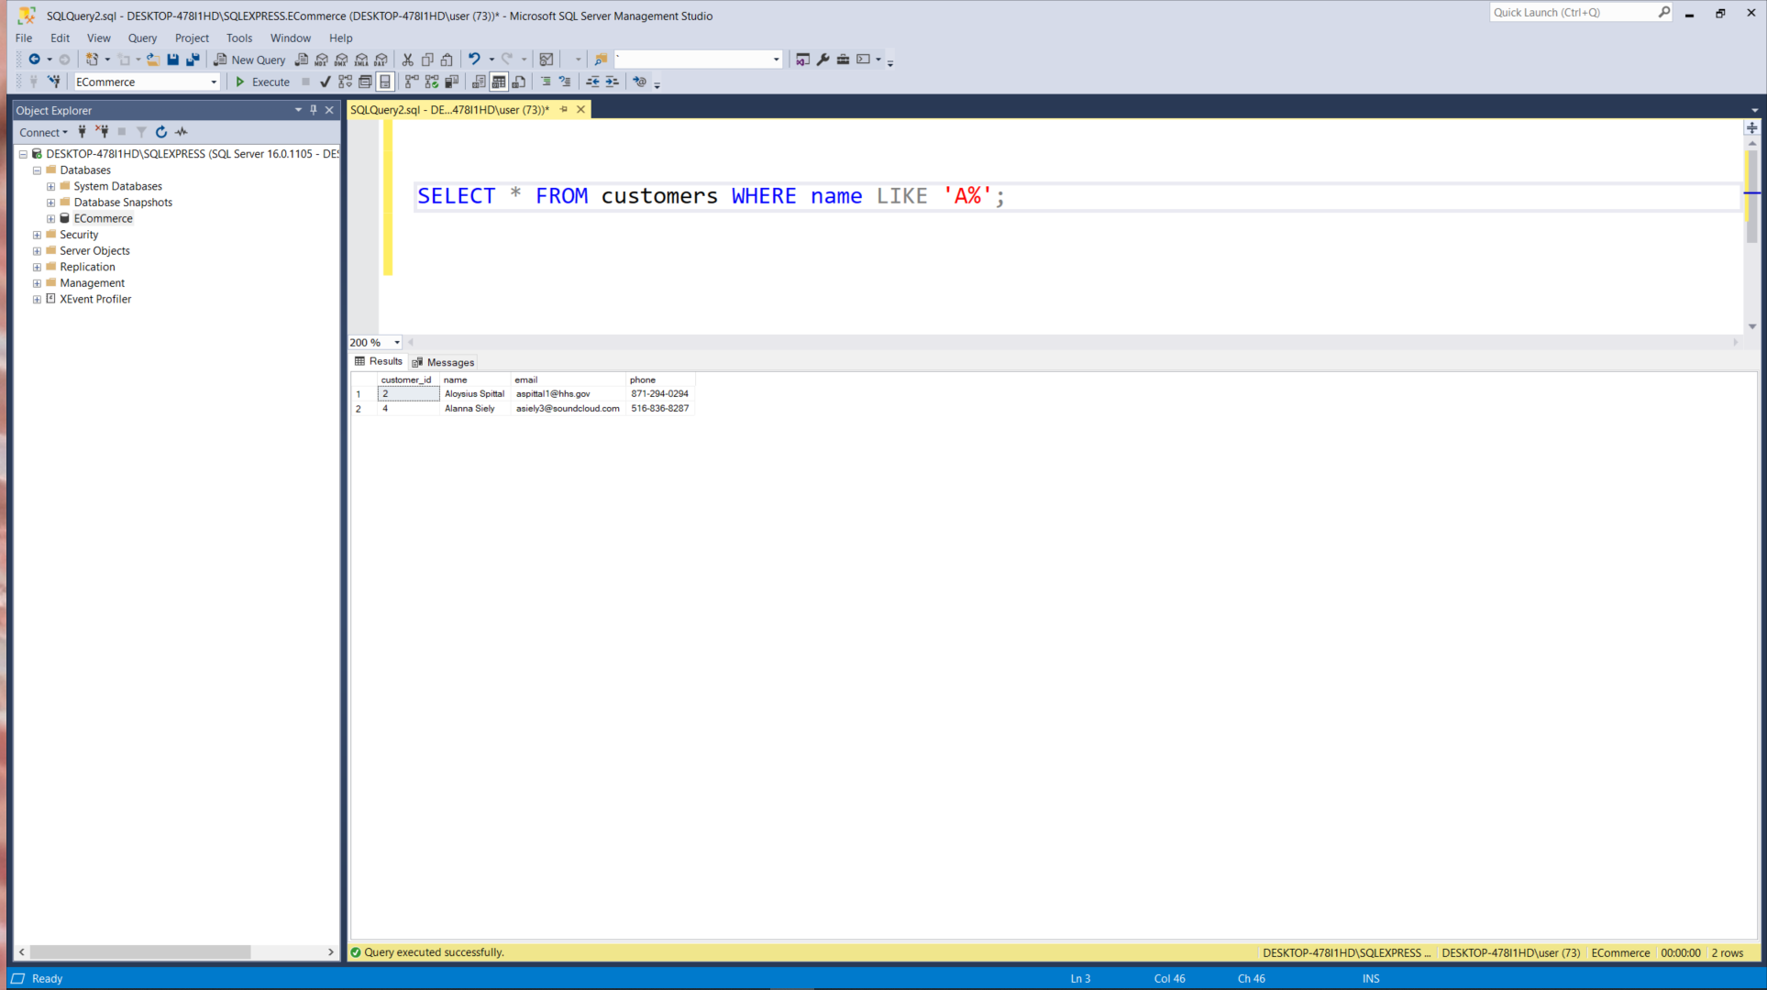

- Group By Command:
Counts the number of orders whose amount is greater than 50 for each customer.
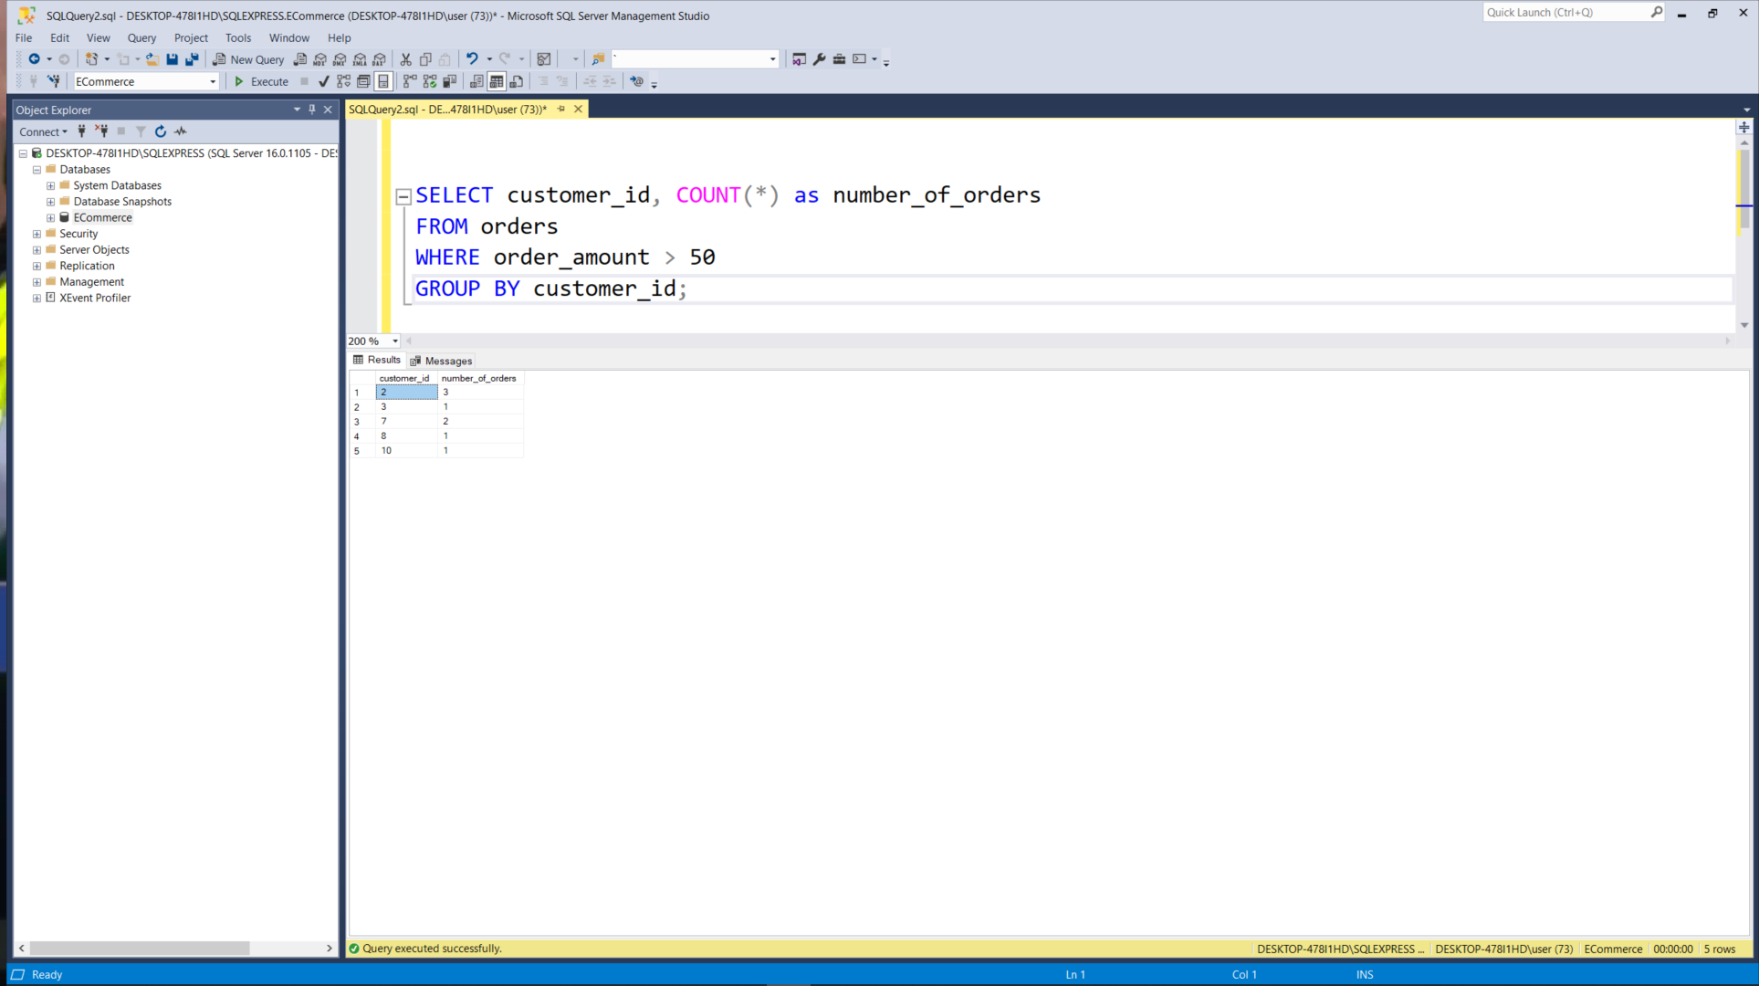
- Join Operation:
Joins the orders, customers, and order_details tables to display order information alongside customer names and total prices.
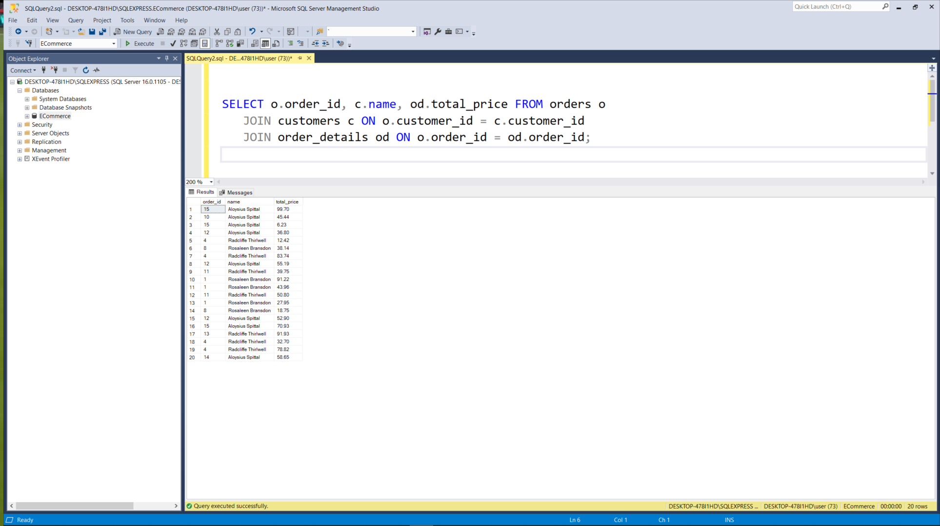
Conclusion
The database is structured to ensure smooth operations of an e-commerce platform, allowing for detailed data analysis and management. The SQL queries developed enable the creation, manipulation, and retrieval of data across the system, reflecting a robust and scalable database design.

