1. Use Case Diagram
Below is a textual representation of the use case diagram for the Home Equity Loan Applicationsystem.
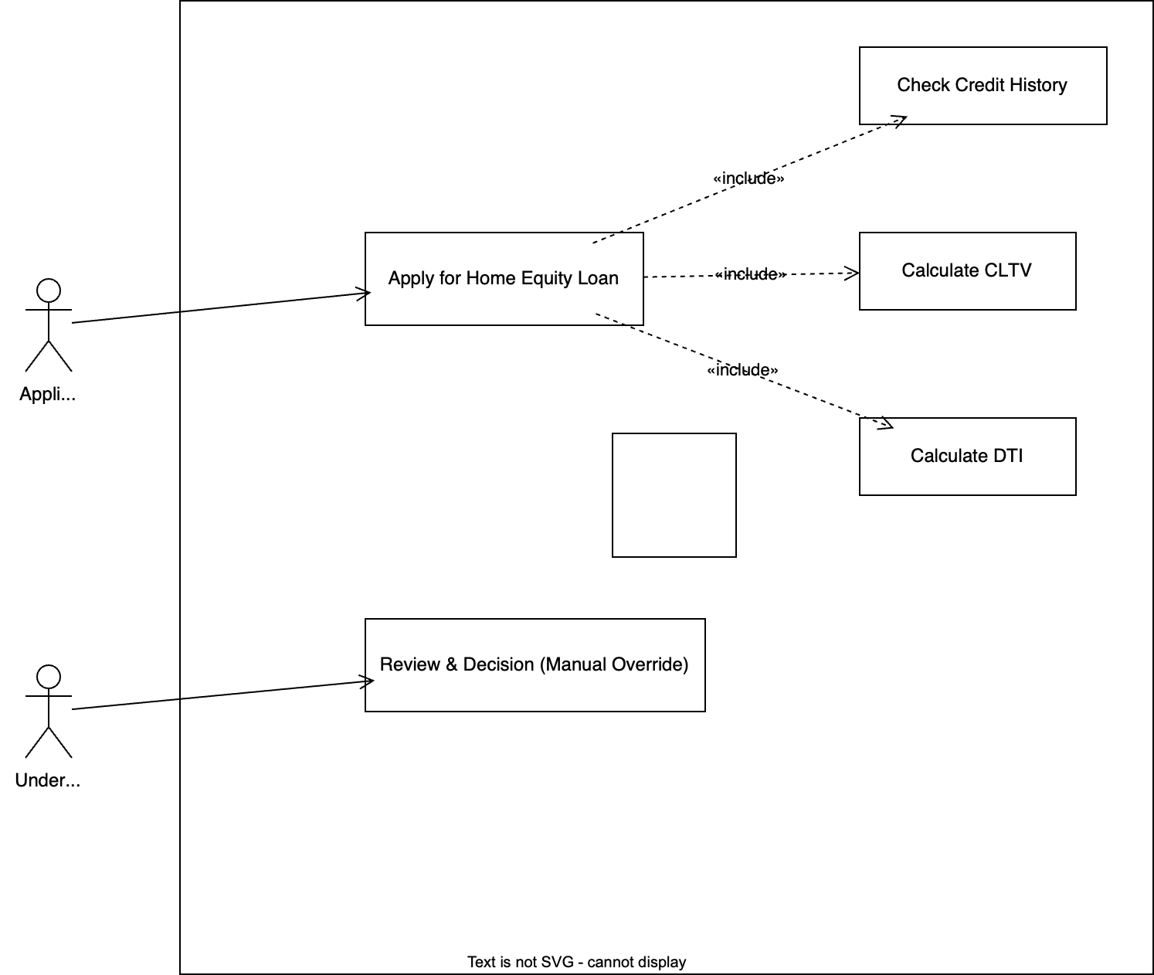

Actors:
- Applicant – submits the loan application.
- Underwriter – manually reviews borderline cases (optional, not in main flow).
Use Cases:
- Apply for Home Equity Loan – main use case.
- Check Credit History – includes credit score, late payments, recency.
- Calculate CLTV – Combined Loan-to-Value = (existing mortgage + requested loan) / home value.
- Calculate DTI – Debt-to-Income = total monthly debt payments / gross monthly income.

2. Use Case Description
Element | Detail
Use Case Name | Apply for Home Equity Loan
Actors | Applicant (primary), Underwriter (secondary – manual review)
Description | Applicant requests a fixed amount of home equity loan. System evaluates credit, CLTV, DTI, and renders an automatic decision (approve, deny, or refer).
Preconditions | 1. Applicant is authenticated.  2. Property address, home value, and outstanding mortgage balance are provided.  3. Income and all debt obligations (credit cards, auto loans, etc.) are supplied.  4. Consent for credit check obtained.
Postconditions | Success (Approve): Loan offer generated and sent to applicant.  Failure (Deny): Rejection notice with reasons.  Refer: Case sent to underwriter for manual review.
Main Success Scenario | 1. Applicant submits loan application with amount ($15k), property details, income, debts.  2. System retrieves credit report (score, late payments with dates).  3. System calculates CLTV.  4. System calculates DTI including proposed loan payment.  5. System evaluates rules:  - CLTV ≤ 85%  - DTI ≤ 43%  - No late payments within last 12 months  6. All rules pass → system approves loan.  7. System generates offer letter.
Extensions (Alternate Flows) | 2a. Credit check unavailable → notify applicant, abort.  3a. CLTV > 85% → deny with reason "Insufficient home equity".  4a. DTI > 43% → deny with reason "Debt-to-income too high".  5a. Late payment within last 12 months → deny with reason "Recent credit delinquency".  5b. Late payments only between 12–24 months → refer to underwriter (conditional path).  5c. Multiple borderline factors → refer to underwriter.

3. Workflow Diagram
Below is a Mermaid-format workflow diagram (can be rendered in any Markdown viewer).
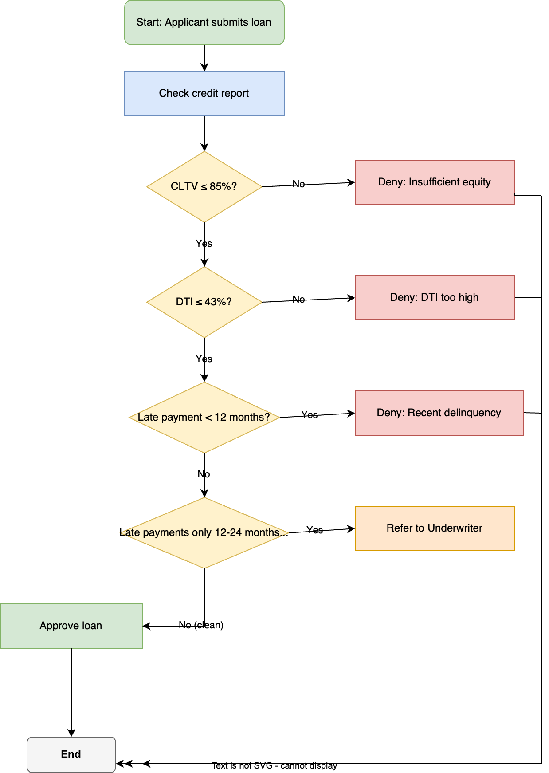

Decision points:
- CLTV – critical threshold.
- DTI – monthly debt burden.
- Late payment recency – <12 months → deny; 12-24 months → refer; >24 months → ignore.

4. List of All Paths as Coverage Items
Based on the three main rule checks (CLTV, DTI, Credit recency), there are 2×2×3 = 12 distinct logical paths when considering the three credit categories (Clean, 12-24 mo late, <12 mo late). However, the workflow treats <12 mo as deny, 12-24 mo as refer, and >24 mo (or none) as clean. Thus the coverage items are:
Path ID | CLTV (≤85%) | DTI (≤43%) | Credit Status | Outcome | Representative Test Scenario
P1 | Pass | Pass | No late ≤24 mo (clean) | Approve | Perfect credit, low LTV, low DTI
P2 | Pass | Pass | Late only 12-24 mo ago | Refer | Good LTV/DTI but one old late payment
P3 | Pass | Pass | Any late <12 mo | Deny (late) | Recent credit slip
P4 | Pass | Fail | Clean | Deny (DTI) | High DTI despite good equity and credit
P5 | Pass | Fail | Late 12-24 mo | Deny (DTI) | DTI fails, late payment irrelevant
P6 | Pass | Fail | Late <12 mo | Deny (DTI) | Same as P5
P7 | Fail | Pass | Clean | Deny (CLTV) | Stevens case – high CLTV, otherwise good
P8 | Fail | Pass | Late 12-24 mo | Deny (CLTV) | CLTV fails, late payment ignored
P9 | Fail | Pass | Late <12 mo | Deny (CLTV) | CLTV fails, also recent late (first reason = CLTV)
P10 | Fail | Fail | Clean | Deny (CLTV) | Multiple fails, system returns first failure (CLTV)
P11 | Fail | Fail | Late 12-24 mo | Deny (CLTV) | Same as P10
P12 | Fail | Fail | Late <12 mo | Deny (CLTV) | Same as P10
Note: In the current workflow, CLTV failure is checked first, so paths 7-12 all result in “Deny (CLTV)” regardless of DTI or credit. To achieve full coverage of decision logic, testers should also design scenarios where the order of checks is altered (e.g., DTI fails first) – but the diagram above prioritises CLTV. For completeness, we keep all 12 logical combinations.

5. Test Procedure for Each Path
The test procedure follows a data-driven approach: for each path, prepare a test case with specific input values that trigger the desired outcome. Use the Stevens family as the baseline for Path P7.

Common Test Setup (Preconditions)
- Applicant “John Stevens” (or variant) is registered.
- Property: value $400k, existing mortgage $350k (unless changed).
- Incomes: $45k + $75k = $120k/year.
- Monthly debts (baseline): mortgage $1,671, car loan $321, credit card min $50 → total $2,042.
- Proposed loan: $15k at 7% / 10 years → monthly payment $174.

Path P7 – CLTV Fail (Stevens original case)
Inputs:
- Home value = $400,000, mortgage owed = $350,000 → requested loan = $15,000 → CLTV = 91.25%
- Late payments: Visa late 17 months ago, car late 35 months ago → both >12 months (clean)
- DTI: existing debts $2,042 + new $174 = $2,216 / monthly income $10,000 = 22.2% → Pass
Expected outcome: Deny with reason “Insufficient home equity (CLTV exceeds 85%)”.
Test steps:
- Login as applicant.
- Enter loan amount $15,000.
- Input property data (value $400k, mortgage $350k).
- Enter income $120k/year.
- Enter recurring debts (mortgage, car, credit card) totalling $2,042/month.
- Authorise credit pull (simulate credit file with two late payments dated 17 and 35 months ago).
- Submit application.
- Verify denial message cites CLTV > 85%.

Other Paths – Representative Test Procedures
Path ID | Modified Inputs (vs baseline) | Expected Outcome | Test Procedure (steps)
P1 (Approve) | Home value $500k, mortgage $350k → CLTV = (350+15)/500 = 73% (pass).  No late payments. | Approve | Same as P7 but with home value $500k and clean credit. Verify approval and offer letter.
P2 (Refer) | CLTV ≤85% (home value $450k, mortgage $350k → CLTV = 81%).  DTI pass.  One late payment 18 months ago (12-24 mo). | Refer to underwriter | Same as P7 but with home value $450k and credit file containing a single 18-month late payment. Verify case goes to manual review queue.
P3 (Deny – late <12 mo) | CLTV ≤85% (home value $450k).  DTI pass.  One late payment 5 months ago. | Deny: Recent delinquency | Same as P7 but home $450k and credit with a 5-month late payment. Verify denial reason “Recent credit delinquency”.
P4 (Deny – DTI) | CLTV pass (home $450k).  DTI fail: increase monthly debts (e.g., add $3,000/mo other loan) → DTI >43%.  Clean credit. | Deny: DTI too high | Same as P7 but home $450k, extra $3k monthly debt, clean credit. Verify denial reason “Debt-to-income too high”.
P5 (Deny – DTI, late 12-24) | CLTV pass (home $450k).  DTI fail (extra $3k debt).  Late 18 months ago. | Deny: DTI too high | Same as P4 but with 18-month late. Ensure denial still cites DTI (first failure after CLTV).
P6 (Deny – DTI, late <12) | CLTV pass (home $450k).  DTI fail.  Late 5 months ago. | Deny: DTI too high | Same as P5 but with recent late.
P8 (Deny – CLTV, late 12-24) | CLTV fail (baseline $400k home).  Late 18 months ago. | Deny: CLTV | Use Stevens’ house value ($400k) but add a late payment 18 months ago. Verify denial cites CLTV.
P9 (Deny – CLTV, late <12) | CLTV fail.  Late 5 months ago. | Deny: CLTV | Same as P8 with recent late.
P10-P12 | CLTV fail + DTI fail + various credit statuses. | Deny: CLTV | Combine high CLTV (house $400k) with extra monthly debts to make DTI >43%. For each credit status, verify denial still says CLTV (first check fails).

Coverage Note
To test the order of evaluation, create separate test cases where CLTV passes but DTI fails (P4-P6) – these already exist. The 12 logical paths ensure every combination of rule outcomes is exercised, even if the workflow short-circuits on the first failure. The test procedures above cover all distinct user-visible outcomes: Approve, Refer, Deny-CLTV, Deny-DTI, Deny-Credit.

