MLOps LABORATORY | END-SEMESTER PRACTICAL
Credit Risk Model
with a CI/CD Quality Gate
An automated pipeline that checks the data, trains a model to spot high-risk credit-card customers, and refuses to release it unless it clears minimum quality standards.
Student | Mukesh Gond
Roll No. | B063
Program | MSc Data Science
Subject | MLOps Lab
Submitted to | Prof. Santosh
Institute | NMIMS
Date | October 2026

1. Aim
To build an end-to-end MLOps pipeline for credit-card risk. Every code or data change is automatically checked, the model is retrained, and two quality gates decide whether the result can be released: a data gate that checks the dataset is fit for use, and a model gate that checks the trained model is good enough and no worse than the previous version.

2. Background

2.1 The problem
A card issuer wants to know which customers are likely to become high risk, so that it can act early (lower a limit, call the customer, review the account). A model that quietly gets worse after a code or data change is dangerous: it either misses risky customers or bothers safe ones. In ordinary software a failing test blocks a release. Here the same idea is applied to data and to model performance.

2.2 Terms used in this report
Term | What it means here
CI (Continuous Integration) | Every push to the repository automatically runs lint, tests, data checks and training.
CD (Continuous Delivery) | If everything passes, the model is packaged and stored as a build artifact.
Data gate | A check that the dataset has the right columns, sensible values and not too many gaps.
Model gate | A script that compares the model's metrics with fixed thresholds and fails the build if any is missed.
AUC | How well the model ranks risky customers above safe ones (0.5 = guessing, 1.0 = perfect).
Recall | Of all customers who really are high risk, the share the model caught.
Precision | Of all customers the model flagged, the share who really are high risk.
KS statistic | The largest gap between the cumulative good and bad customers; common in credit scoring.
Baseline | The model trained earlier on the v1 data. The new model is compared against it.

3. The Data
Two versions of the customer file were provided. Each row is one credit-card customer with nine descriptive columns and a label, High_Risk_Customer (1 = high risk).
Column | Meaning
Customer_ID | Unique ID (not used for modelling)
Age, Tenure_Months | Customer age and months since the account was opened
Income_Bracket | Low, Medium or High
Credit_Limit, Current_Balance | Card limit and what is currently owed
Monthly_Spend, Num_Transactions_Monthly | Spending activity in a typical month
Payment_Delay_Days | Average days a payment is late
High_Risk_Customer | Target label

3.1 v1 and v2
v1 has 800 customers and v2 has 1,100. When I compared them, the first 800 rows of v2 are identical to v1, so v2 is v1 plus 300 newly added customers. The share of high-risk customers is almost unchanged (18.9% and 19.0%), so the new data has not shifted. This gives a natural workflow: the model trained on v1 becomes the baseline, and the model trained on v2 has to prove it is at least as good.
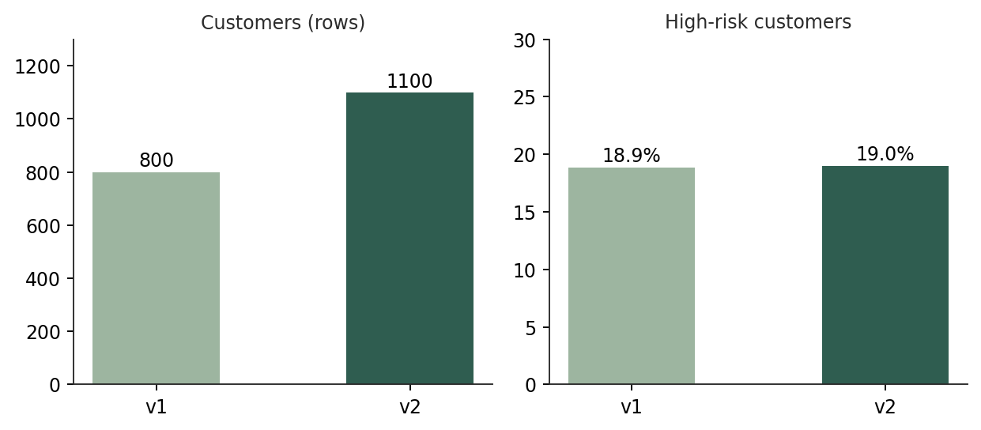
Figure 1. Size and high-risk share of the two data versions.

3.2 Data quality findings
- No duplicate customers, no negative amounts, and no balance above the credit limit.
- Credit_Limit, Current_Balance and Payment_Delay_Days are missing together for the same customers: 24 rows in v1 and 33 rows in v2, about 3% in both.
- About 19% of customers are high risk, so the classes are imbalanced and accuracy alone would mislead.
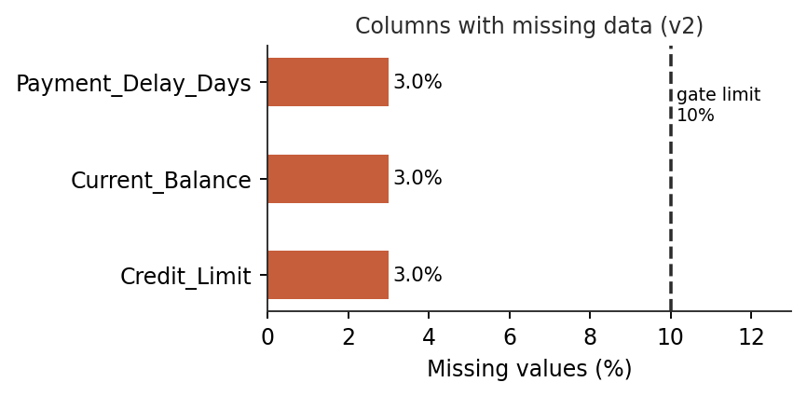
Figure 2. Missing values in v2, well inside the 10% gate limit.
The missing values are filled with the median of each column during training. The gap is small and the pattern is consistent, so this is a reasonable choice.

3.3 What separates risky customers
Looking at the averages, high-risk customers owe more (balance of about 5,238 against 2,811) and are later with payments (6.7 days against 4.1). The strongest single signal, however, is not a raw column. It is credit utilisation, which is balance divided by limit. It averages 0.67 for high-risk customers and 0.34 for the rest, and correlates 0.64 with the label, far higher than any original column (the best of those is Current_Balance at 0.31).
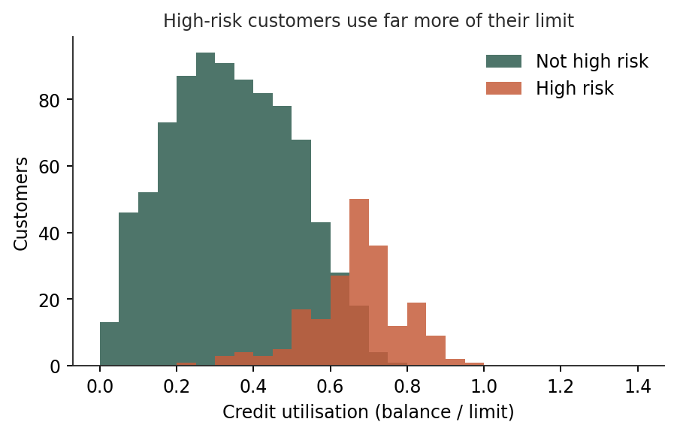
Figure 3. High-risk customers cluster at high utilisation.

4. System Design
The pipeline runs on GitHub Actions. Each stage must succeed before the next one starts. There are two gates, one before training and one after.
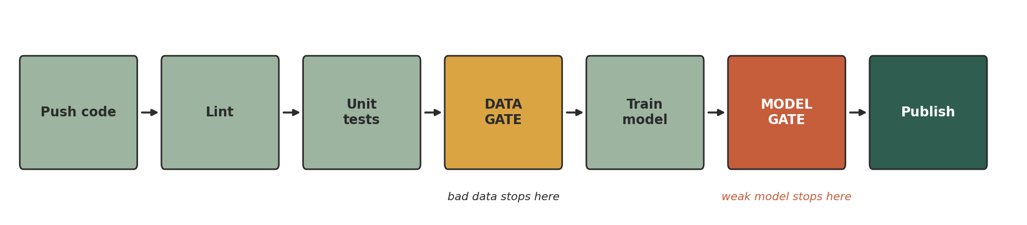
Figure 4. Pipeline stages. Yellow is the data gate, orange is the model gate.
- Lint (flake8): catches style problems and obvious mistakes in the code.
- Unit tests (pytest): 18 tests covering data checks, feature creation, training and the gate logic.
- Data gate: validates the CSV; a corrupted file stops the build before any training happens.
- Train: builds the model, scores it on a held-out 20% test set and writes metrics.json.
- Model gate: compares metrics with config.yaml and with baseline_metrics.json; exit code 1 on failure.
- Publish: uploads the models folder as an artifact, only if every earlier step passed.

5. Project Structure
File | Purpose
data/ | credit_card_customers_v1.csv and v2.csv (the supplied data).
src/data_validation.py | The data gate: schema, ranges, missing values, duplicates, label check.
src/features.py | Drops the ID, encodes income, adds utilisation and two ratio features.
src/train.py | Trains the model, computes AUC / recall / precision / KS, saves model and metrics.
src/quality_gate.py | The model gate. Prints a pass/fail table and sets the exit code.
src/make_plots.py | Draws the figures used in this report.
config.yaml | All thresholds and settings, kept out of the code.
baseline_metrics.json | Metrics of the model trained on v1.
tests/ | Four test files, 18 tests.
.github/workflows/ci.yml | The CI/CD pipeline definition.
run_all.ps1 and demo scripts | PowerShell helpers to run the pipeline and show both gates failing.

6. Implementation

6.1 Data gate
The data gate reads the CSV and returns a list of problems. If the list is not empty the script exits with code 1. It checks:
Check | Rule
Columns | All expected columns are present.
Size | At least 500 rows.
IDs | No duplicate Customer_ID.
Missing values | No column has more than 10% missing.
Ranges | Age 18 to 100; limit above 0; balance, spend, delay, tenure and transactions not negative.
Categories | Income_Bracket is only Low, Medium or High.
Label | High_Risk_Customer is 0 or 1, and the high-risk share is between 5% and 40%.

6.2 Features and model
Income_Bracket is converted to 0, 1, 2. Three ratio features are added: utilisation (balance / limit), spend-to-limit and spend per transaction. Missing values are filled with the column median, the inputs are standardised, and a logistic regression with balanced class weights is fitted on 80% of the data.
I compared four options using 5-fold cross-validated AUC on v2 before settling on this one:
Model | Inputs | CV AUC
Logistic regression | Original columns only | 0.922
Gradient boosting | With ratio features | 0.943
Random forest | With ratio features | 0.946
Logistic regression (chosen) | With ratio features | 0.952

The simple model won, and it has a second advantage: its coefficients can be read and explained to a risk officer or an auditor, which matters for credit decisions. The ratio features lifted AUC from 0.922 to 0.952, more than any change of algorithm did.

6.3 The model gate
The gate is a small, separate script so it can be unit-tested. Its core is:
CHECKS = [("AUC", "auc", "min_auc"), ("Recall", "recall", "min_recall"),
("Precision", "precision", "min_precision"), ("KS", "ks", "min_ks")]

def check(metrics, gate, baseline=None):
failures = []
for label, key, thr in CHECKS:
if metrics[key] < gate[thr]:
failures.append(f"{label} {metrics[key]} < {gate[thr]}")
if baseline:
drop = baseline["auc"] - metrics["auc"]
if drop > gate["max_auc_drop_vs_baseline"]:
failures.append(f"AUC dropped {drop:.4f} vs baseline")
return failures # main() calls sys.exit(1) if this is not empty

Check | Threshold | Reason
AUC | ≥ 0.90 | The model must rank risk clearly better than chance.
Recall | ≥ 0.75 | At least three in four risky customers must be caught.
Precision | ≥ 0.35 | Stops a model that simply flags everybody (that would score about 0.19).
KS | ≥ 0.60 | Good and risky customers must be well separated.
AUC drop vs baseline | ≤ 0.03 | The new model must not be noticeably worse than the v1 model.

6.4 Automated tests
Eighteen tests run on every push. Seven check the data gate, including that it catches a negative age, too many missing values, an unknown income level, a missing column and duplicate IDs. Three check the feature code, two check that the model trains, beats chance and gives the same result twice, and six check the gate logic. Testing the gates matters: a gate that never fails gives false confidence.

6.5 CI/CD workflow
steps:
- uses: actions/checkout@v4
- uses: actions/setup-python@v5 # Python 3.11
- run: pip install -r requirements.txt
- run: flake8 src tests --max-line-length=100
- run: pytest -v
- run: python -m src.data_validation # data gate
- run: python -m src.train
- run: python -m src.quality_gate # model gate, exit 1 stops here
- uses: actions/upload-artifact@v4 # only runs if all above passed
if: success()

7. Results
The baseline model was trained on v1 and the new model on v2. Each was scored on its own held-out 20% (160 and 220 customers). The new model clears every threshold and is better than the baseline on AUC, recall and KS.
Metric | Baseline (v1) | New model (v2) | Required | Status
AUC | 0.9249 | 0.9587 | ≥ 0.90 | Pass
Recall | 0.9000 | 0.9524 | ≥ 0.75 | Pass
Precision | 0.5625 | 0.5556 | ≥ 0.35 | Pass
KS | 0.7462 | 0.7951 | ≥ 0.60 | Pass
CV AUC (5-fold) | 0.9552 | 0.9524 | not gated | –

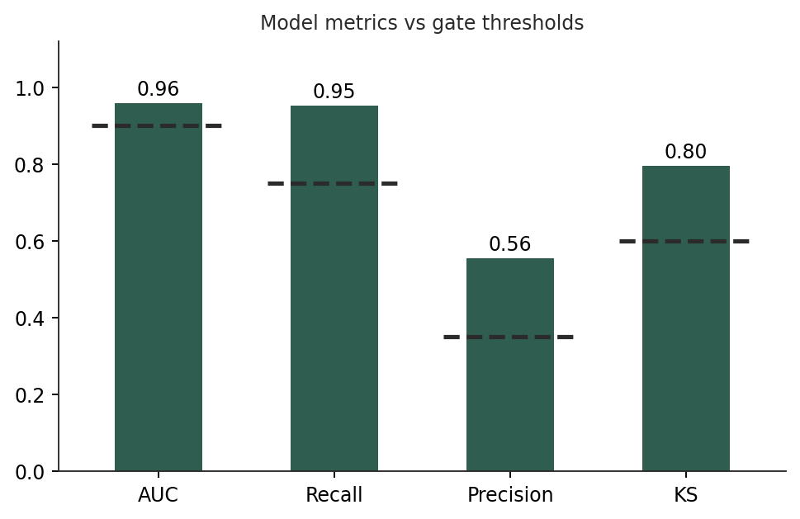
Figure 5. Green bars cleared their threshold (dashed line).
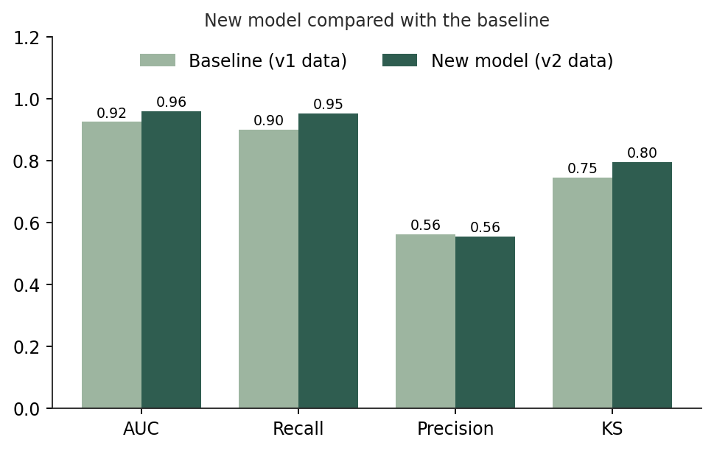
Figure 6. The model trained on more data matches or beats the baseline.
The 5-fold cross-validated AUC is 0.952 on v2 and 0.955 on v1. It is a steadier measure than a single 220-customer test set, and it shows the improvement is small and the model is stable rather than lucky.
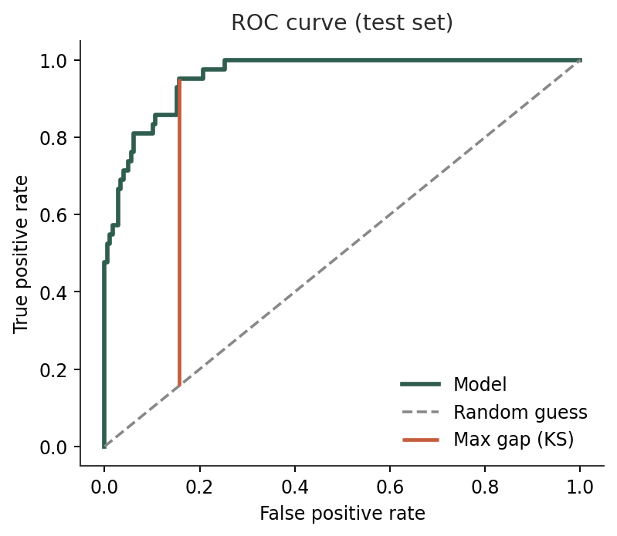
Figure 7. ROC curve on the test set; the orange line marks the KS gap.
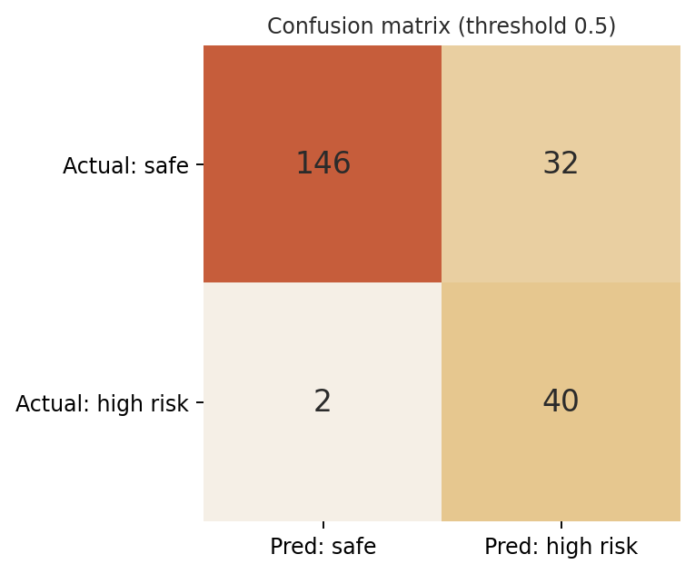
Figure 8. Of 42 high-risk customers 40 were caught and 2 missed; 32 safe customers were flagged.
The model misses very few risky customers, but about 44% of the customers it flags are actually safe (precision 0.56). That is the price of favouring recall. In practice a flag would send an account for review, not trigger an automatic action.
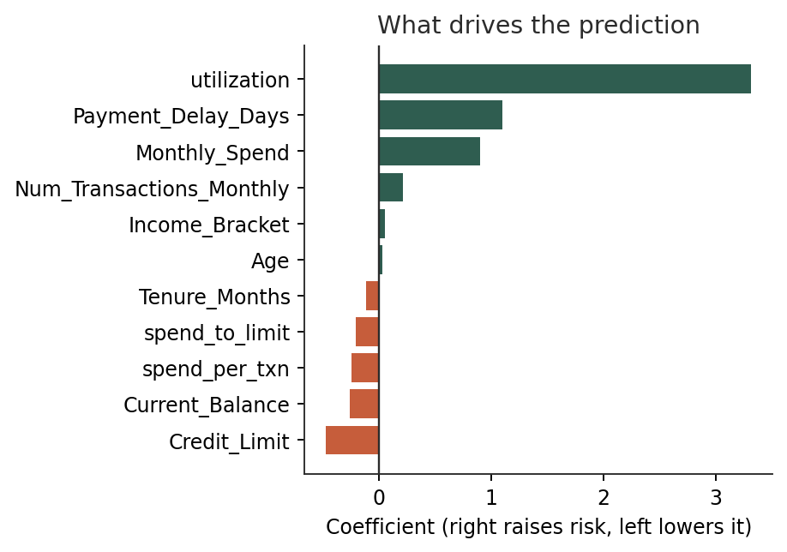
Figure 9. Utilisation and payment delay push risk up; credit limit pulls it down.
Utilisation has by far the largest weight, followed by payment delay and monthly spend. Age and income bracket have almost no influence. That is a reassuring result, because it means the model judges customers on their behaviour with the card rather than on who they are.
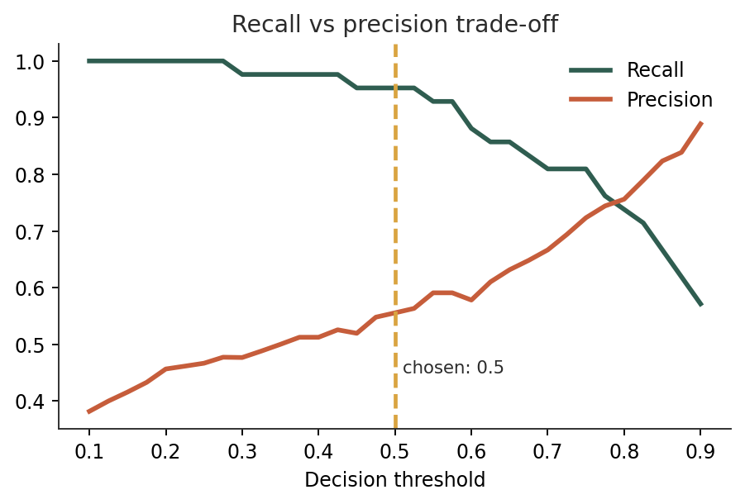
Figure 10. Raising the threshold gives fewer false alarms but misses more risky customers.

8. Demonstrating the Gates
A gate is only convincing if it can be seen to fail. I tested both.

8.1 Model gate
I raised the AUC requirement to 0.99, which no realistic model reaches. The same model that passed is now rejected, and the exit code becomes 1. In GitHub Actions this appears as a red cross and the upload step is skipped.
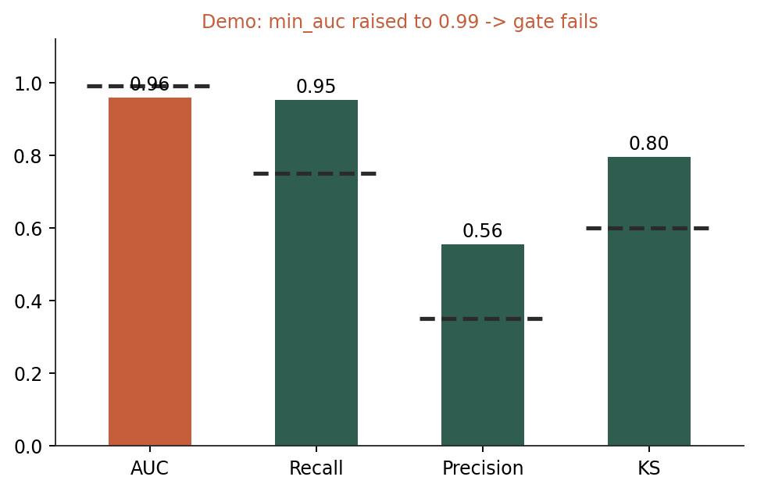
Figure 11. With min_auc = 0.99 the AUC bar turns orange and the build fails.

8.2 Data gate
I made a corrupted copy of v2 with 40 impossible ages, 30% of credit limits blanked and an unknown income level. The data gate rejected it before any training took place.

8.3 Terminal output from the run
The captures below are the actual output of the project, in the order the pipeline runs it.
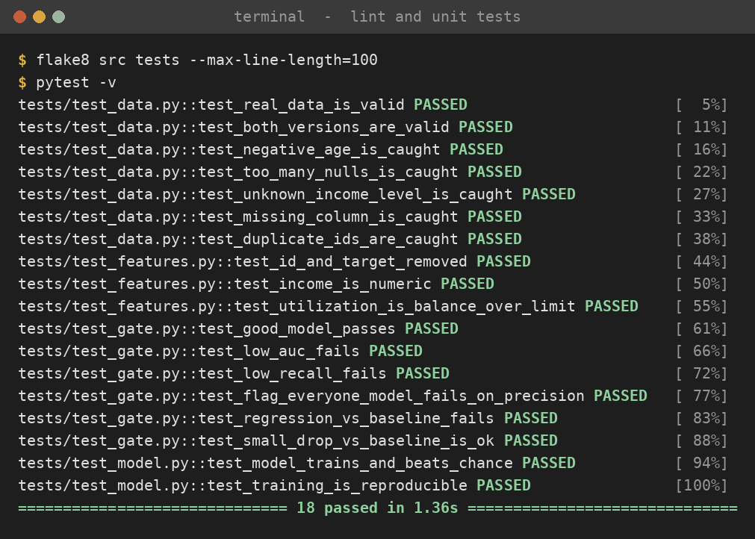
Figure 12. Lint is silent (no issues) and all 18 tests pass.
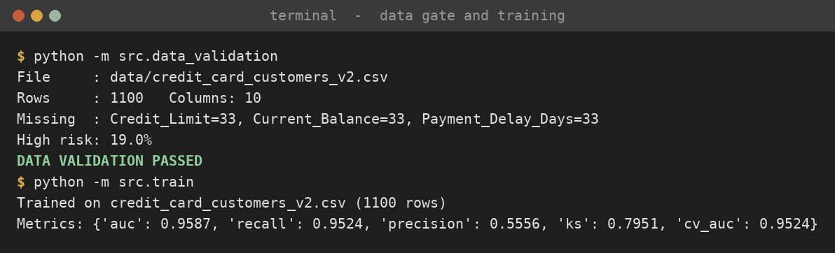
Figure 13. Data gate passes, then the model is trained on v2.
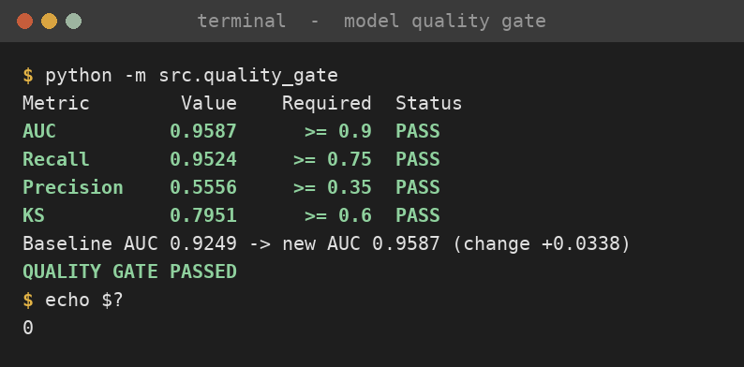
Figure 14. Model gate passes and exits with code 0.
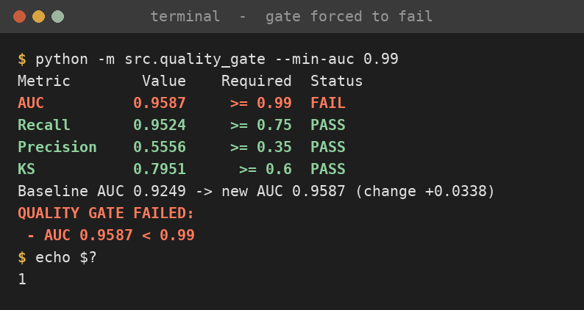
Figure 15. Same model, min_auc = 0.99: gate fails, exit code 1.
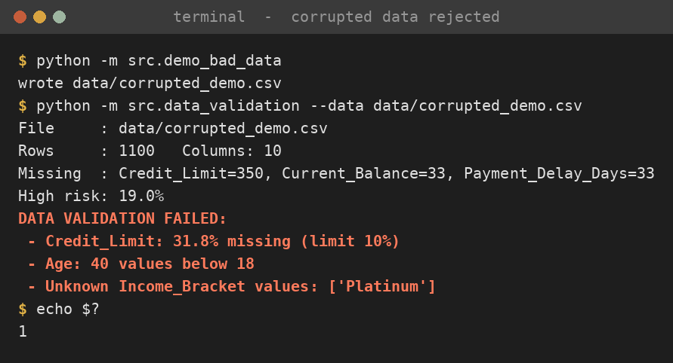
Figure 16. Corrupted data is rejected by the data gate, exit code 1.

9. How to Run
All commands are for Windows PowerShell, from inside the project folder.
python -m venv .venv
Set-ExecutionPolicy -Scope Process -ExecutionPolicy Bypass
.\.venv\Scripts\Activate.ps1
pip install -r requirements.txt

.\run_all.ps1 # lint, tests, data gate, train, model gate
.\demo_fail.ps1 # demo 1: model gate fails
.\demo_bad_data.ps1 # demo 2: data gate fails
python -m src.make_plots # regenerate the figures

To run it online, create a GitHub repository, push the folder, and open the Actions tab.

10. Limitations and Future Work
- The test sets are small (160 and 220 customers, with 42 high-risk cases in the latter), so single metrics can move by a few points. Cross-validated AUC is reported alongside for that reason.
- The baseline and the new model are scored on different test sets because the data grew. A stricter comparison would score both on the same customers.
- The baseline file is updated by hand (make_baseline.ps1). A model registry would store and compare versions automatically.
- There is no drift monitoring after release and no fairness test across customer groups, which a production credit model would need.
- Experiment tracking with MLflow and data versioning with DVC would make runs reproducible, and a deployment stage (for example a FastAPI service in Docker) could follow the gate.

11. Conclusion
The project treats data and models like any other part of a software release. Changes are tested automatically, bad data is stopped before training, and a weak or regressed model is stopped before release. On the supplied data, a simple logistic regression with a few ratio features reached an AUC of 0.959 and caught 40 of 42 high-risk customers in the test set, and both gates were shown to fail when they should.

Appendix: Questions I Prepared For
Why not just use accuracy?
About 19% of customers are high risk, so a model that calls everyone safe would be 81% accurate and useless. AUC, recall, precision and KS look at how well risky customers are found.
How are v1 and v2 related?
v2 contains all 800 rows of v1 plus 300 new customers. I trained the baseline on v1 and the new model on v2, so the gate checks that more data did not make things worse.
Why logistic regression and not a bigger model?
It scored best in cross-validation (0.952 against 0.943 to 0.946), and its coefficients can be explained, which matters for credit decisions.
What made the biggest difference to accuracy?
The utilisation feature, balance divided by limit. It lifted cross-validated AUC from 0.922 to 0.952.
How were missing values handled?
About 3% of rows lack three columns together. They are filled with the column median, and the data gate fails the build if any column goes above 10% missing.
Why a precision gate as well as recall?
A model that flags every customer has perfect recall. Requiring precision of at least 0.35 rules that out, since flagging everyone would give about 0.19.
What happens when a gate fails?
The script exits with code 1, GitHub marks the step red, and the upload step is skipped, so the model is not published.
What would you add with more time?
MLflow tracking, a model registry, drift monitoring, a fairness check and a deployed prediction API.

