**Distributed Shared White Board Report**

**Author: Yvonne Tao**

**Student number: 1183577**

**Author: Haiyao Yan**

**Student number: 1073969**

**System Architecture**

**The following diagram shows the general architecture of our distributed shared whiteboards, which allow multiple users to draw simultaneously on a canvas.**

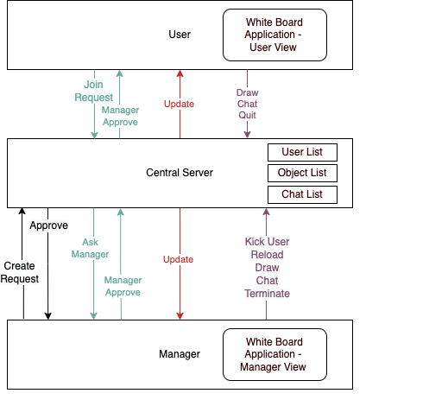

**The main component contains:**

1. **A central server that manages all the system state. The server keeps three lists (user list, object list and chat list), and keep them up to date with every client changes so that it can broadcast any changes to all other users.**
2. **User who requires manager’s approval to join the white board, afterward being able to draw shapes on to the white board, and send messages to chat window, and choose to leave the Application.**
3. **A white board manager who has all the ability as a normal user, plus a few higher privileges such as kick out user, open a new white board, reload a saved white board and terminate the application for all users.**

**This architecture connects all client nodes directly to a central server, who will broadcast any updates it receives to all clients.**

**Considering the high demand on concurrency and consistency of white board application, the choice of using a single central server will make sure all users are drawing on the same white board as there is only one source of truth. Besides, users will have better experience with less latency time for any remote update from other users.**

**One of the disadvantages of such design, however, is its inability to scale after a certain limit as the server can only have a finite number of ports open for connections. It is also very vulnerable to DOS attack, and once the server is down, it causes the single point of failure as there is no other server up for sending/receiving responses and requests.**

**Communication Protocols**

**The communication between server and clients are through sockets using the TCP protocol. Specifically, the server will establish a server socket awaiting, and accepts all connection that come in from clients. It will server each single connection with a separate thread, keeps the connection open until the user decides to quit or the manager terminate the whole application.**

**The main reasons of choosing socket for communication is that it has easy access to centralized data, which is exactly what the system requires. Compared with Remote Method Invocation (RMI), Socket connection allows us to format Messages in a custom way. In addition to that, the communication required for this white board application is nothing more than Strings and numbers (for passing username, chat box message, object coordinates, width, heights, class names, etc.), using Socket is sufficient. It’s also more effective as it produces less network traffic.**

**The reasons we choose TCP as exchange protocols over UDP is its reliability. Often in between the transport, the segments may get lost on its way to the destination, using TCP protocol ensures each segment reaches to the receiver so that users see the same white board, which is somewhat important for application like shared white board.**

**Message Formats**

**All messages are serialized to JSON serializable object before transform and then deserialize back to strings after transform using message factory. This will ensure the correctness of each message, also allows transmission of more complex objects such as a list of shapes a user draw on the white board.**

**Design Diagrams (UML)**

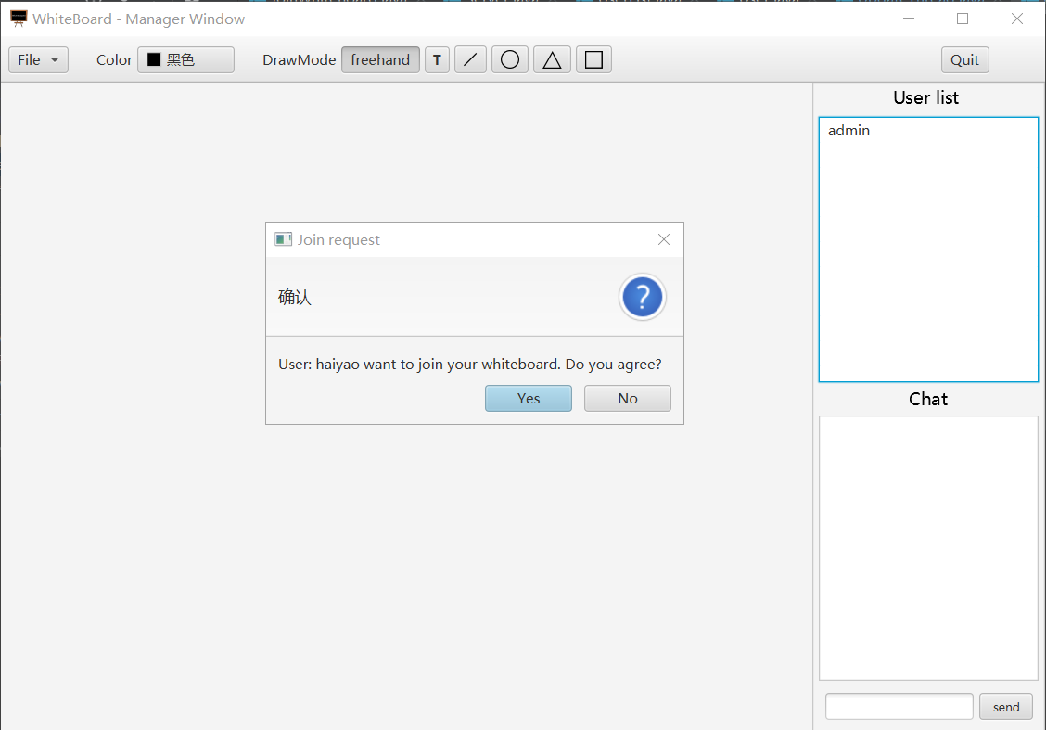**Implementation details**

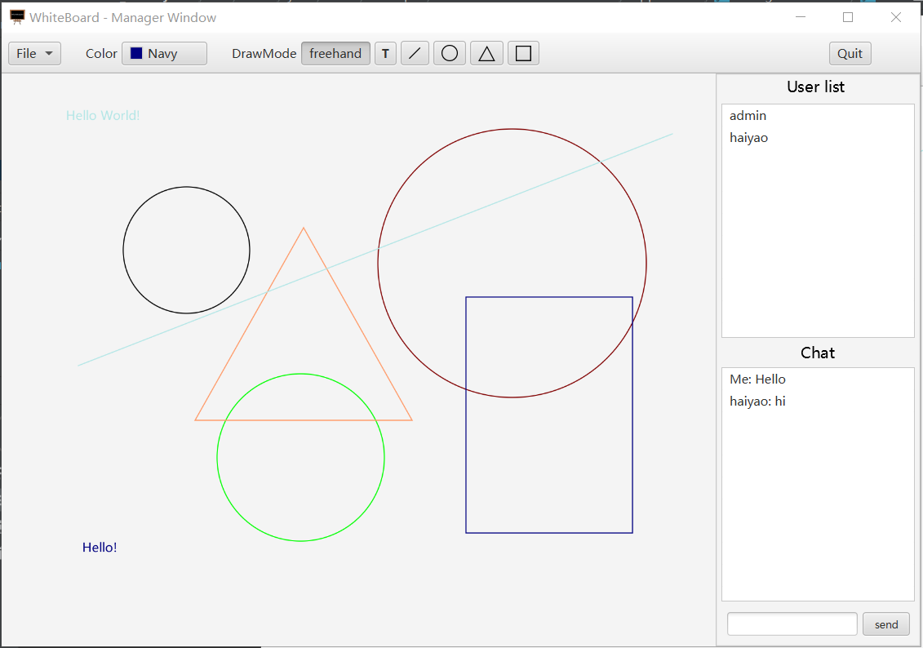**Screen shot of prompt User joining dialog**

**Screen shot of Manager window**

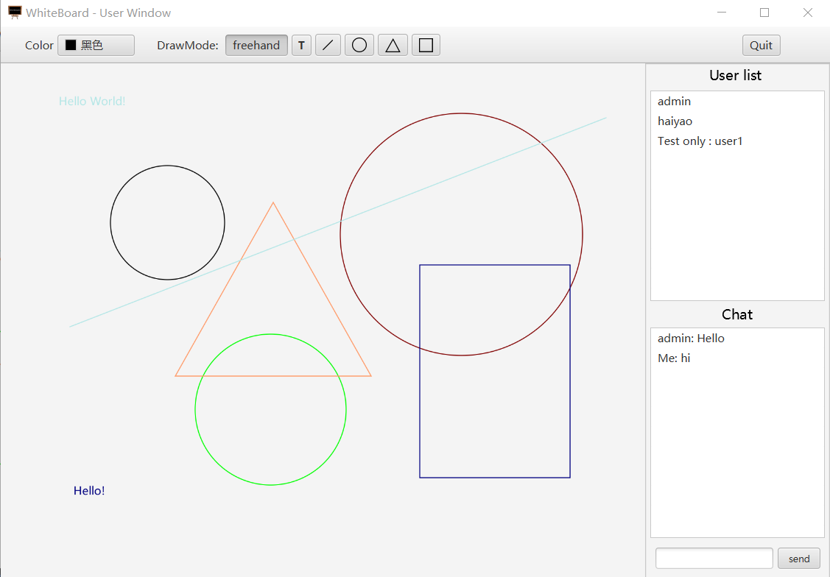**Screen shot of User window**

**Application is the start point which first set up socket connection between user and server, then launch the GUI. Controller defines how the application would behave, such trigger a event when a button being clicked or display confirmation dialog when receive update from server. Model is a data container which store information that is relevant to the object and define how the object would behave.**