IB BIOLOGY SL · B1.1 · PRACTICAL

Making a calibration curve for starch concentration

BEFORE YOU COME TO THE LESSON — INSTALL THE APP
The spectrometer will not talk to your laptop without Vernier Spectral Analysis. It is free.
Install it at home from vernier.com/spectral-analysis — there are versions for Windows, Mac, iPad and Android.

Why you are doing this. A colorimeter does not measure starch. It measures how much light a solution absorbs. To turn absorbance into a concentration you first measure a set of solutions whose concentration you already know — the standards — and plot absorbance against concentration. That graph is the calibration curve. After that, any absorbance reading from your experiment can be converted into a concentration by reading off the curve. This is how you follow starch being digested or built up over time.

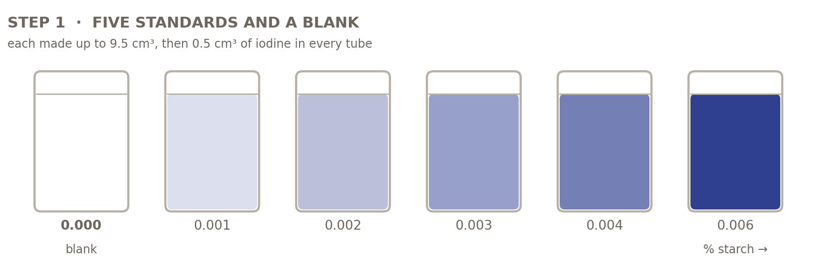

Apparatus
What you get | What it is for
Colorimeter + a cuvette for every tube | Set to absorbance in the orange range, 610 nm. The starch–iodine complex is blue, so it absorbs orange light most strongly. You are given one cuvette per tube, so nothing has to be rinsed between readings. If your class only has one cuvette, rinse it with distilled water and then with a little of the next solution, and work from the lowest concentration upwards.
0.01% starch stock solution | Made up for you by the technician. This is your stock solution: every standard and both unknowns are made from it.
Iodine solution, 0.01 mol dm⁻³ | Eye protection on. Measure 0.1 cm³ (100 µL) of iodine into every tube with the small micropipette, set to 100 µL. The same volume must go into every tube, the blank included.
Micropipette 200–1000 µL + 2 tips | Your main measuring tool. TIP 1 · starch stock into the tubes, drawn 1 cm³ at a time. TIP 2 · filling the cuvettes. Never swap them.
8 test tubes + rack | Five standards, one blank, and one for each of the two unknowns.
Graduated pipette 10 cm³ + filler | For the distilled water only. Read the volume at the bottom of the meniscus, at eye level.
Small micropipette 100 µL + 1 tip | Iodine only, and nothing else all lesson. It is a different size from the big one, so the tips cannot be confused. One draw at 100 µL per tube.
Droppers (spare) | A fallback, not the plan. If a micropipette is defeating you a dropper will fill a cuvette, and droppers are handy for mixing. But never use one to measure the iodine: a drop is about 0.05 cm³ and varies by a quarter from drop to drop, and that variation goes straight into every reading.

Making the standards
Five standards and a blank, all made from the 0.01% stock solution. Each tube holds 9.9 cm³ of liquid plus 0.1 cm³ of iodine, so 10 cm³ in total. Work out the final concentration by proportion. This is the calculation you are expected to be able to do.
cm³ of 0.01% stock solution | cm³ water | volume before iodine | final concentration / %
1 | 8.9 | 9.9 | 0.001
2 | 7.9 | 9.9 | 0.002
3 | 6.9 | 9.9 | 0.003
4 | 5.9 | 9.9 | 0.004
6 | 3.9 | 9.9 | 0.006
0 | 9.9 | 9.9 | 0 — the blank
Worked example: 2 cm³ of a 0.01% solution contains 2 cm³ × 0.01% = 0.0002 g of starch. Spread through the final 10 cm³, that is 0.002%. In general, final % = 0.01% × (volume of stock solution ÷ 10).
THE BLANK IS NOT JUST WATER
It is water plus the same 0.1 cm³ of iodine solution, because iodine solution is itself coloured. Use it to zero the colorimeter, so every reading afterwards is due to the starch–iodine complex alone.

Method
- Collect the 0.01% stock solution — already made up for you by the technician. Everything you make today comes from it. It is deliberately dilute: Vernier state that their colorimeters and spectrometers are only reliable between 0.1 and 1.0 absorbance, and a starch solution a hundred times stronger reads far above that.
- Measure the volumes in the table above into six labelled test tubes. Use the micropipette with TIP 1, drawing 1 cm³ at a time — so the 3 cm³ tube is three draws. Work from the lowest concentration upwards, and if you want to be extra careful, rinse the tip by drawing distilled water in and out between tubes.
- Make each tube up to 9.9 cm³ with distilled water, using the 10 cm³ graduated pipette. Read the volume at the bottom of the meniscus, at eye level.
- Set up the blank: 9.9 cm³ of distilled water in a sixth tube.
- Add 0.1 cm³ of iodine solution to every tube, including the blank, once all the starch is in. Use the small 100 µL micropipette and its own tip — one draw per tube. Then mix each tube: draw the liquid gently up and down a few times, or squeeze a dropper in and out. Do not shake — bubbles scatter light and the machine counts that as absorbance. Eye protection on.
- Zero the colorimeter on the blank at 610 nm.
- Read each standard in turn, lowest concentration first. Change to TIP 2 on the big micropipette and fill a cuvette — three draws of 1 cm³ fills it — or use a clean dropper if you would rather. Wipe the clear faces with tissue and line them up with the light path. You have a cuvette for every tube, so nothing has to be rinsed: fill them all, then read them. If your class only has one cuvette, rinse it with distilled water and then with a little of the next solution, and go lowest to highest.
- Treat each unknown like a standard: 9.9 cm³ into its own tube, 0.1 cm³ of iodine, mix, read at 610 nm. One of your two unknowns will land neatly between your standards. The other will not — read “Using the line” before you decide what to do with it.
- Plot absorbance (y) against concentration (x) and draw the best-fit line through the points. Do not join the dots.
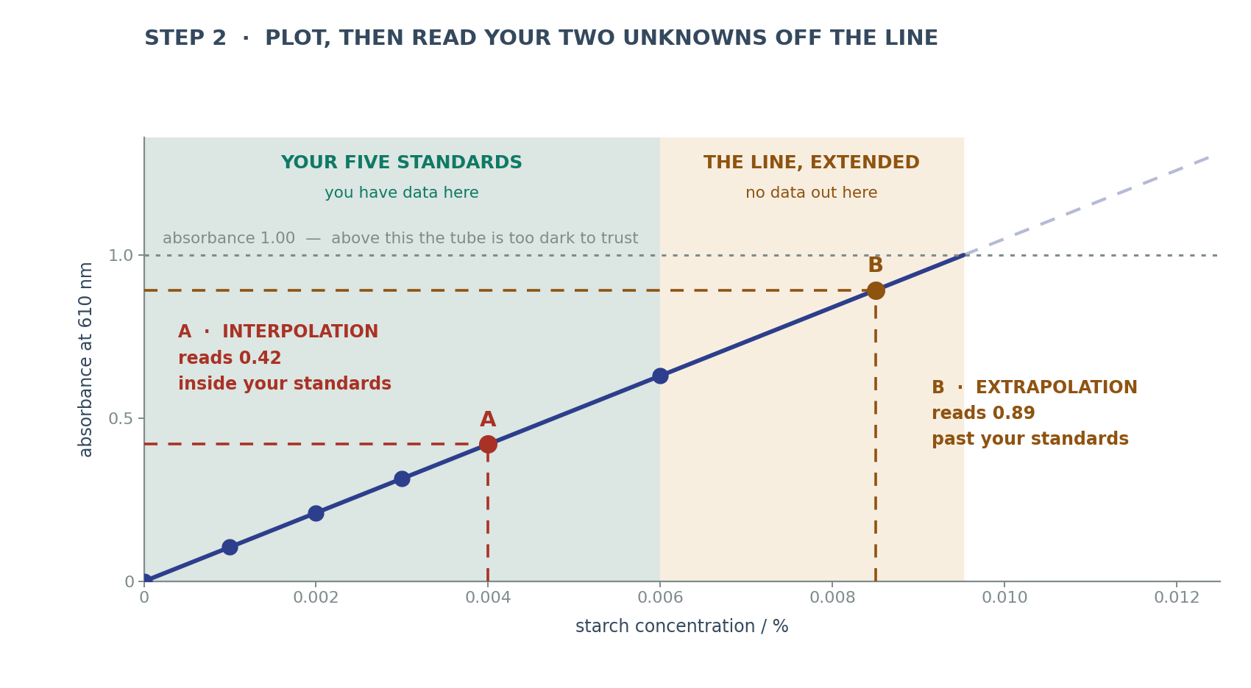

Using the line
- Find your unknown's absorbance on the y-axis, go across to the line, then straight down to the x-axis. If the point lands between your standards, that is interpolation, and it is the reading you can defend most strongly — the line is backed by your own data there.
- If it lands past your strongest standard, that is extrapolation. You may still read it, but you are trusting the line somewhere you have no data, so say so in your write-up.
- You must dilute, however, if an unknown reads above about 1.0 absorbance. That is not an extrapolation problem, it is an instrument problem: so little light reaches the detector that the reading means nothing. Dilute by a known factor (1 cm³ into 9 cm³ of distilled water is a factor of 10), read again so it falls inside your standards, then multiply the answer by that factor. Diluting an extrapolated unknown is also the safer choice whenever you have time.
- Express your answer to an appropriate level of precision — your colorimeter and your standards do not justify four decimal places.
WHY THE CONCENTRATIONS ARE SO LOW
The blue starch–iodine complex is one of the most strongly coloured substances you will meet. Above roughly 0.01% starch a solution absorbs so much light that almost none reaches the detector, and every tube then reads about the same however much starch it contains.

Fitting the line, and judging it
Plot all your points. If they lie on a straight line, fit the line to all of them. If the top ones bend away, fit a straight line to the low-concentration part only, and use that line to convert absorbance into concentration. R² tells you how well the points sit on the line you chose. A low R² has two very different causes, and saying which one you have is what earns the evaluation mark.

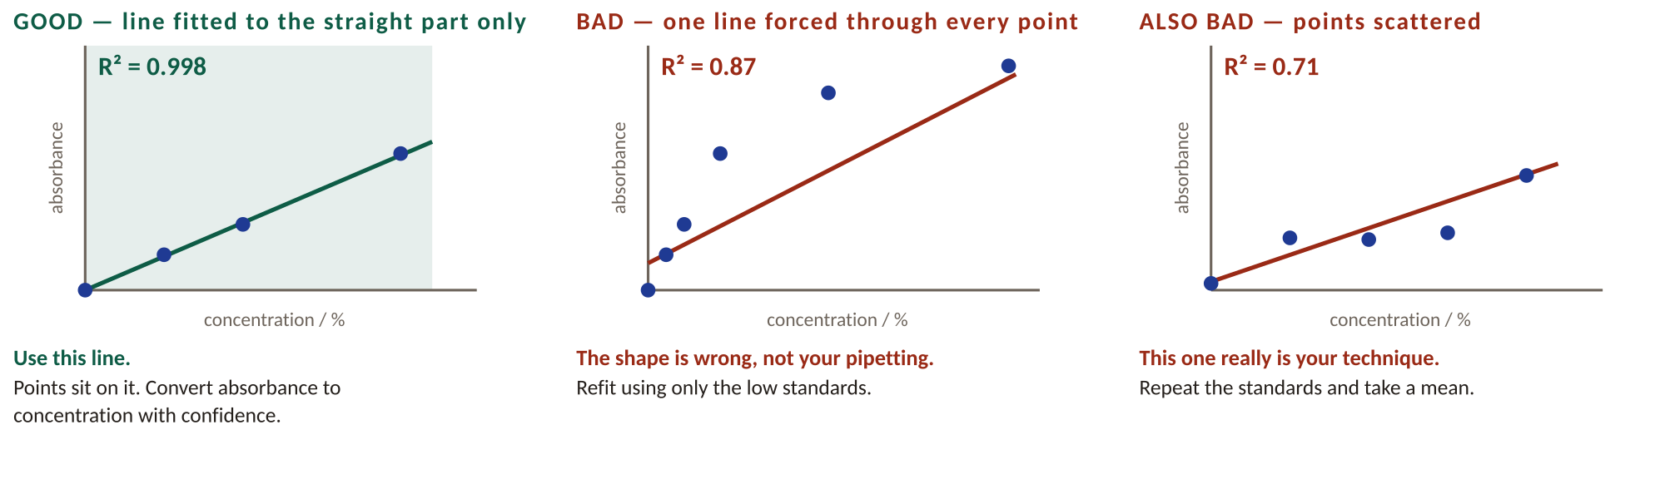

WORKED EXAMPLE — AN UNKNOWN THAT LANDS ON THE PLATEAU
The numbers below are invented to show you the steps — yours will be different, and where your graph stops being straight is something you find from your own points. Suppose your line is absorbance = 105 × concentration, R² = 0.998, straight across the whole range in the table.
1. Unknown A reads 1.85. That is far above your strongest standard, which read about 0.63, and above the 1.0 ceiling, so the tube is too dark for the instrument to resolve. Any answer would be little better than a guess.
2. Dilute it: 1 cm³ of unknown into 9 cm³ of distilled water. That is a dilution factor of 10.
3. Read it again: absorbance 0.42. This time it falls inside the range your line covers, so the line can be used.
4. Use the line: 0.42 ÷ 105 = 0.0040%.
5. Multiply back: 0.0040% × 10 = 0.040%. Your reading gave two significant figures, and multiplying by 10 multiplies the uncertainty by 10 too, so quote the answer to two significant figures. Diluting and multiplying back does not make an answer more precise.

If your results look wrong
Five things go wrong in this practical. Each one bends the graph in its own way. Find yours below, then say so in your evaluation. Spotting which one you had is worth more marks than a tidy graph.

EVERY TUBE READS ABOUT THE SAME, AND ABOVE 1
Your solutions are too dark. Light cannot get through them.
The machine still shows a number. That number is not a valid measurement.
Fix: dilute the starch more. Do not add more iodine — that makes it darker still.

THE TOP OF YOUR PEAK IS COVERED IN SPIKES
Same cause. At the peak the colour is strongest, so the least light gets through.
When almost no light reaches the detector, the reading jumps up and down.
The spikes sit on the peak because that is the darkest part of the scan.
Fix: dilute the starch until the peak is below 1.0.

THE PEAK IS SMALL AND SITS NEAR 560 nm, NOT 610 nm
There was not enough iodine, or the iodine was old.
Iodine escapes from the bottle over time, so an old bottle is weaker than its label.
Weak iodine builds only short chains inside the starch. Short chains look red-purple, not blue.
Fix: use fresh iodine, kept in a dark bottle, and the same volume in every tube.

YOUR LINE DOES NOT START AT ZERO
Your blank was wrong. It must contain the same 0.1 cm³ of iodine as every other tube.
If it did not, every reading carries the colour of the iodine itself.
Fix: remake the blank with iodine in it and zero the machine again.

These are the shapes to compare your own results with.

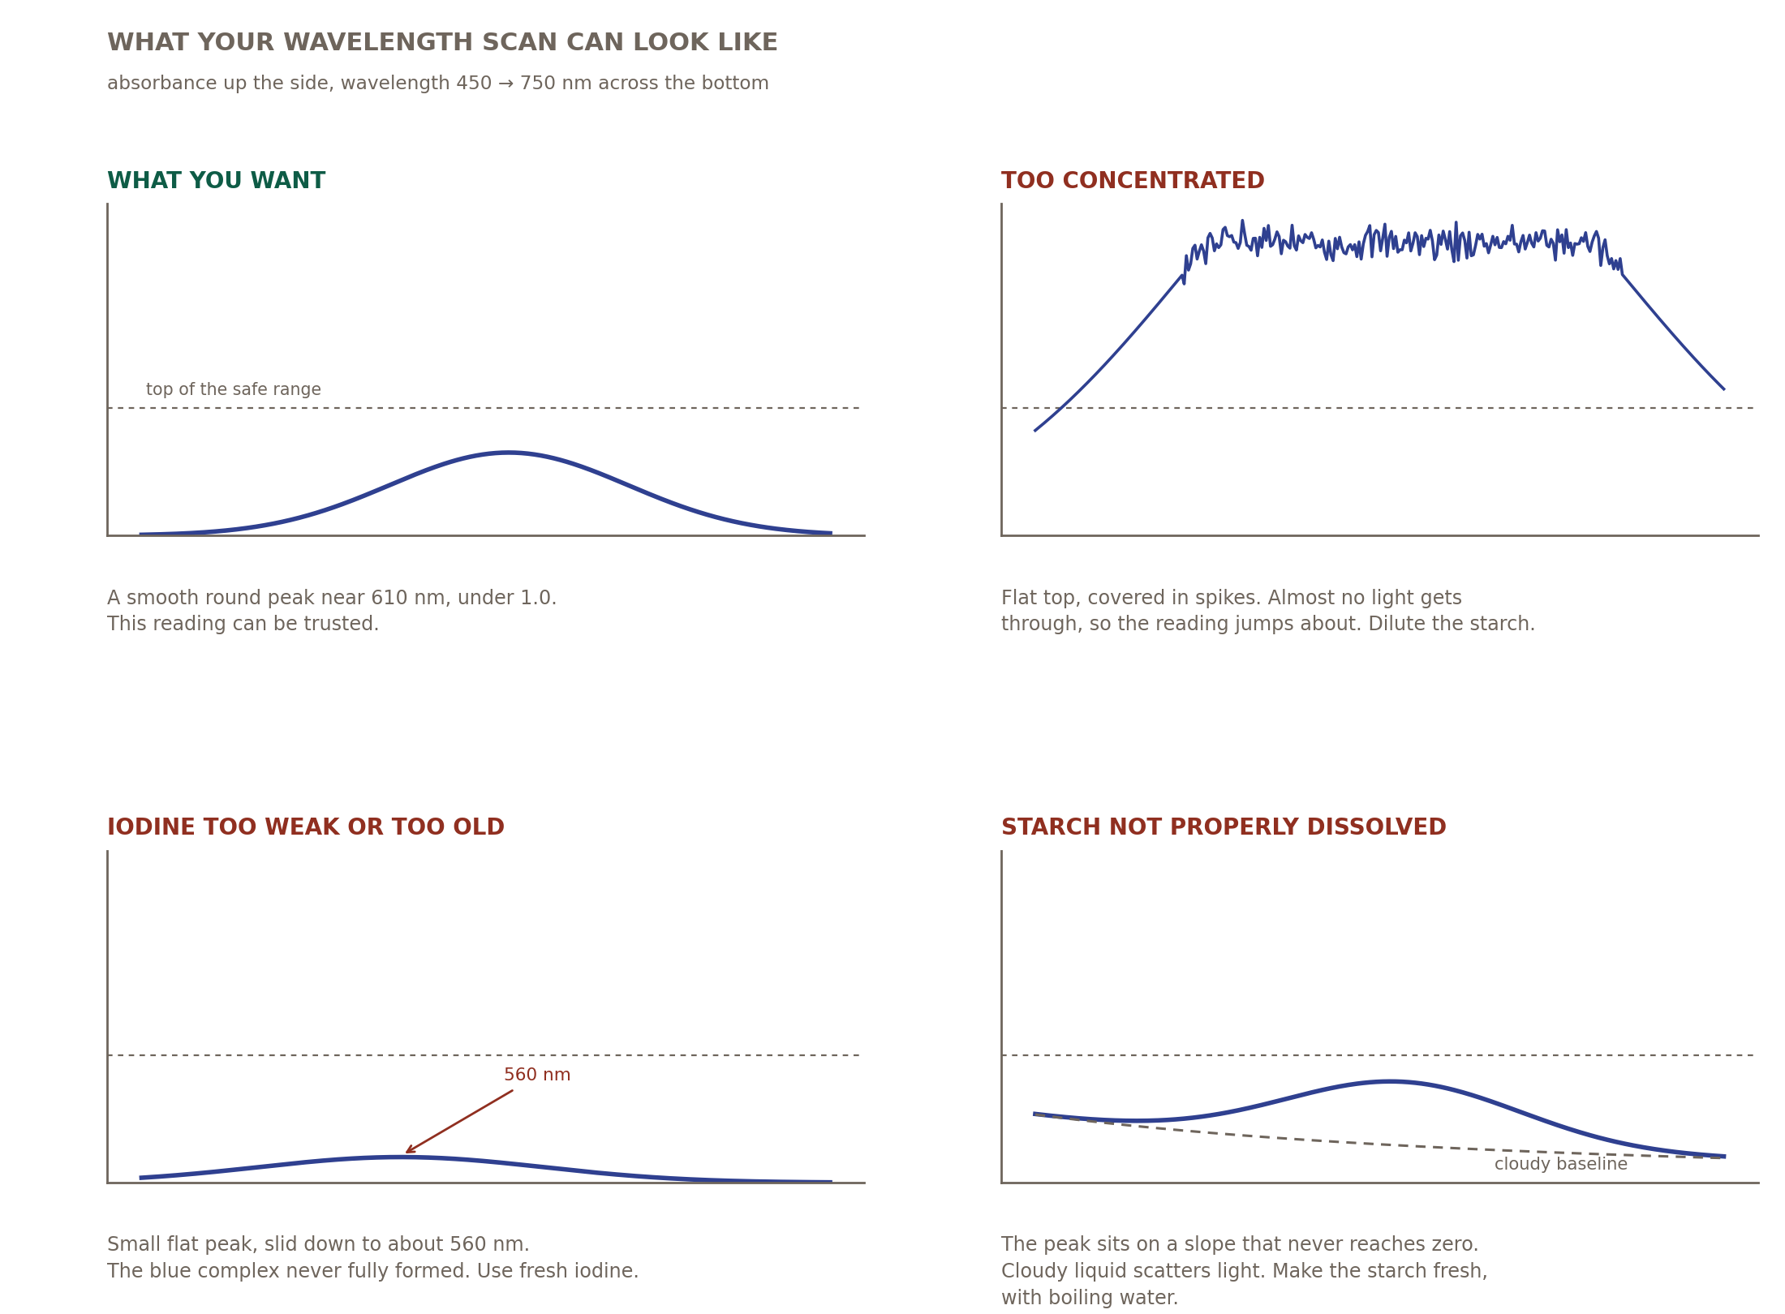
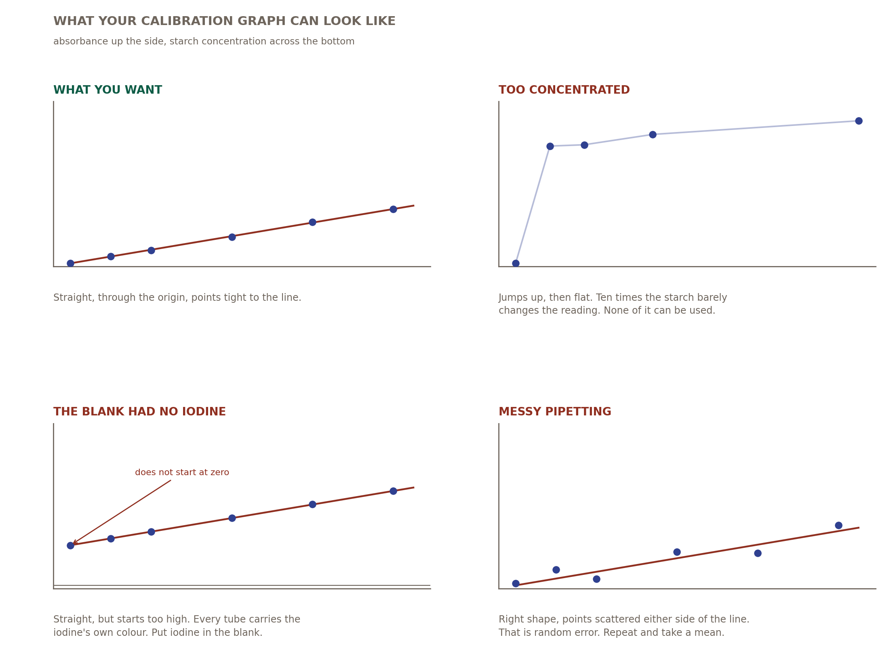
The skills you are being assessed on
These are quoted from “Skills in the study of biology” in the IB Biology guide (first assessment 2025). Page numbers are the guide’s own printed page numbers — look them up so you know what the wording is.
Where it comes from | Exact wording in the guide | Page
Tool 1 · Applying techniques | colorimetry or spectrophotometry · serial dilutions | 30
Tool 2 · Applying technology to process data | use spreadsheets to manipulate data · represent data in a graphical form | 30
Tool 3 · Applying general mathematics | calculations involving decimals, fractions, percentages, ratios, proportions | 30
Tool 3 · Processing uncertainties | apply the coefficient of determination (R²) to evaluate the fit of a trend line | 31
Tool 3 · Graphing | plot linear and non-linear graphs · draw lines or curves of best fit · extrapolate and interpolate graphs | 31
Inquiry 1 · Controlling variables | appreciate when and how to calibrate measuring apparatus | 32
Inquiry 2 · Interpreting results | assess accuracy, precision, reliability and validity | 32
Inquiry 3 · Evaluating | identify and discuss sources and impacts of random and systematic errors | 33
WHAT YOU ALREADY BRING FROM IGCSE
Using a graduated pipette and reading to the bottom of the meniscus · making a solution up to a fixed volume · plotting a scatter graph with labelled axes and units · drawing a smooth curve of best fit · reading a value off a graph.
What IB adds: judging how good the fit is numerically (R²), judging the range within which you are allowed to read, and writing an evaluation that separates random error from a systematic problem with the method.

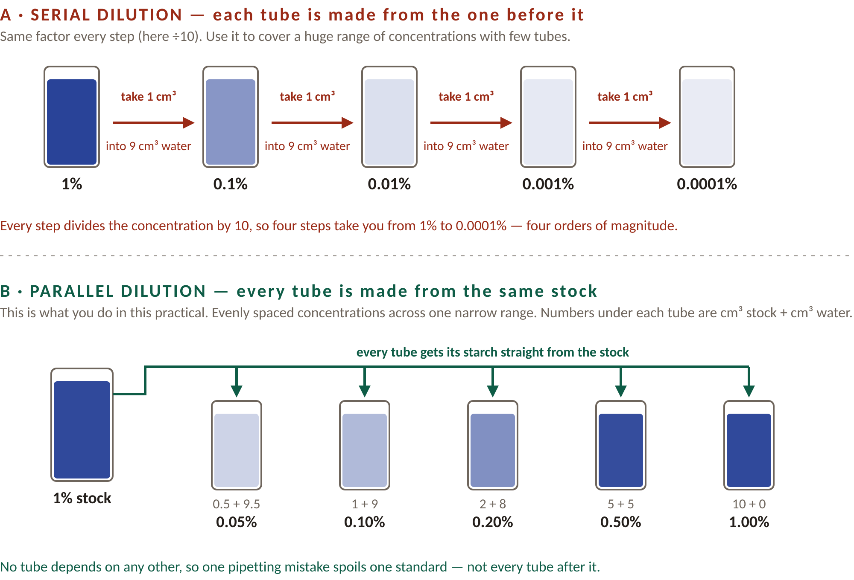
Serial dilution — the other technique you must know
The guide lists serial dilutions as a technique you must meet, and you will use one later in the course. The dilutions in this practical are not serial — every standard is made independently from the same stock solution. That is a parallel dilution. Learn both, and do not call this one a serial dilution.
How to do a 1-in-10 serial dilution. Put 9 cm³ of distilled water in each of tubes 2 to 5. Transfer 1 cm³ of stock into tube 2 and mix — that tube is now one tenth of the stock. Transfer 1 cm³ of tube 2 into tube 3 and mix. Repeat down the row. The number you divide by each time (here 10) is the dilution factor. Change the pipette tip, or rinse the pipette, between transfers.
Which to use | Serial dilution | Parallel dilution
Where each tube comes from | the previous tube | the same original stock
Spacing of concentrations | multiplying — 1, 0.1, 0.01, 0.001 | adding — 0.05, 0.10, 0.20, 0.50
Best for | covering several orders of magnitude, e.g. enzyme or antibiotic concentrations | even coverage of one narrow range, e.g. a calibration curve
If you make one pipetting error | every tube after it is wrong too | only that one standard is wrong
Volumes needed | small — one stock and a little water | a larger volume of stock

THE CALCULATION, EITHER WAY
C₁V₁ = C₂V₂ — concentration before × volume taken = concentration after × total volume.
Serial, tube 2: 0.01% × 1 cm³ = C₂ × 10 cm³, so C₂ = 0.001%. Parallel, the 2 cm³ tube: 0.01% × 2 cm³ = C₂ × 10 cm³, so C₂ = 0.002%. The same equation both times — only where the starting solution came from changes.

For your evaluation
VALIDITY — THE WORD IB USES
A method is valid if it really measures what you say it measures, so that your conclusion follows from your data. A method can be precise and repeatable and still not be valid. (“Fair test” is IGCSE wording — in IB, write validity.)

Why this experiment may not be valid
- Where the graph is flat, very different concentrations of starch give almost the same absorbance, so absorbance no longer distinguishes between them.
- The absorbance depends on the volume of iodine solution added as well as on the concentration of starch, and the volume of one drop is not constant.
- The blue colour fades. If some tubes wait longer than others before being read, you are partly measuring time.
- The curve only applies to the same starch, the same iodine and the same colorimeter, read on the same day.

Errors to name
- Random error: reading the graduated pipette, variation in the volume of one drop, a cuvette not wiped clean. Repeat each standard and take a mean.
- Systematic error: zeroing on distilled water instead of water plus iodine solution, or starch not fully dissolved in the stock. Every reading shifts in the same direction, so repeating will not reveal it.
- A realistic improvement: measure a fixed volume of iodine solution with a pipette instead of using a drop, read every tube after the same time interval, and work only within the straight region of the graph.

Results from this practical are often poor. That is normal — but say which of the points above caused it. Naming the cause scores marks; writing “human error” does not.

