**Launching AWS Academy:**

1. Enter into <https://awsacademy.instructure.com/>
2. Select: AWS Academy Learner Lab
3. Launch AWS Academy Learner Lab  
   A screenshot of a computer

   Description automatically generated
4. Start Lab, wait a few minutes and click on AWS:  
     
   A screenshot of a computer

   Description automatically generated
5. AWS Console will open:  
     
   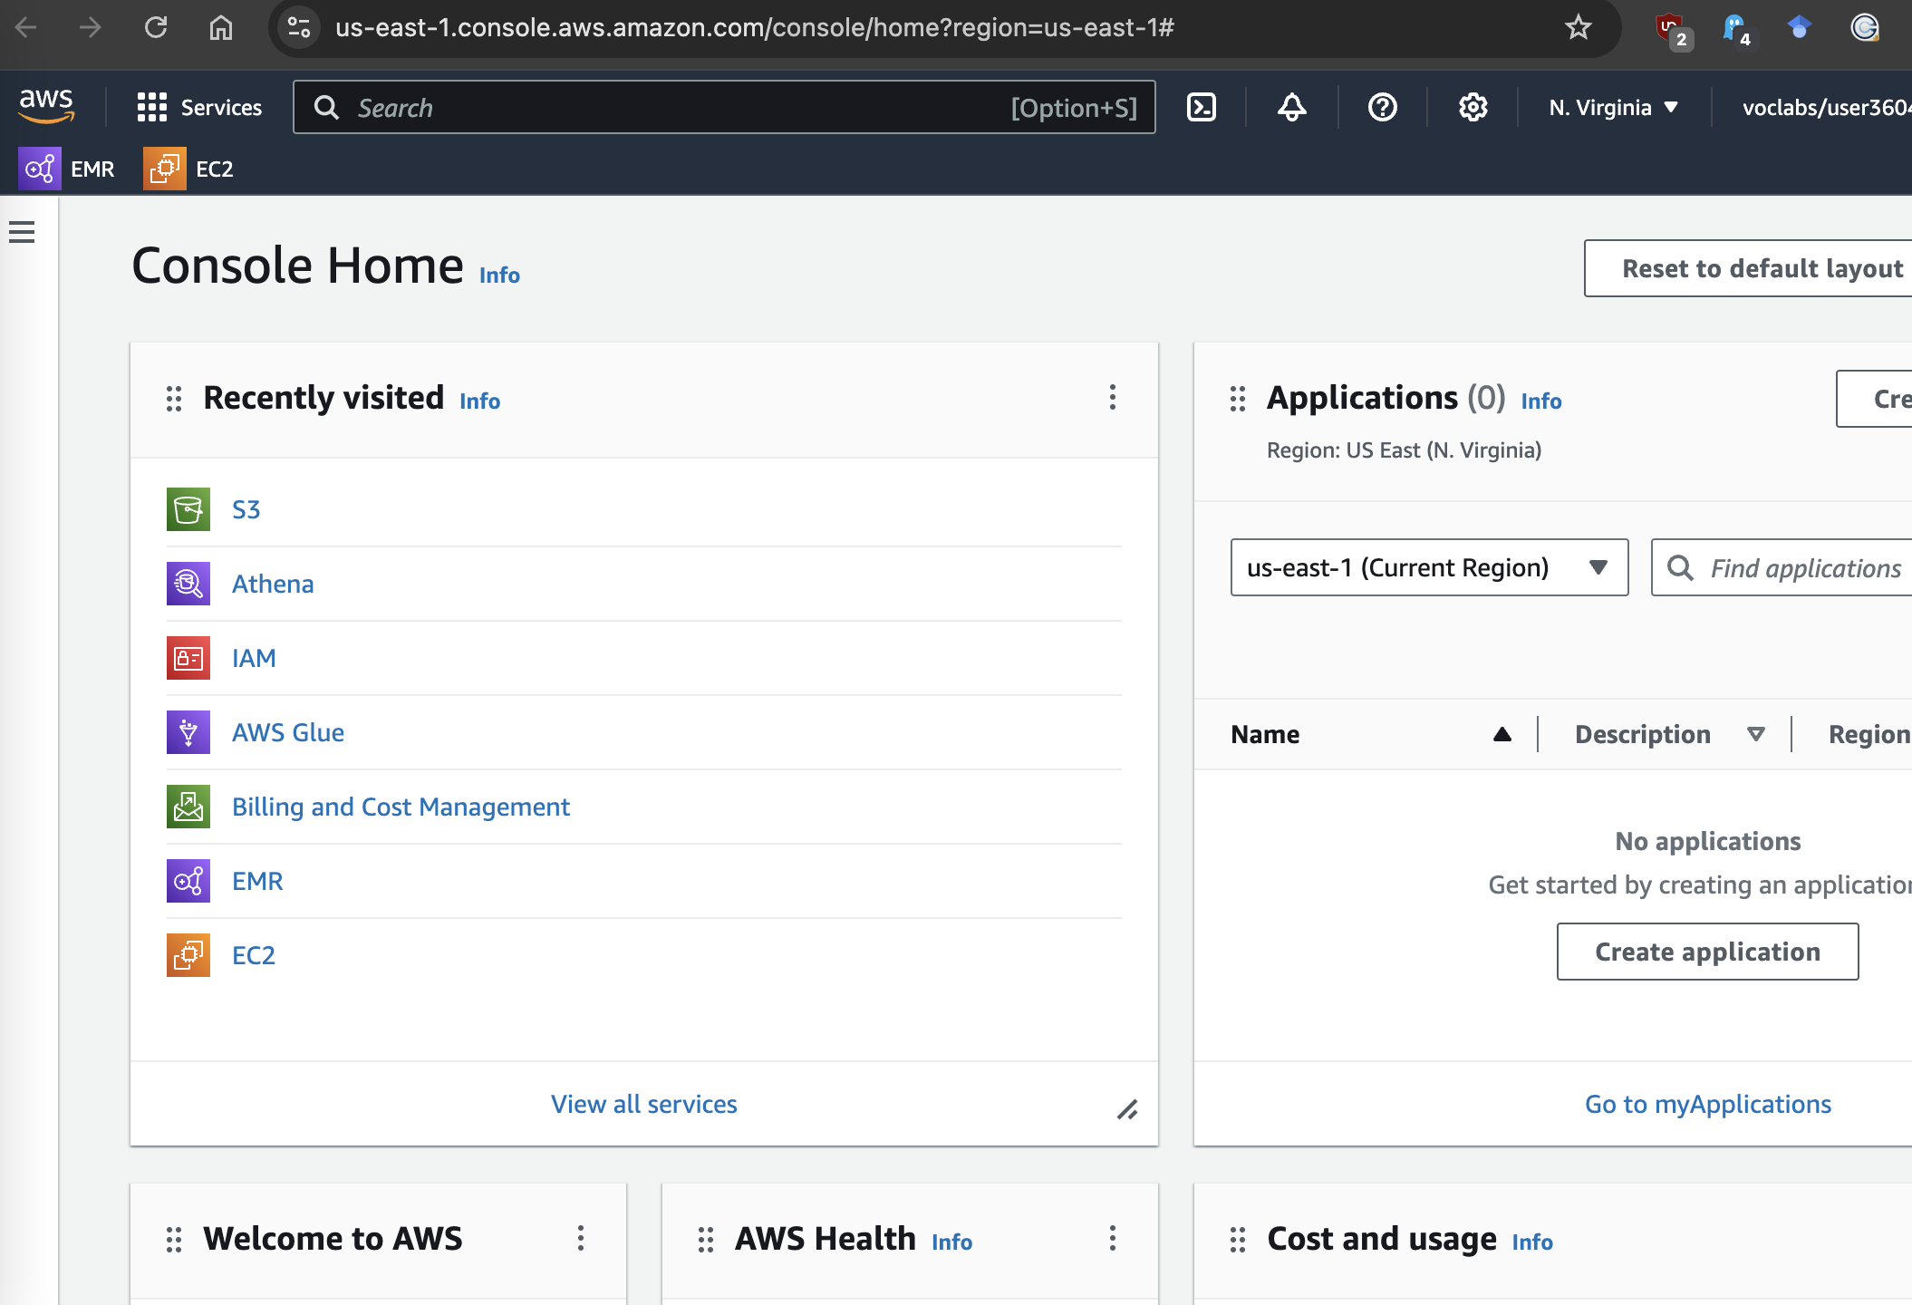

**Setting up a cluster on EMR**

1. Open Elastic Map Reduce (EMR)  
     
   A screenshot of a computer

   Description automatically generated
2. Create a new cluster (**EMR -> Create Cluster)**  
   A screenshot of a computer

   Description automatically generated
3. Choose settings:
   1. Amazon EMR version: emr-7.1.0
   2. Installed applications: JupyterHub 1.5.0
   3. Size:
      1. Master: 1 instance
      2. Core: 1 instance
   4. EC2 security groups: default
   5. Logs in Amazon S3: disabled
   6. Service role for Amazon EMR: EMR_DefaultRole
   7. EC2 instance profile: EMR_EC2_DefaultRole  
        
      A screenshot of a computer

      Description automatically generated

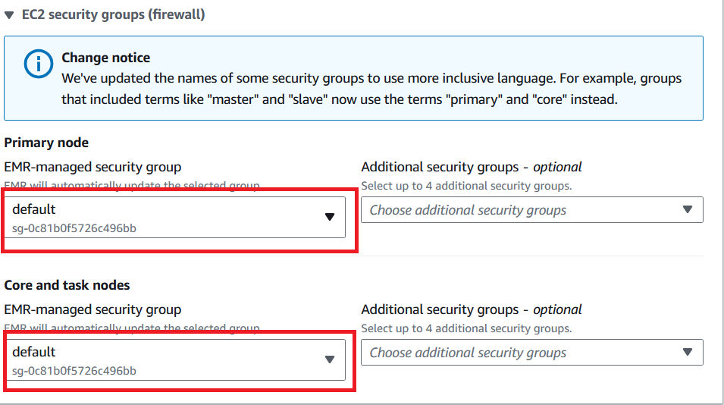

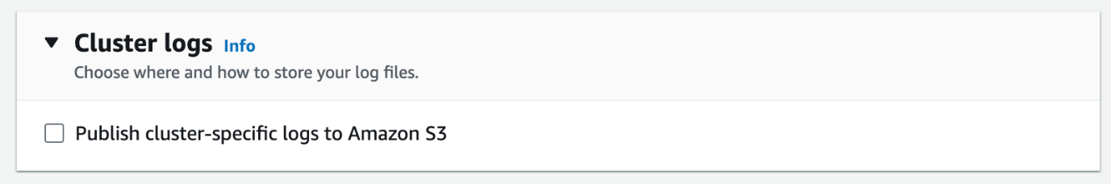

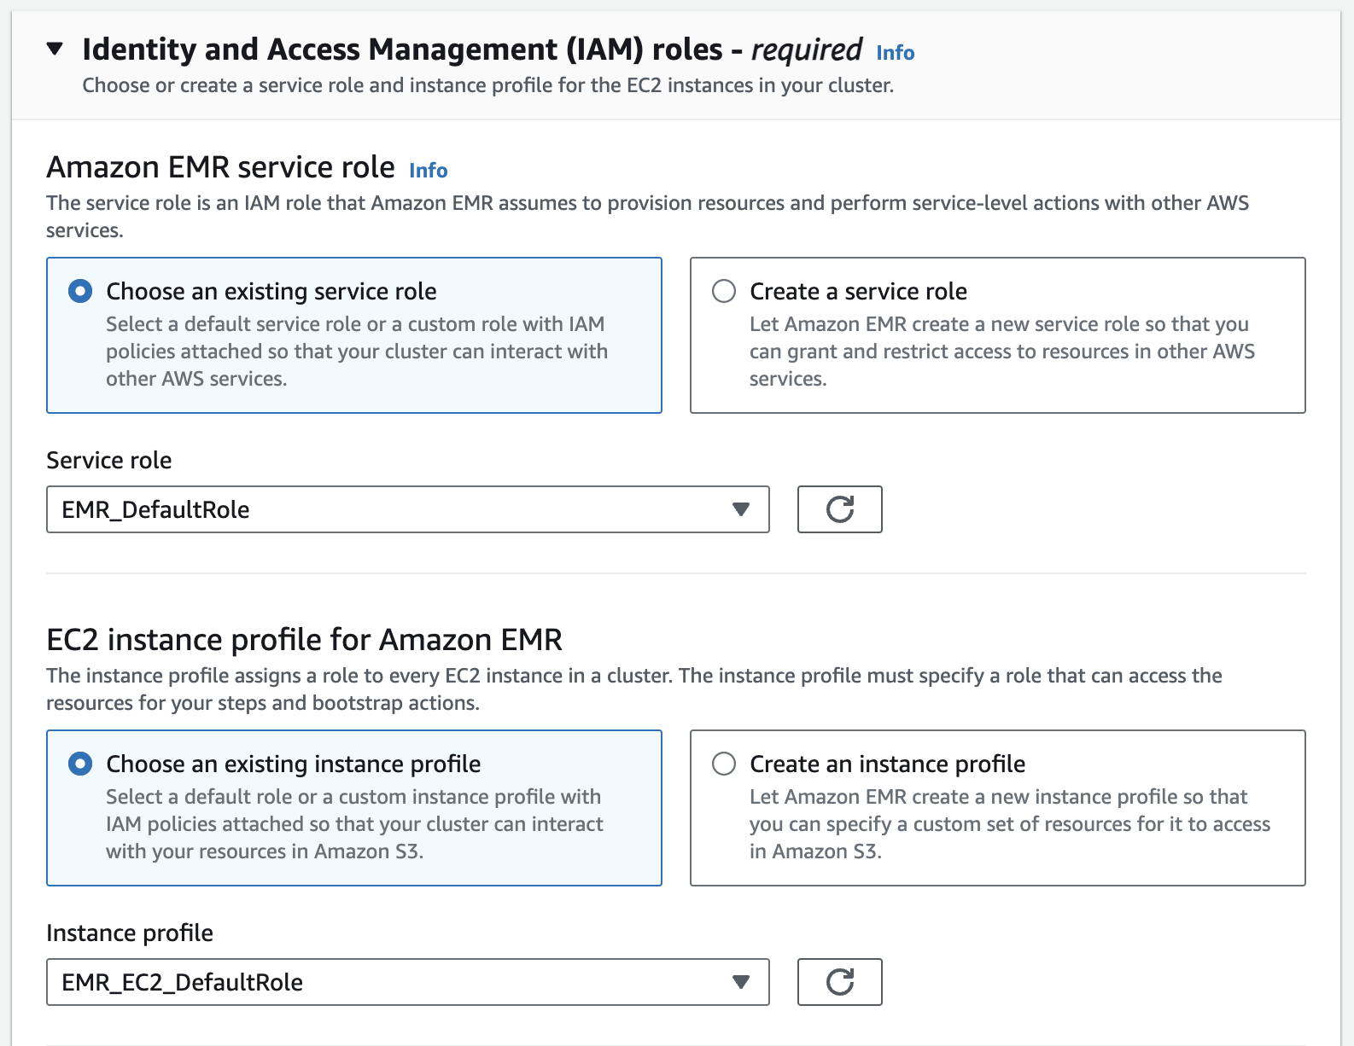

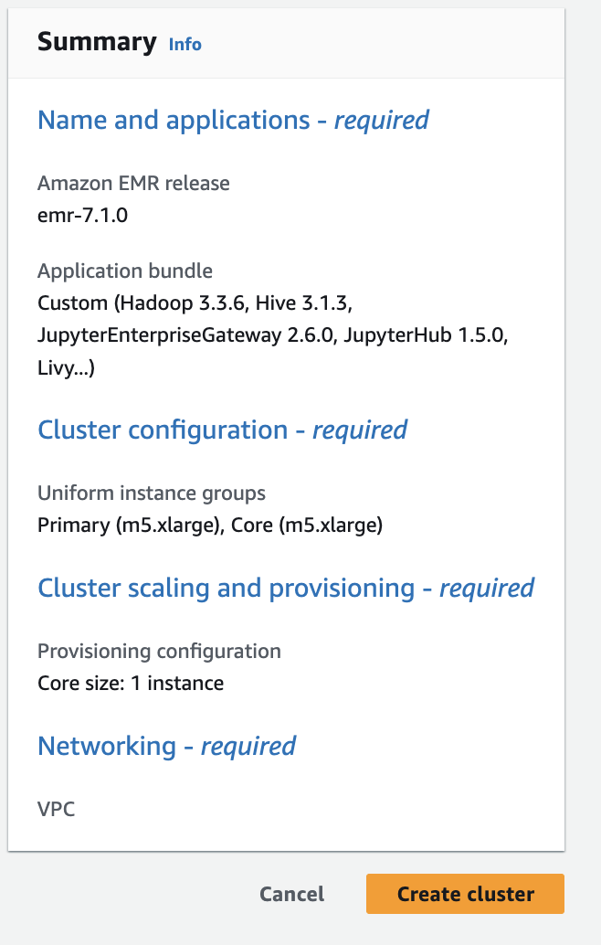

**Accessing Jupyter Interface**

1. Open Cluster configuration  
     
   A screenshot of a computer

   Description automatically generated
2. Network and security – we need to open ports
   1. open ports 9443, 18080 in security groups  
        
      A screenshot of a computer

      Description automatically generated
   2. Add inbound rules  
        
      A screenshot of a security group

      Description automatically generated
   3. Add rule, open to the world (all IPv4)  
        
      A screenshot of a computer

      Description automatically generated
3. In Applications, access Jupyter Hub at port 9443  
     
   A screenshot of a computer

   Description automatically generated
4. Login to JupyterHub using
   1. User: jovyan
   2. Password: jupyter

**Troubleshooting**

1. To start the cluster again, you may need to remove the inbound rules in the EC2 security groups (firewall) as the cluster security policy check will fail at the startup.
2. Instead of opening the ports, you can set up a tunnel using SSH, see: <https://docs.aws.amazon.com/emr/latest/ManagementGuide/emr-ssh-tunnel-local.html>