Republic of the Philippines

Department of Education

**National Capital Region**

**Schools Division Office of Caloocan City**

**AMPARO HIGH SCHOOL**

**#95 Marang Street, Amparo Subdivision, Caloocan City**

WORK IMMERSION PORTFOLIO

*(based on DepEd Order No. 30 s. 2017)*

This belongs to:

Boreres, Jasmhen M.

Name of Student-Trainee

ABM - A

Track / Strand / Section

JP Events

Agency / Company / Cooperative

2023 - 2024

School Year



**Mock Job Interview**

**During the conduct of the mock job interview, do you think you did well?**

For me, yes, even though I’m not used to interviews and not very good or confident in speaking English, I still did my best to answer the questions honestly and properly during the mock job interview. So, for me, during the conduct of the mock job interview, I did my best and I did well.

**What are the areas that you think you are good at and areas that needed to be improved?**

The areas where I think I am good at are: I am a fast learner, willing to learn as long as I enjoy what I’m doing, and I easily adapt to my surroundings and changes in my surroundings. The areas that I need to improve are my communication skills. I need to improve my socializing skills, but I am slowly improving and I am willing to further improve it.

**Are you more confident now to answer during job interview?**

Now, I can say that I am confident to answer in a job interview since I already have experience in how a job interview goes. I can apply my experiences and what I’ve learned during the mock job interview. I will apply and do everything that Sir taught and advised me on how to answer a job interview correctly and just be confident.

# THE COMPANY

I. **Objectives:** Appreciating management processes by observing, identifying and describing the following:

1. Nature of the business
2. Description of the products/services
3. Target clientele
4. Organizational structure
5. Company rules and regulations

#### Profile of the Company/Establishment

**Company Profile**

As Owner Jeff Paraños said “JP event is a different company it builds upon the faith as a Christian my company I started with faith I have no investment just trust. I told the Lord that I want to have a company that will bless me a lot especially in marriage. That’s why I didn’t get rich because when I talk to married couples, I first ask how much you can afford, how much your budget is because my goal is to get married so that’s according to my promise to the Lord. And about the financial, about the money, about involving money,” JP Event the Grand ballroom at Amparo village Malanting corner Bangkal St Caloocan north city boundary of QC venue.

**Write description and profile of your work immersion area. Please include pictures.**

When you look at JP Events from the outside, it looks like an ordinary place because it doesn’t have much design and looks small. But once you step inside, you will be amazed by the beautiful designs, as if you are in a luxurious palace. It is also very spacious. On the first floor of JP Events, you will see the kitchen where the food is cooked during events, and where the dishes are washed. On the second floor of JP Events, you will see Sir Jeff’s office, where you can do an appointment if you want to rent the event venue, and you will also see the makeup room. On the third floor, you will find the place where the main event is held.

**Vision**

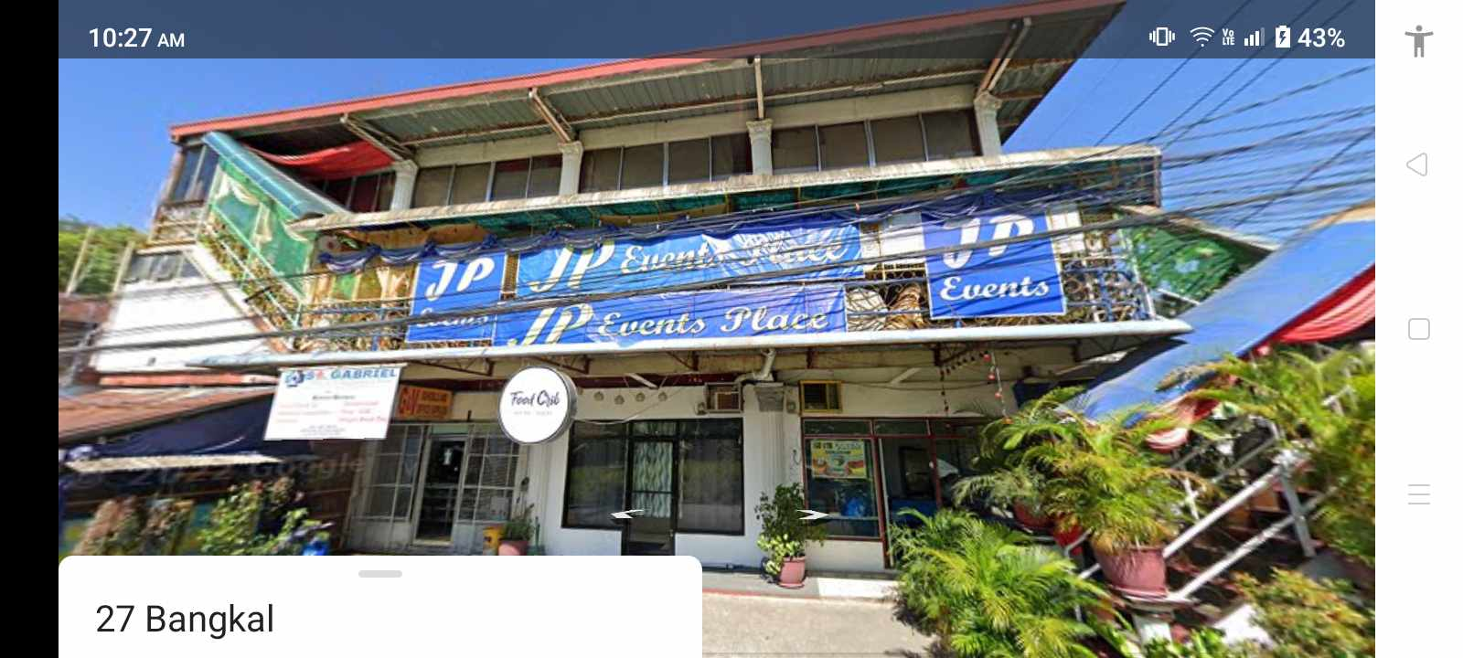

*Insert Company Picture*

To ensure client satisfaction and loyalty as we deliver personal

and unique experiences that are beyond expectation and create

long term loyal relationships by consistently providing outstanding

service that creates an overall extraordinary event experience.

**Mission**

To be the world leading Event Management Company that delivers

high quality, value-driven services while focusing on the uniqueness

and peculiarities of our clients’ project.

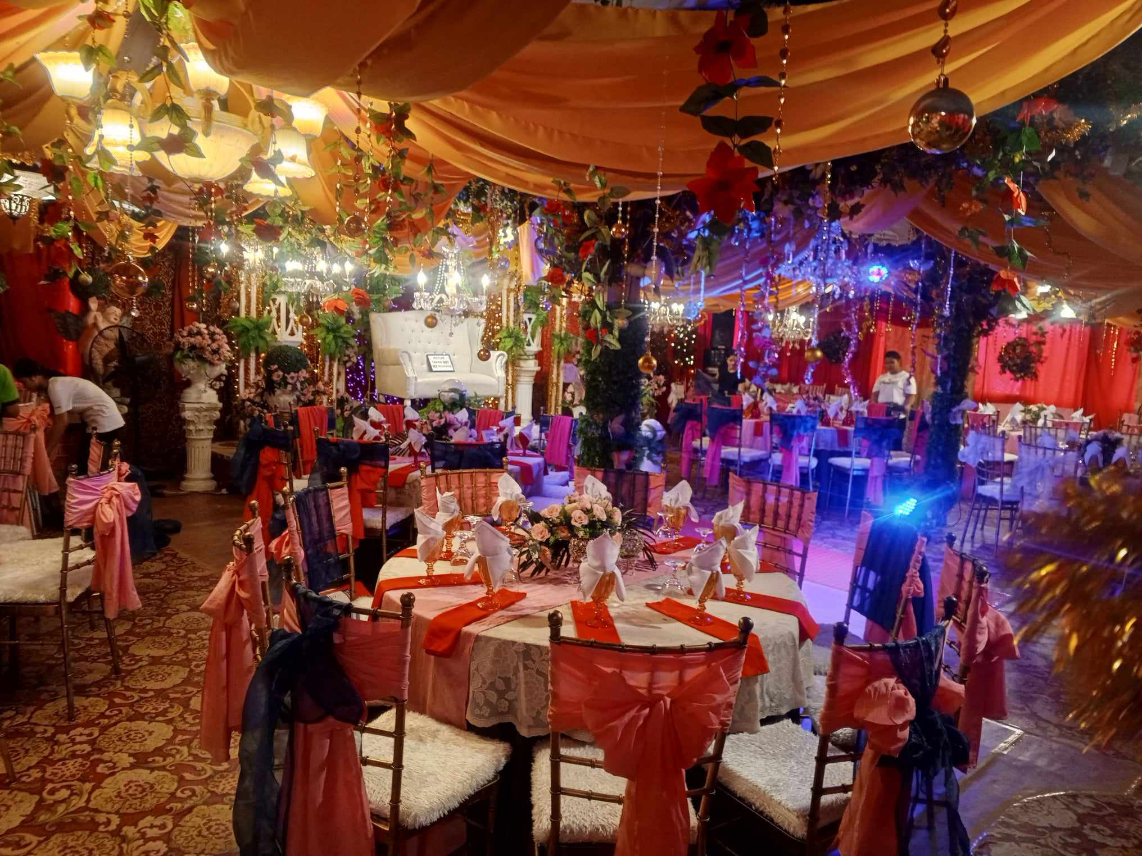

*Insert Company Picture*

**Objectives**

These may include building brand recognition, enhancing customer

loyalty, creating meaningful connections with stakeholders, or

reaching a target audience. The event’s purpose can be educating,

networking, promoting a product or service.

**Core Values**

Our values are to strive hard in building our reputation within the

industry and develop good connections with our clients to

understand their needs and requirements. Our attention to every

detail on events is the norm and the highest value of our company.

#### Organizational Chart

An organizational chart is a graphic representation of the structure of an organization, showing the relationships of the positions or jobs within it.

**JP Events Organizational Chart**

Owner

Cooks

Event Organizer

Washer

Dishwasher

#### Company Rules and Regulation

Describe briefly and/or insert or paste here.

The rules and regulations of the JP Event prohibit the use of cellphones while working. You should only work during working hours. For every event, you should look presentable, meaning you need to look clean. Your attire should be neat, your hair should be well-groomed, and you should wear makeup to look neat and presentable.

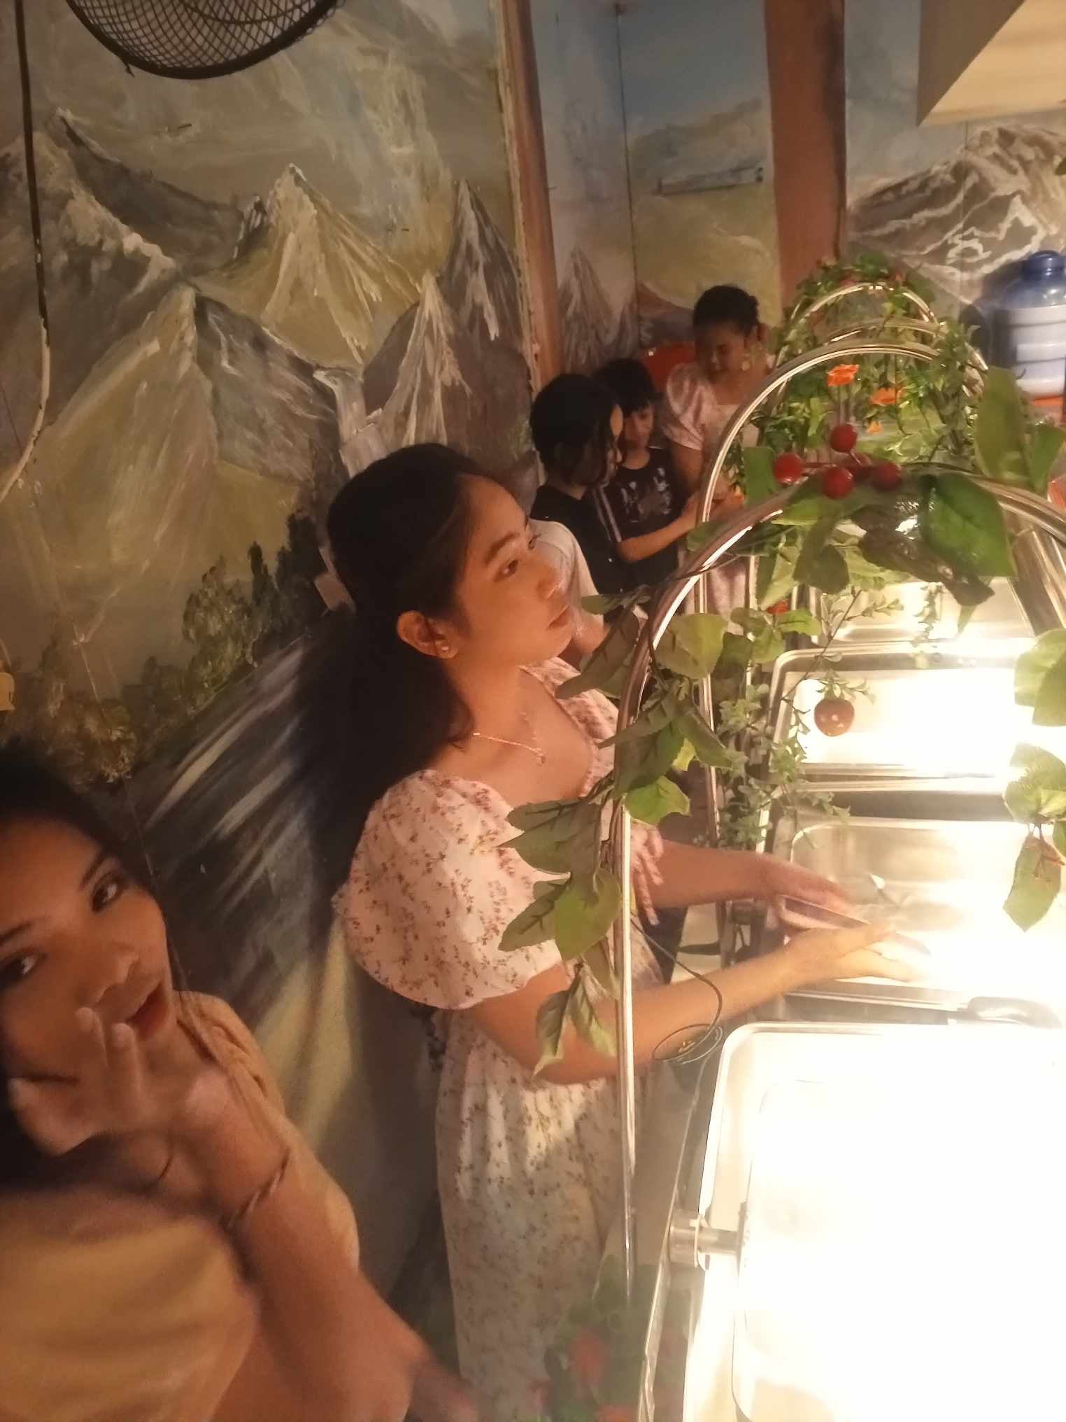State the work functions delegated unto you and how you accomplished it, Attach documents or pictures.

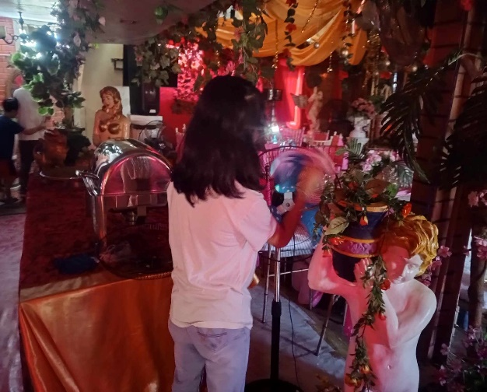

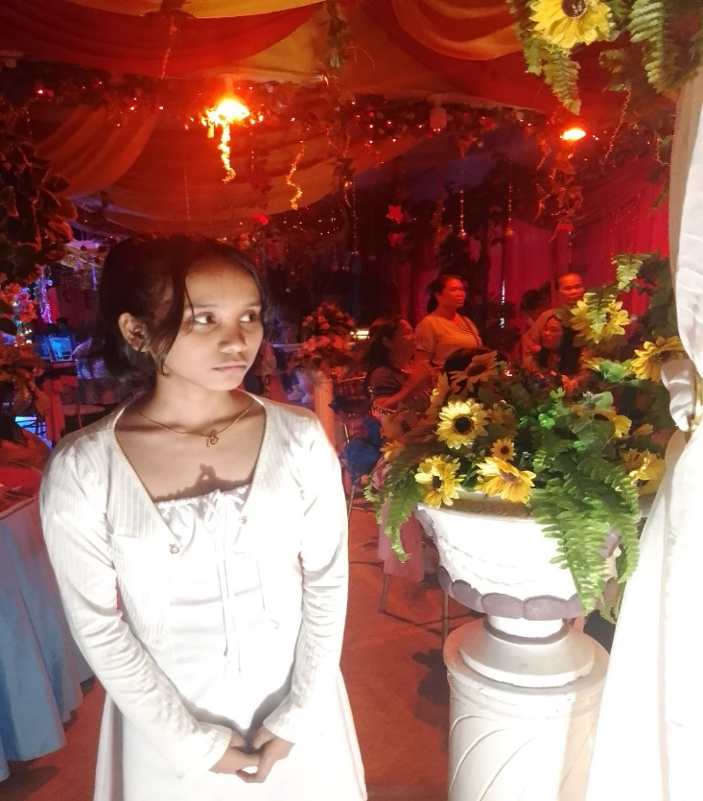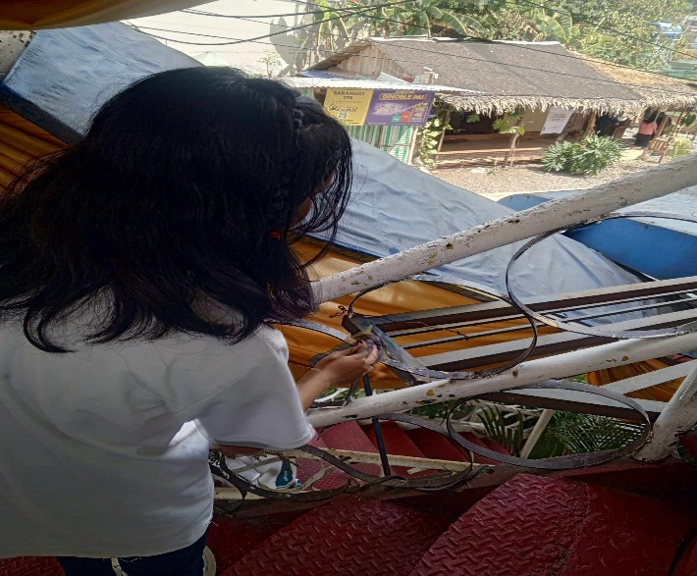

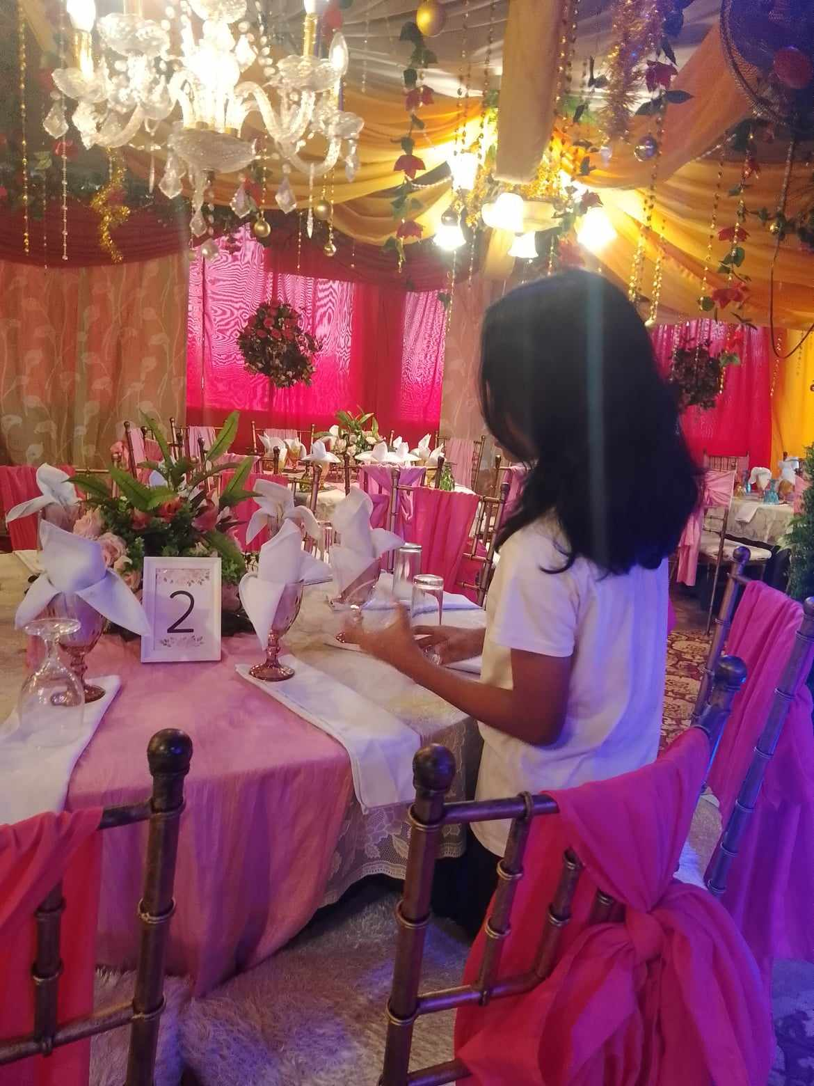

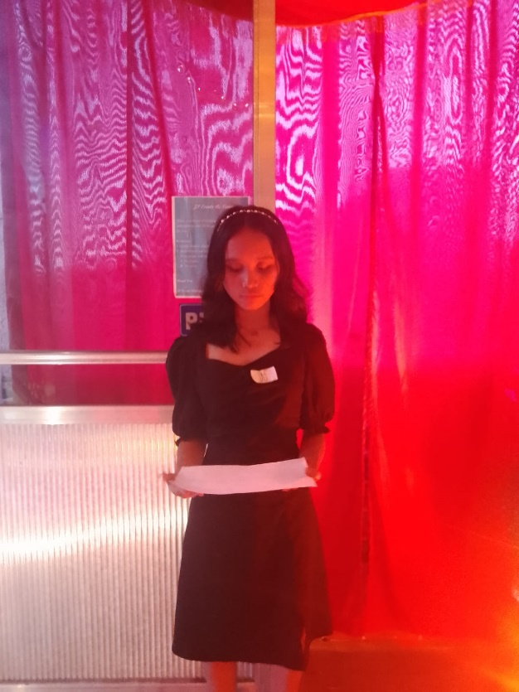

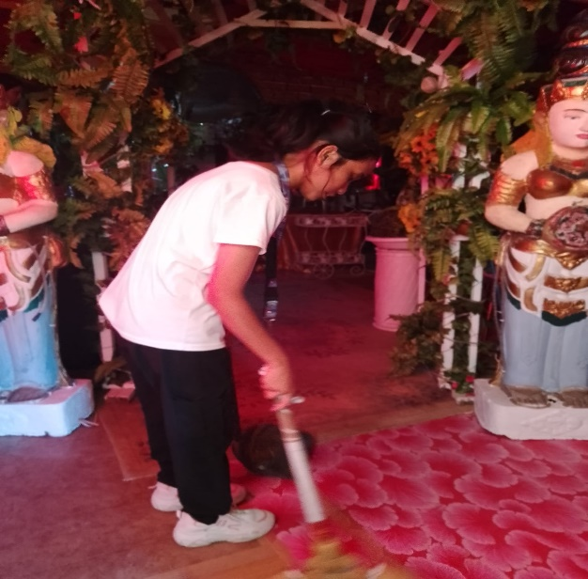

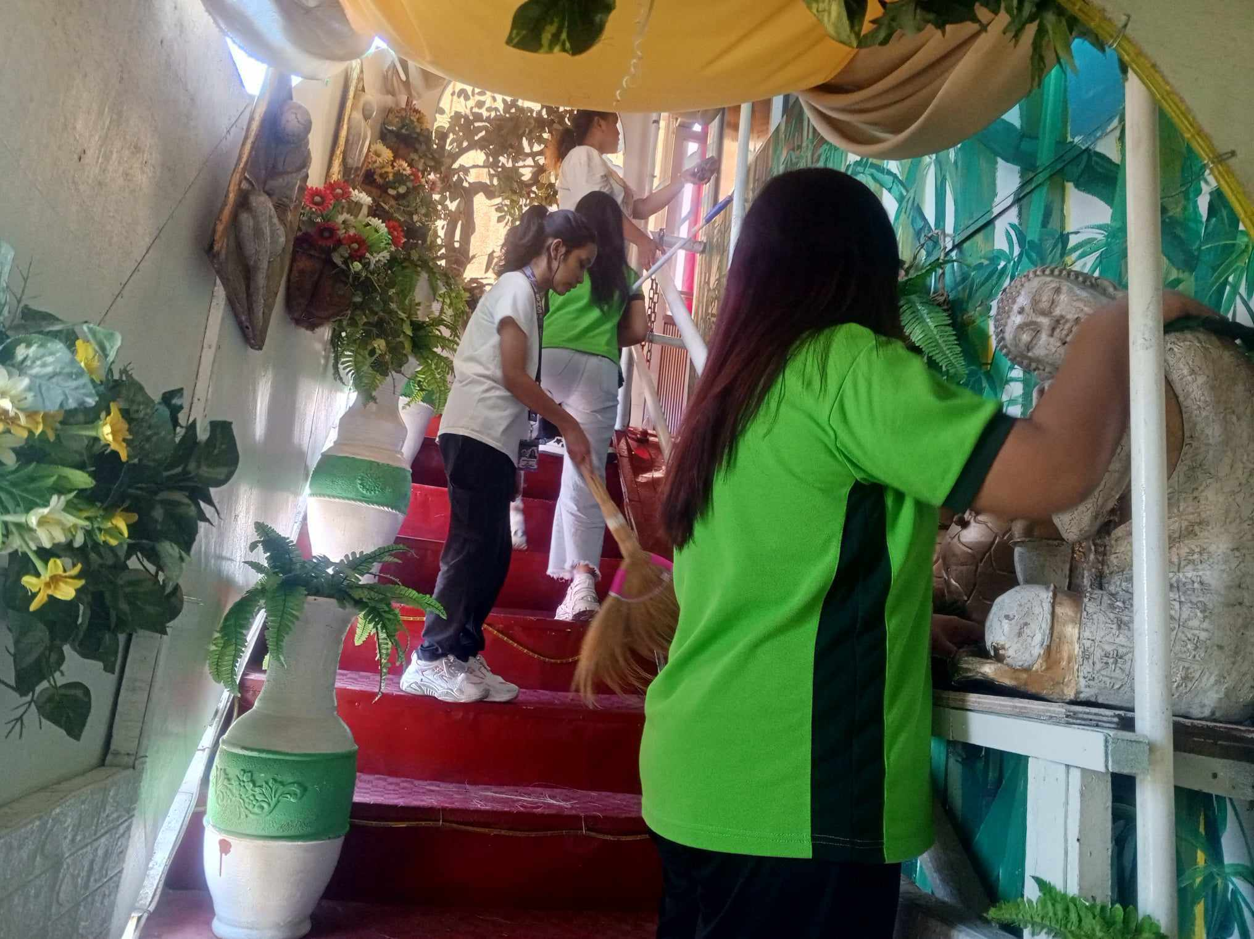

**ACCOMPLISHMENT REPORT**

Every time we have an immersion, we repeatedly do the same things like sweeping and wiping the floor to keep the place clean. We clean the electric fans, and we clean the JP Event Place when there is an upcoming event or when there is an event, we still clean. We help in arranging the ribbons on the chairs, arranging the table napkins, arranging the plates, glasses, forks, and spoons; we arrange everything needed for the events. When the events are about to start, we welcome each person entering, and when it’s complete inside, we prepare the drinks and help serve the food. The people we serve are 100 or less. After the event, we help clean up and arrange the things used. After cleaning the whole JP Event Place, we can go home.

**WORK IMMERSION HIGHLIGHTS**

*(Pictures with captions)*

On the last day of our immersion, Sir Jeff treated us food and drinks again.

With the people at the church. They are kind and friendly.

Rest time because the immersion is over.

Our first day immersion at JP event.

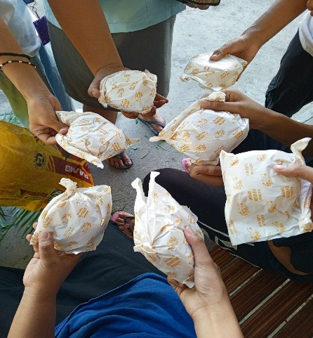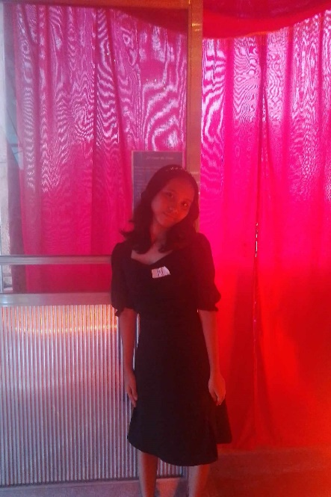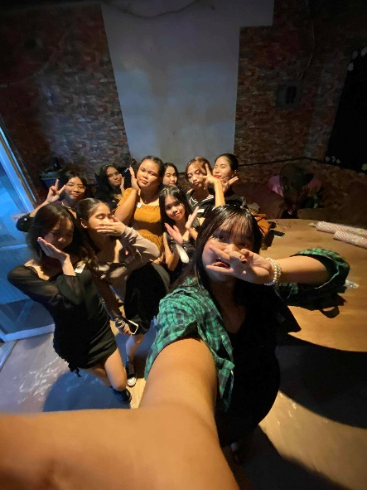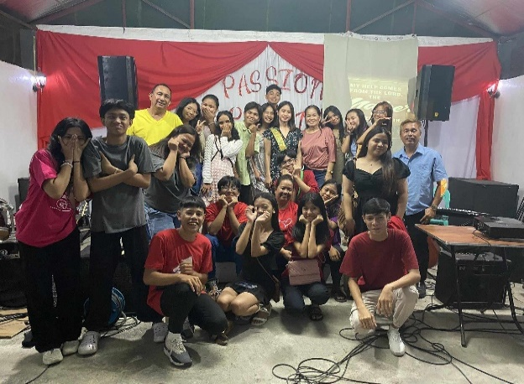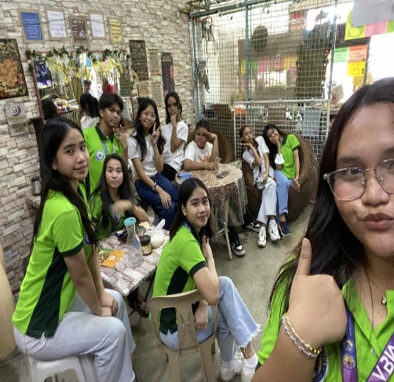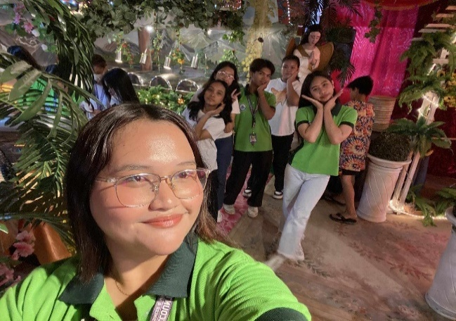

I welcome people entering the JP Event Place.

This photo was our first event where we served.

**REFLECTION**

How did the experience change me as a person, and how will it help me in the future.

My experience with JP Events taught me a lot, not just about cleaning and working, but also about how to socialize and express gratitude to people and to God. Sir Jeff is a person of faith; sometimes we go to Malaria Church where we were taught to be thankful to God every day and also how to socialize. We also learned to socialize there because many people at church are friendly and will approach you to talk. During our immersion at JP Events, Sir Jeff taught us and showed us what real work is and what is done when working at an events company because that’s what JP Events does. There were times when Sir Jeff scolded us, but after scolding us, he would explain to us what we did wrong. He scolded us, but there was a lesson to be learned that we can take with us when we start working. There are workers there whom we could talk to, and because of them, I learned how to socialize with people; they are very easy to get along with. My experience in JP Events has helped me develop stronger communication and interpersonal skills from interacting with colleagues and clients, which I know will be a great help for my future.

##### **PRE-IMMERSION RUBRIC**

**Objectives:** Understanding work immersion by discussing:

* 1. ***Expected Behaviour*** – Work ethics, Safety in the workplace, workplace rights and responsibilities, confidentiality in the workplace, effective conflict resolution and teamwork skills
  2. ***Appreciating the importance of credentials by:*** writing a resume, filling out application forms, secure clearances, job interview skills training

**Performance Indicator:**

(10) - Excellent (9) - Very Good (8) - Good (7) - Fair, (6) - Poor Performance

***\*To be rated by the Work Immersion Teacher and should be indicated in the Written Works 1***

|  |  |  |  |  |  |  |  |  |
| --- | --- | --- | --- | --- | --- | --- | --- | --- |
| **Competency** | **Activity No.** | **Task/Output/Artefact** | **Performance Rating** | | | | | **Rate** |
| *10* | *9* | *8* | *7* | *6* | **WI Teacher** |
| **A.** (example) |  | | | | | | | |
| Work ethics  Safety in the workplace  Confidentiality in the workplace  Effective conflict  resolution | 1 | Participated pre-immersion orientation and perform expected behavior. |  |  |  |  |  |  |
| B. |  | | | | | | | |
| Writing a resume | 2 | Sample Resume |  |  |  |  |  |  |
| Filling out application forms | 3 | Application Letter |  |  |  |  |  |  |
| Secure clearances | 4  5  6  7 | Barangay, Police,  Mayor’s Clearance,  Medical Certificate |  |  |  |  |  |  |
| Job interview skills | 8 | Job Interview |  |  |  |  |  |  |
| Other documents | 9  10 | Insurance Policy Parent’s Consent |  |  |  |  |  |  |
| **Perfect Score: 100** |  | Total Raw Score |  | | | | |  |
| **Descriptor** |  | **Average** = *Total Raw*  *Score / No. of activities* |  | | | | |  |

**Feedback of Work Immersion Teacher:**

*Name and Signature of Work Immersion Teacher*

##### **POST WORK IMMERSION RUBRIC**

* 1. **Objectives:** Evaluating the Work Immersion Experience

***Skills Indicator:*** (10) - Excellent (9) - Very Good (8) - Good (7) - Fair (6) - Poor Performance

***\*To be rated by the Work Immersion Teacher and should be indicated in the Written Works 2***

|  |  |  |  |  |  |  |  |  |
| --- | --- | --- | --- | --- | --- | --- | --- | --- |
| Competency | Activity No. | Task/Output/Artefact | Performance Rating | | | | | Rate Teacher |
| 10 | 9 | 8 | 7 | 6 |
| Presenting a portfolio with entries | 26 | Accomplished forms, Collage |  |  |  |  |  |  |
| Comparing school and work application of skills, knowledge, and  attitude | 27 | Accomplishment Report and/or Weekly diary *(issues faced & resolutions)* |  |  |  |  |  |  |
| Writing an updated resume | 28 | Updated Resume |  |  |  |  |  |  |
| Reflecting on experiences | 29 | Work Immersion  Highlights |  |  |  |  |  |  |
| 30 | Reflections |  |  |  |  |  |  |
|  | Completion Certificate |  |  |  |  |  |  |
| **Perfect Score:** 40 | | Total Raw Score |  | | | | |  |
| **Descriptor** | | **Average** = Total Raw Score/ no. of activities | | | | | |  |

**What went well? _______________________**_________________________________________________________________

**What needs to be improved?**

*Name and Signature of Immersion Teacher*