**Marketing Strategies Employed by Small Business Owners to Promote Sales**

**of Mango Sticky Thrice Balls in a Stall Business Location.**

**Abstract**

This study investigates the what various marketing strategies employed by small business owners to promote the sales of mango sticky rice Balls in stall businesses. Through a quantitative approach, data was collected from a sample of student using structured questionnaires. The study will use the SWOT analysis for the stall business selling the mango sticky rice. To determine the Strength, Weakness, Opportunity, and Threats in acquiring marketing strategies to promoting mango sticky rice balls. It used descriptive statistics such as frequency count, percent, mean and rank are considered. Findings indicate that a combination of social media promotions and attractive product presentation significantly correlates with increased sales of mango sticky rice in stall businesses. The study contributes to the understanding of effective marketing strategies for small business owners in the food industry and provides actionable insights for enhancing sales performance in mango sticky rice stalls.

**Introduction**

Mango sticky rice is a popular Thai dessert known for its unique blend of sweet mangoes and sticky rice, often topped with coconut milk. While this delicacy has gained popularity worldwide, by creating an innovation, we decided to make this mango sticky rice much interesting instead of making a simple rice, we decided to make it as a rice balls with a mango filling inside of it and at the top the creamy coconut milk.little research has been conducted on the optimal location selection for selling it. This study aims to fill this gap by examining various marketing strategies that can help small business owners identify the ideal location for selling mango sticky rice. In putting mango sticky rice, location selection is an important part of running a business. A good business location can greatly increase customer flow, reduce operating costs, and increase business revenue. Therefore, it is necessary to select an appropriate location for business premises. In business location, decisions are one of the most important decisions that small business owner face with during their entrepreneurial activities.

In the competitive markets, small business owners must employ marketing strategies to attract customers and maximize profitability. Effective marketing strategies are crucial for small business owners to thrive in competitive markets. One key aspect of success is selecting an ideal location for the business. This study focuses on the marketing strategies employed of small business owners in their ideal location fin promoting mango sticky rice, a popular delicacy with a growing demand.

The amount of resources spent to this kind of decisions, shows the importance of business location decisions of small business owner who are begin their business or relocate to another location (Karakaya&Canel, 2019). Without sufficient knowledge, time, or motivation to review all available information, they often rely on visual information to inform their purchase decisions, especially for fast-moving consumer goods, because the visual cues are easy to understand and process automatically (Kahn, 2020, Townsend and Kahn, 2020).

**Literature Review**

Smykova (2023) A small business study in Kazakhstan observed that marketing audits positively impact the growth of financial indicators in small businesses. This affordable marketing tool can improve economic metrics and positively impact the country’s economy. The study used foreign researchers’ experiences and questionnaires from 120 small business representatives to test the hypothesis. However, the results revealed low awareness of existing marketing audit tools among small business owners, and poor working conditions among employees, hindering motivation to improve business performance. Agustin (2019) this study examines the entrepreneurial practices of stall owners in the Mall of the Valley of Tuguegarao City, focusing on their ability to deliver quality products and services despite facing challenges in raising capital due to government assistance. The research uses a descriptive correlational research design and a structured questionnaire, revealing that despite the lack of government assistance, stall owners prioritize social responsibility and satisfaction of consumers in their entrepreneurial practices. This highlights the importance of commercial stalls in meeting local needs. Small business marketing strategy was explored through business owners who have a consistent knowledge of their product or service and are not considered experts in the field of marketing; such business owners struggle with how to implement strategic planning, a marketing plan, and other elements necessary for success (Day, 2020). More specifically, small businesses struggle due to lack of marketing knowledge that is aimed a t understanding specific marketing problems (Free man, 2019). When small business owners seek help, a struggle exists to understand if the know ledge they have sought out is worthwhile to the success of their business (Day, 2020) Choosing the right advertising channels is also critical to successful promotional marketing. Different channels, such as social media, digital marketing or print advertising, can be effective depending on the target audience and campaign objectives. It is important not to focus on just one channel, but to diversify and use multiple channels to reach a wider audience. By choosing the right promotional channels, companies can maximise reach and engagement, leading to increased brand awareness and sales (Abuselidze G., Talavyria M., Vyshnivska B., Bondarenko V., Makedon H., Kniazieva T., Salkova I. 2023).

**Method**

**Statement of the Problem**

This study aims to provide insights into the challenges and opportunities faced by small business owners in the context of marketing strategies for promoting sales of mango sticky rice balls in their stall business location. Specifically, this study sought to answer the following questions:

1. Demographics profile in terms of:

1.1 Age

1.2 Gender

1.3 Income Status

2. What marketing strategies does small business owners used to promote Mango Sticky Rice in terms of:

2.1 Social Media Marketing

2.2 Referral Marketing

2.3 Event Marketing

3. How does small business owners formulate marketing strategies in promoting Mango sticky rice?

3.1 Advertising

3.2 Defining the targets customers

3.3 Customer engagement

4. How does the different barriers affect the promotion of Mango Sticky Rice in terms of:

4.1 Low income

4.2 Limited materials/ resources

4.3 Time Constraints

5. What pricing strategy you can recommend that suit to your business to gain sales?

**Population and Sample**

The researchers choose a sample of fifteen (15) random selected stall business owners around Rotonda, Mabolo, and Capitol Street in Caloocan City. The researcher will use simple random sampling in this study. By employing simple random sampling, the researcher can ensure that each small business owner in the population has an equal chance of being included in the sample. The respondent’s will be randomly selected because the researchers believe that using this sampling method is the most straight- forward and unbiased method of sampling. It reduces the potential for bias and ensures that the sample is representative of the population.

**Research Design**

The research design that we used Is SWOT Analysis. SWOT (strengths, weaknesses, opportunities, and threats) analysis is a method for identifying and analyzing internal strengths and weaknesses and external opportunities and threats that shape current and future operations and help develop strategic goals. These factors to guide small business owners in Making informed decision about the location of their establishments and how they will enhance the promotion of mango sticky rice balls in stall business location.

**Data Collection**

In obtaining data, the researcher used the survey questionnaire to collect data because it is one of the easiest ways to get the result immediately. The researcher conducted the research in Amparo, Caloocan City. The survey questionnaire is related to SOP to determine the most convenient way to gather information that the researcher wants to gather and that is answered by the small business owners. The researcher asks the permission of the respondents and explains to them the importance of their response to the study. They clarify some terms for the respondents so that they can answer the questionnaire with full knowledge of their responsibility as the subject of the study. The respondents were given enough time to answer the questionnaires. After collecting the data, the researchers used the information to calculate scores, apply statistical analysis that will be used in the study, and develop a conclusion and recommendations for the research.

**Analysis of the data**

Responses to the questionnaire by stall business owners were statistically analyzed with the data requirements of the study. Descriptive statistics such as frequency count, percent, mean and rank are considered.

To analyze and interpret the data, the researcher employed the following statistical procedure:

1.Frequency, percentage and ranking- This will help the researchers easily tally the data they gathered. This percentage and ranking will be a big help in the researchers’ analysis of the data and in describing the socio-demographic profile of the respondents.

Formula: P= F/N x 100

Where:

P= Percentage

F= Frequency

N= Total number of respondents

2. Frequency, weight mean and ranking- This tool was used to provide answer to the questions. The formula is:

Formula:

WM= ∑ [(F)(w)] / N

Where:

WM= weighted mean

∑= summation

F= Frequency

W= unit weight

N= number of respondents

|  |  |  |
| --- | --- | --- |
| Points | Scale | Verbal Interpretation |
| 5 | 4.50 – 5.00 | Strongly Agree |
| 4 | 3.50 – 4.49 | Agree |
| 3 | 2.50 – 3.49 | Neither |
| 2 | 2.00 – 2.49 | Disagree |
| 1 | 1.00 – 1.49 | Strongly Disagree |

**Research** **Paradigm**

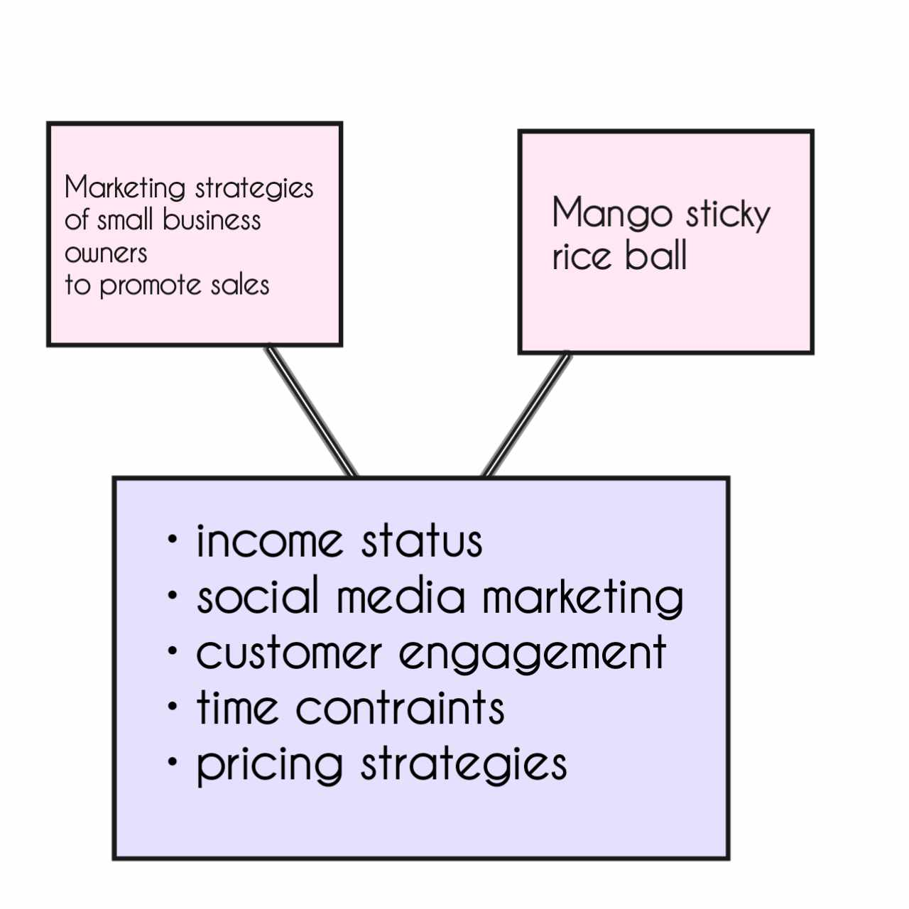

**Results** **and** **Discussion**

This section presents the Statistic Data, Data Presentation, Analysis, and Interpretation are all covered in this section. The information below was taken from the online survey questions that the researches gave the participants.

**Table 1**. Ages of the business owners

Age Frequency Percentage Rank

Under 18 years old 2 13.3% 3

19 – 29 years old 7 46.7% 1

30 – 40 years old 5 33.3% 2

41 – 51 years old 1 6.7% 4

52 years old above 0 0% 5

Total: 15 100%

The demographic profile of the respondents in Table 1 shows that the most of the respondents are of between 19 – 29 years old which is equivalent to 46.7 %. This means that the most of the business owners are young adults and followed by 30 – 40 years old which is equivalent to 33.3%.

**Table 2**. Demographic profile of the respondents

Gender Frequency Percentage Rank

Male 6 40% 2

Female 9 60%

Total: 15 100%

As illustrated in the table above, most of the respondents are Female with a percentage 60 and Male with a percentage of 40.

**Table 3**. Income Status

Income Status Frequency Percentage Rank

₱1,000 – ₱5,000 2 13.3% 2

₱5,001 –₱ 10,000 5 33.3% 1

₱10,001 – ₱15,000 1 6.7% 3

₱15,001 – ₱20,000 5 33.3% 1

₱20,001 – ₱25, 000 2 13.2% 2

₱25,001 Above 0 0% 0

Total: 15 100%

As reflected in the table above, the majority of small business owners surveyed has an income of ₱15,001 – ₱20,000 and ₱5,001 – ₱10,000 with a frequency of 33.3%. While ₱1,000 – ₱5,000 and ₱20,001 – ₱25,000 rank 2 in the survey with a frequency of 13.3%. And ₱10,001 – ₱15,000 rank last in the survey with a frequency of 6.7%.

**Table 4**. Marketing Strategies

W.M V.I Rank

The Stall Business actively engages   
with customers on social media 4.46 Agree 1  
platforms

Customers are encouraged to  
 refer friends and family to the 4.06 Agree 2  
Stall Business through incentive  
 or rewards

The Stall Business participates in   
local events, festivals, or markets 3.6 Agree 3  
to promote mango sticky rice.

As shown in the table above, small business owners rated social media marketing highest, with an average rating of 4.46, indicating its effectiveness in promoting sales of mango sticky rice. Referral marketing has a rate of 4.06 and event marketing got 3.6. They also received favorable ratings, suggesting that these strategies are commonly used by stall businesses to attract customers and generate sales.

.

**Table 5**. Formulation of Marketing Strategies

W.M V.I Rank

The Stall Business invests in  
advertising to promote mango 3.93 Agree 3  
sticky rice. (e.g., flyers, banners)

The Stall Business has a clear   
understanding of its target 4.2 Agree 2  
customers for mango sticky rice.

The Stall Business actively engages  
with customers to gather feedback 4.4 Agree 1  
and improve marketing strategies.

As reflected in the table above, customer engagement rank 1 in the survey with an average of 4.4 and verbal interpretation of agree. It states that the owners engage with customers to gather feedback and improve marketing strategies. While defining the target customer rank 2 in the survey with an average of 4.2 and advertising rank 3 with an average of 3.93.

**Table 6**. Barries to promotion

W.M V.I Rank

The Stall Business invests in  
 advertising to promote mango   
sticky rice. (e.g., flyers, banners) 4.06 Agree 2

The Stall Business has a clear   
understanding of its target 4.13 Agree 1  
 customers for mango sticky rice.

The Stall Business actively engages  
 with customers to gather feedback 3.6 Agree 3  
 and improve marketing strategies.

As illustrated above, the limited access of resources/materials rank 1 in the survey with an average of 4.13 and a verbal interpretation of Agree. It indicates that business owners don’t have enough ingredients in preparing mango sticky rice. While the low-income rank 2 with an average of 4.06 and time constraints rank 3 with an average of 3.6.

**Table 7**. Pricing strategies

W.M V.I Rank

The stall business offers competitive

prices for mango sticky rice 3.8 Agree 3

compared to other vendors.

The Stall Business offers discounts

or promotions to attract customers to 4.13 Agree 2

purchase mango sticky rice.

The pricing of mango sticky rice

reflects its perceived value to customers 4.2 Agree 1

(e.g., quality, authenticity).

Value based pricing rank in 1 the survey with an average of 4.20 and verbal interpretation of agree. It is the most commonly used pricing strategy among small business owners, they set the prices of the product that they believe the customers is willing to pay. On the other hand, promotional pricing rank 2 on the survey with an average of 4.13 and competitive pricing rank last with withy an average of 3.8.

**Conclusion**